ASSIGNMENT 8

ADITYA DEVCHAKKE
KD-1

Q1) Assume each salesperson has 12% commission. Write a query on the orders table that will produce the order number ,salesperson number and amount of the salespersons commission for that order

→
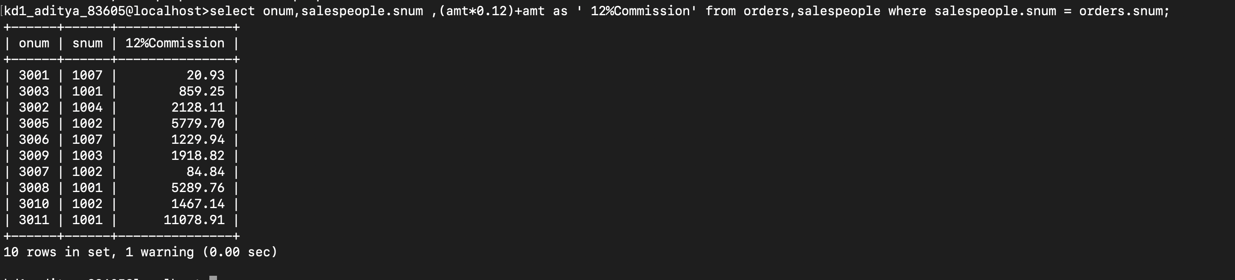
select onum, salespeople.snum, (amt*0.12)+amt as ' 12%Commission' from orders, salespeople where salespeople.snum = orders. Snum;

Q2) Write a query on customers table that will find the highest rating in each city put output in following form
‘ for the city (city), the highest rating is:(rating)’

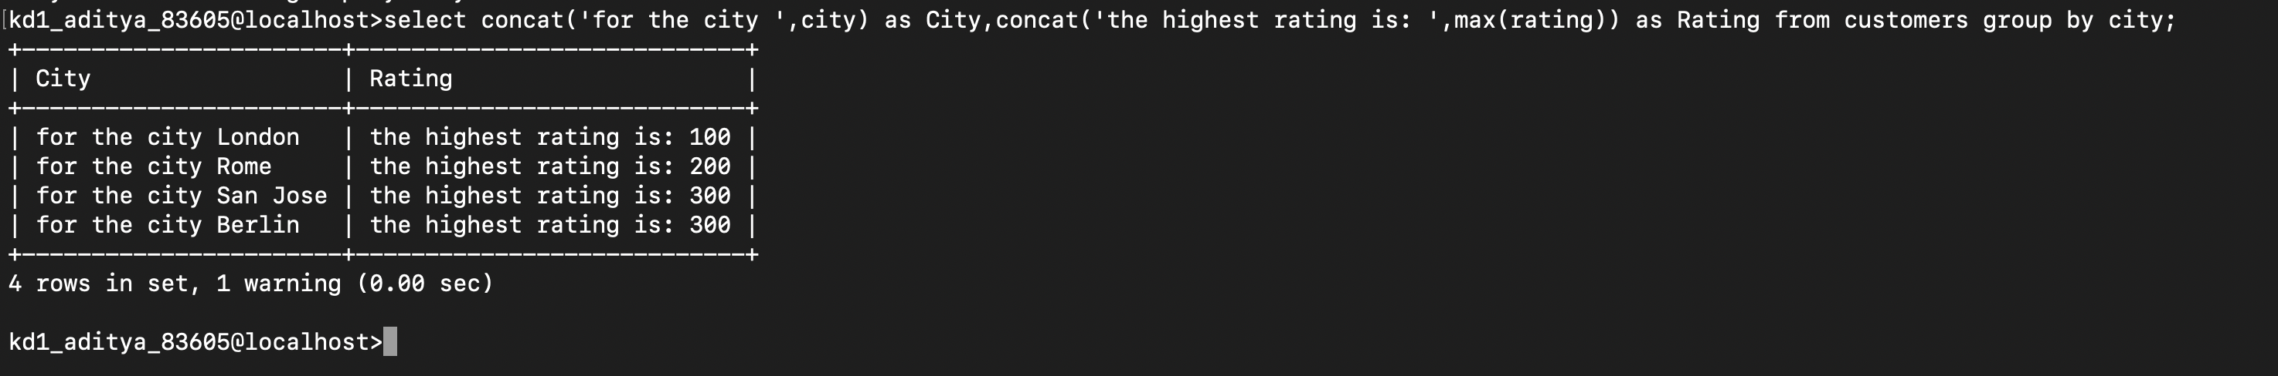
→
select concat( 'for the city ',city) as City, concat ('the highest rating is: ',max(rating)) as Rating from customers group by city;

Q3) Write a query that lists customers in desc order of rating.Output the rating field first, followed by customers name and number
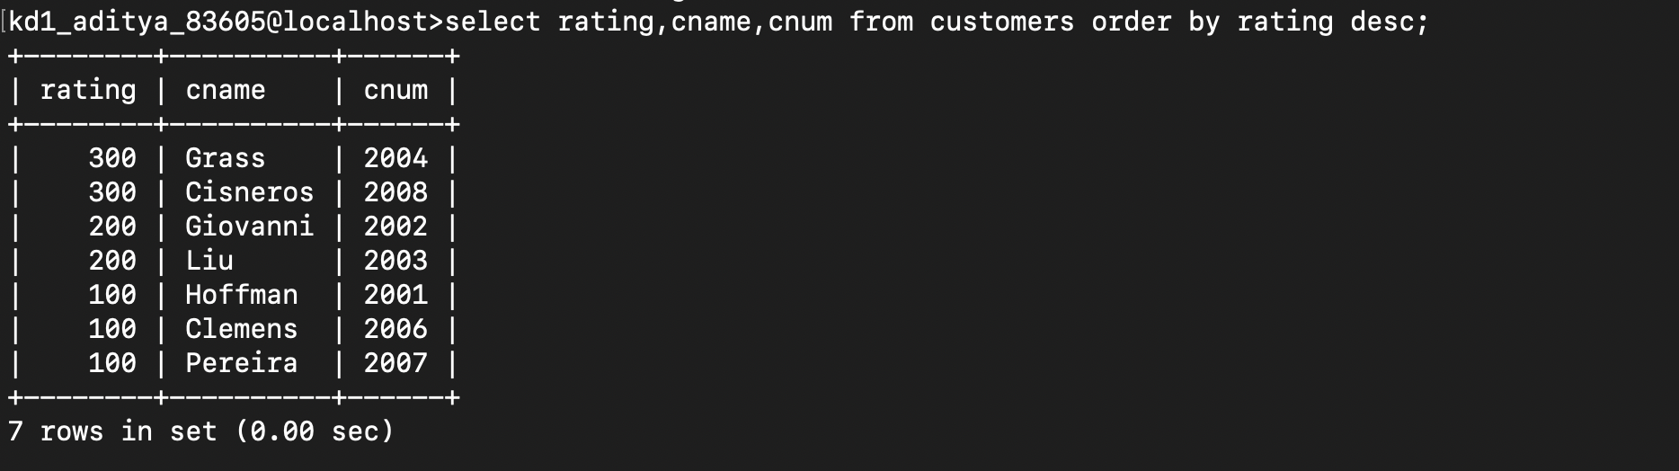
→
select rating, cname, cnum from customers order by rating desc;

Q4) Write a query that totals the orders for each day and places the results in desc order
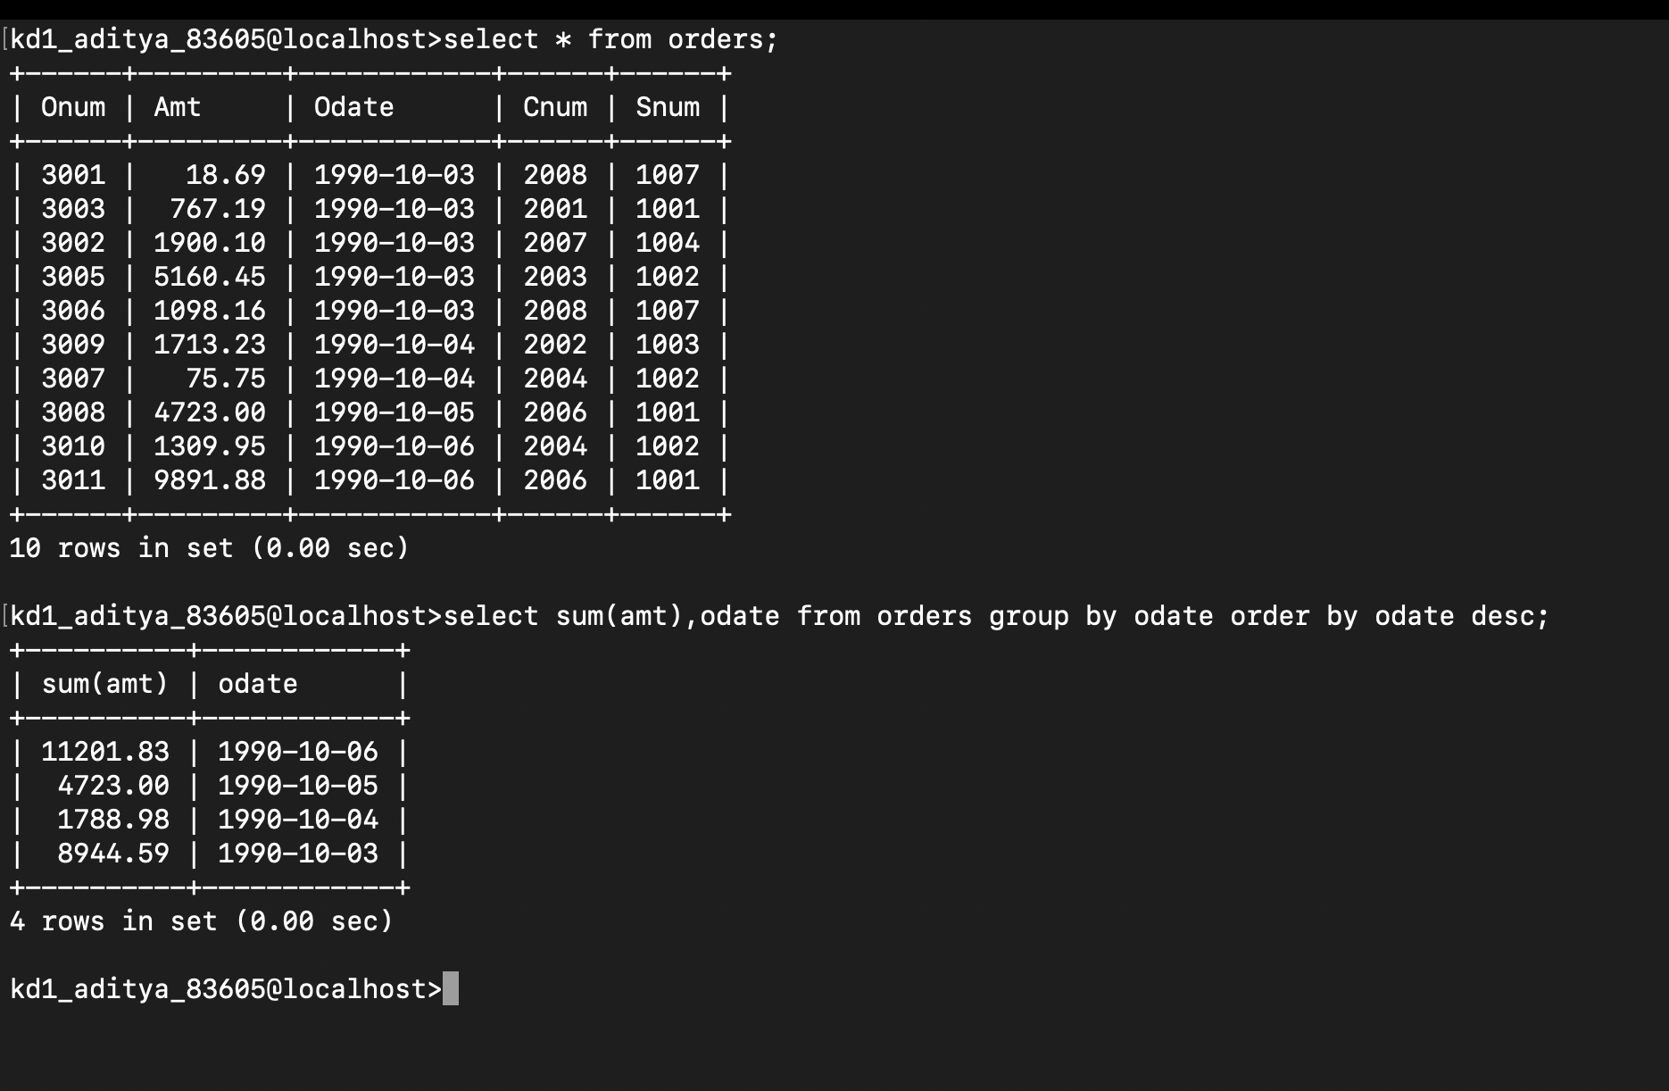
→
select sum(amt), odate from orders group by odate order by odate desc;

