ASSIGNMENT 4
ADITYA DEVCHAKKE
KD – 1

Q1) Write a select command that produces the order number ,amount and date for all rows in the orders table

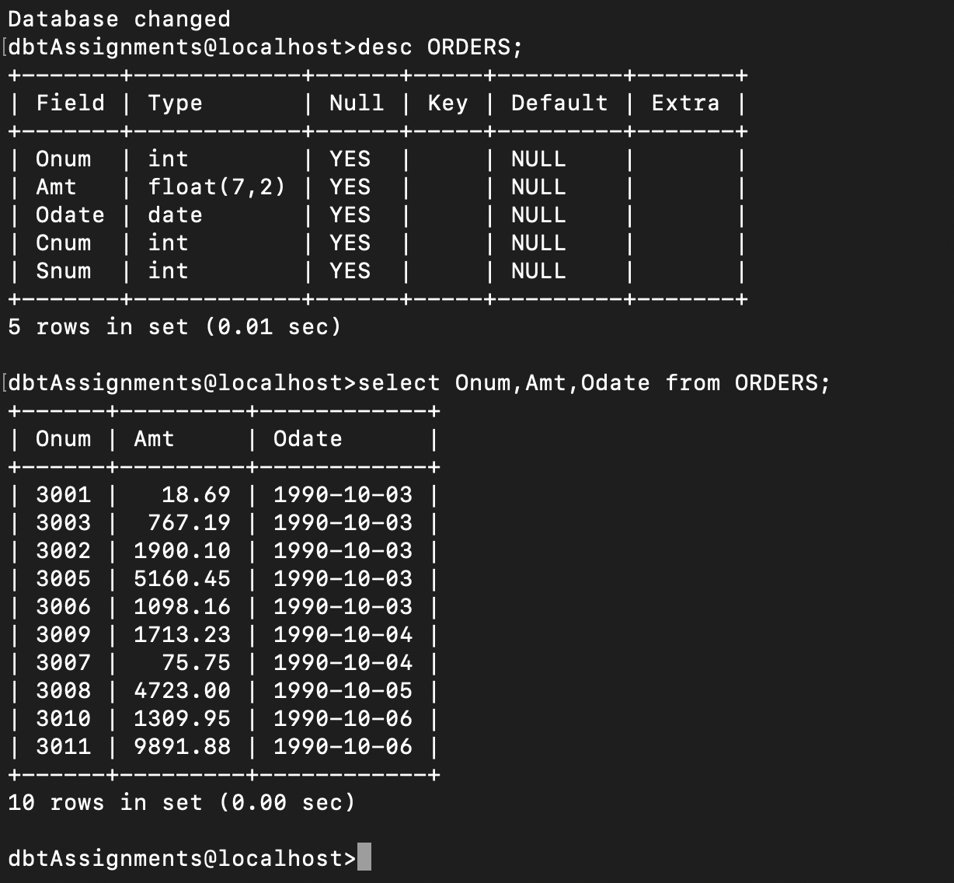
select Onum, Amt, Odate from ORDERS;

Q2) Write a query that produces all rows from the customers table for which the salesperson’s number is 1001

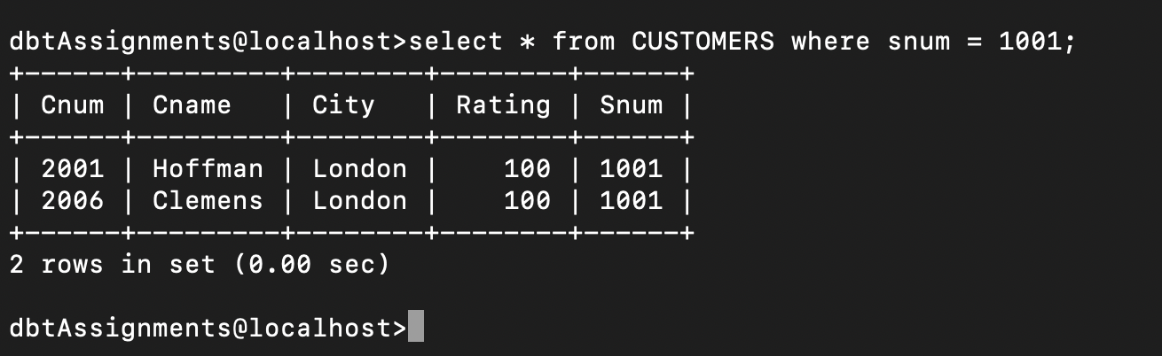
select * from CUSTOMERS where snum = 1001;

Q3) Write a query that displays the salespeople table with the columns in the following order
city,sname,snum,comm

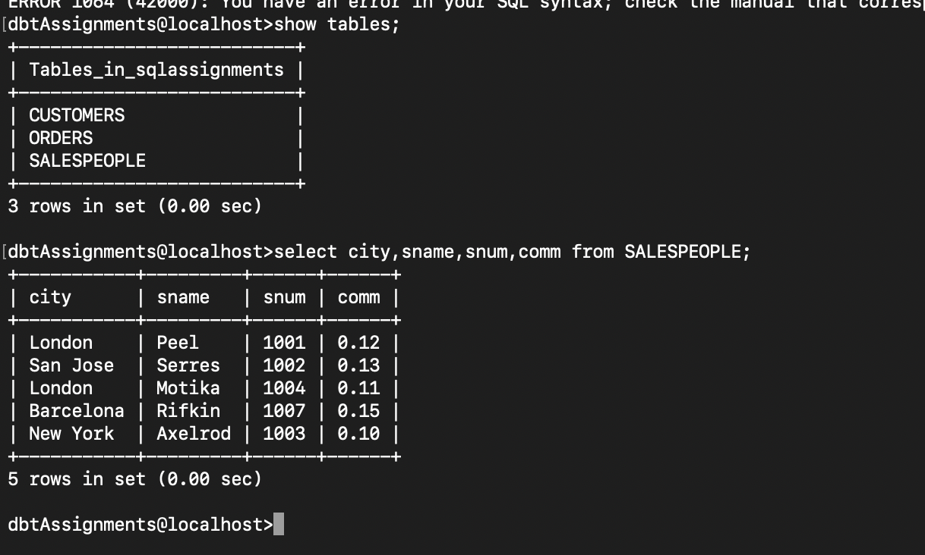
‘

select city, sname, snum, comm from SALESPEOPLE;

Q4) Write a select command that produces the rating followed by the name of each customer in san jose

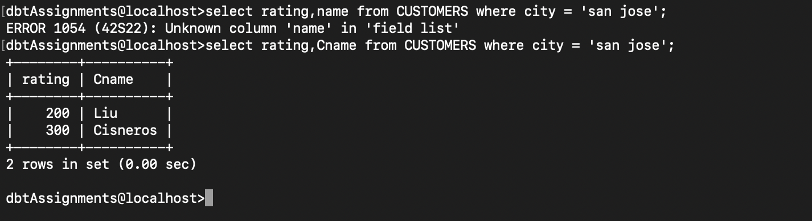
‘

select rating, Cname from CUSTOMERS where city = 'san jose';

