ASSIGNMENT 5

ADITYA DEVCHAKKE
KD-1

Q1) Write a query that will give you all orders for more than rs 1000

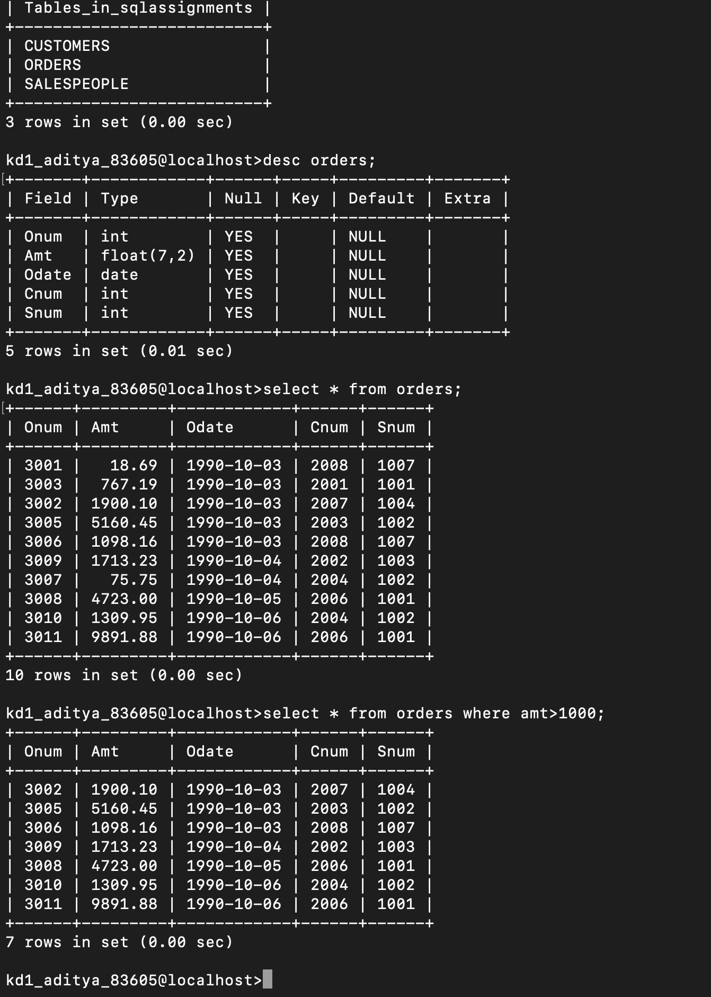
select * from orders where amt>1000;

Q2) Write a query that will give you the names and cities of all salespeople in london with a commission above 0.10

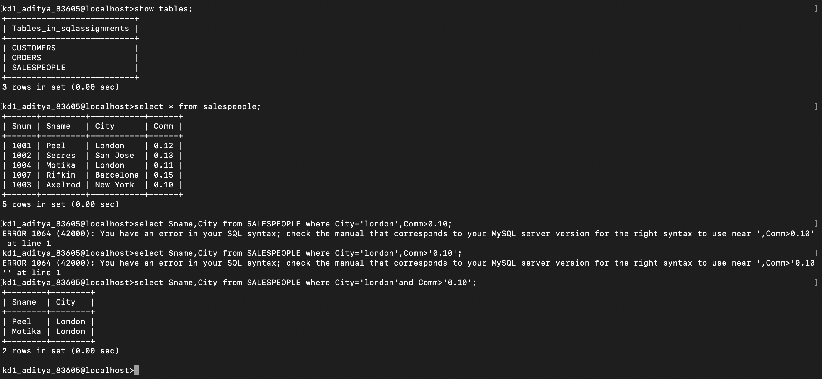
select Sname, City from SALESPEOPLE where City='london ' and
Comm> '0.10';

Q3) Wrie a query on the customers table whose output will exclude all customers with a rating <= 100, unless they are located iin rome

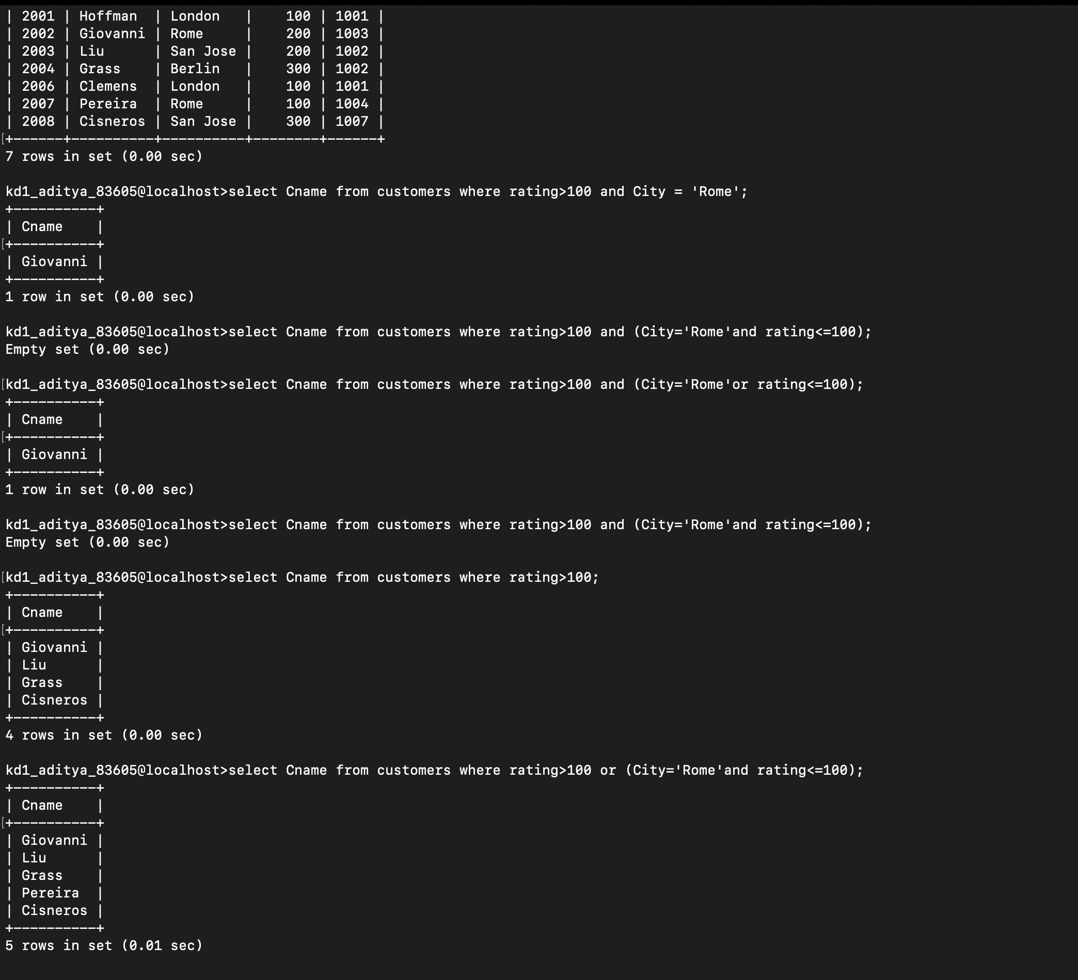
select Cname from customers where rating>100 or (City='Rome'and rating<=100);

Q4) what will be the output from following query
select * from orders where (amt<1000 or not(odate = ‘1990-10-03’ and cnum > 2003));

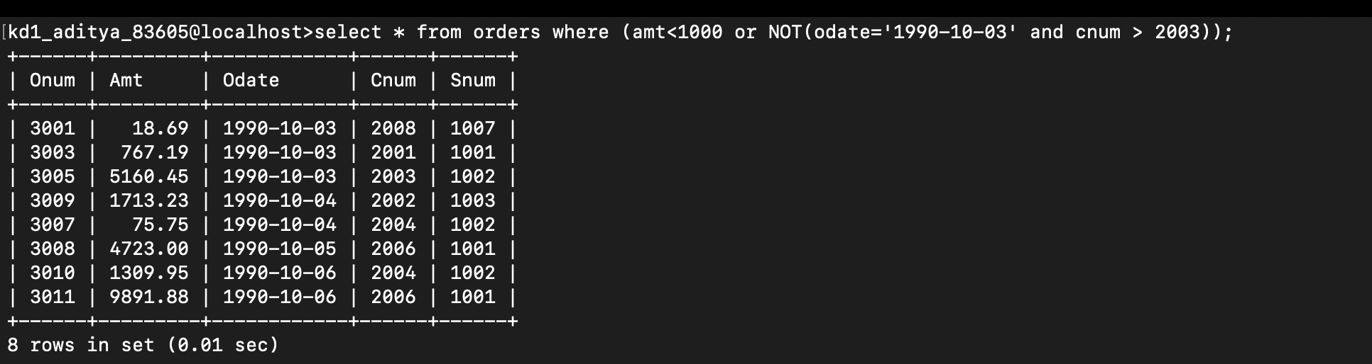
gives all onum with amount <1000 and odate should not be 03 oct with customer number greater the 2003

Q5) What will be the output of following query

select * from orders where not ((odate=’1990-10-03’ or snum>1006 and amt>=1500);

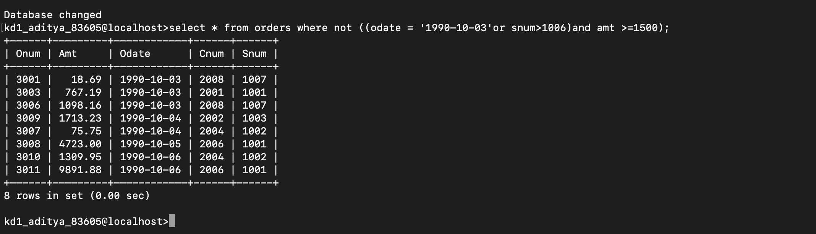

Q6) What is the simpler way to write this query?
Select snum,sname,city,comm from salespeople where (com>0.12 or comm<0.14);

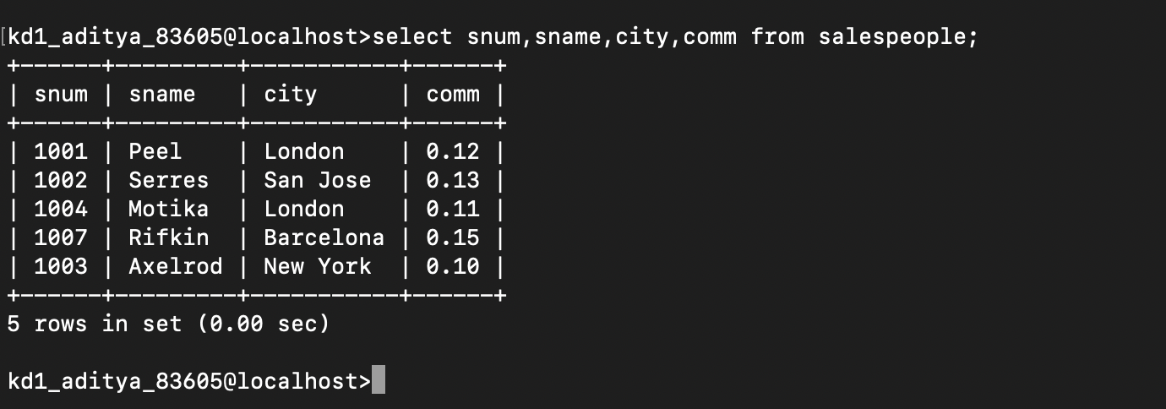
gives all the values

