ASSIGNMENT 6

ADITA DEVCHAKKE
KD-1

use special operators

Q1) Write two different queries that would produce all orders taken on oct 3 or oct 4 1990

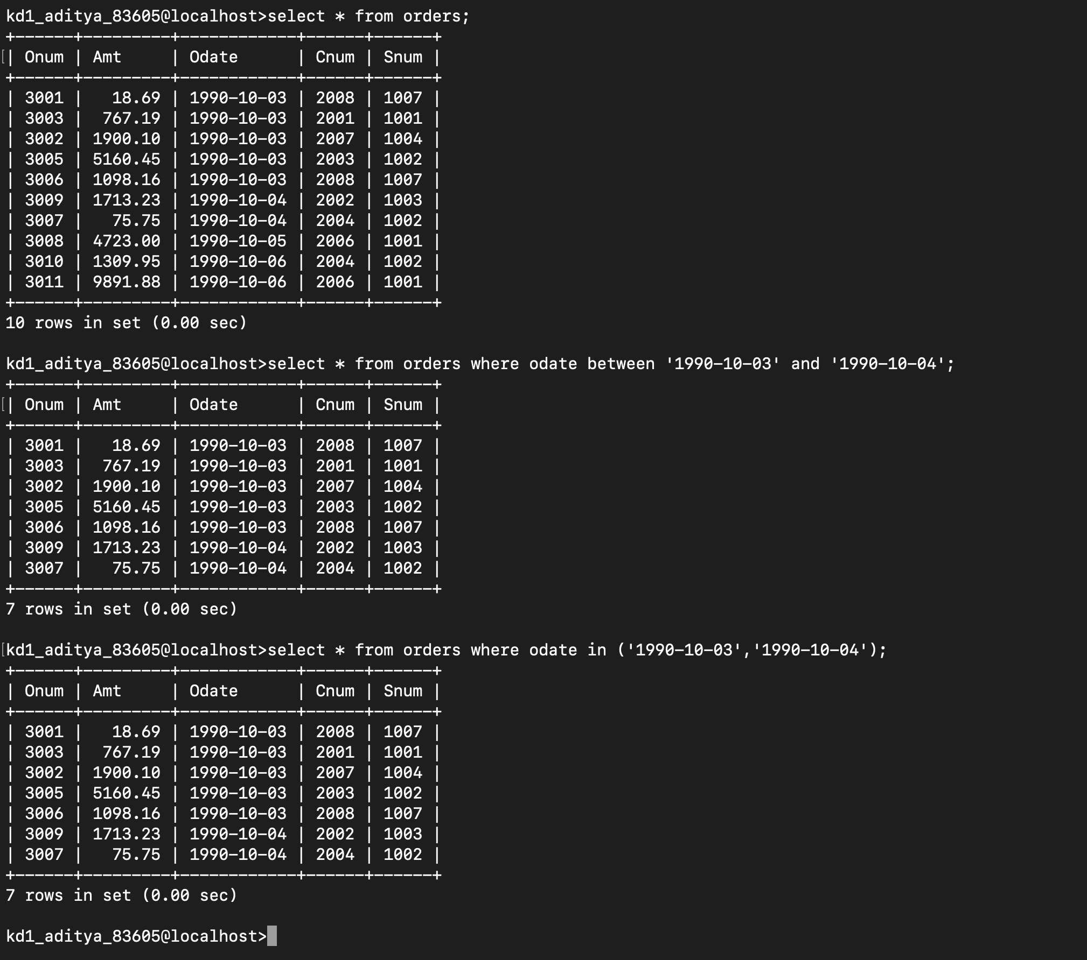
select * from orders where odate between '1990-10-03' and '1990-10-04';

select * from orders where odate in ('1990-10-03', '1990-10-04');

Q2) write a query that selects all of the customers serviced by peel or motika

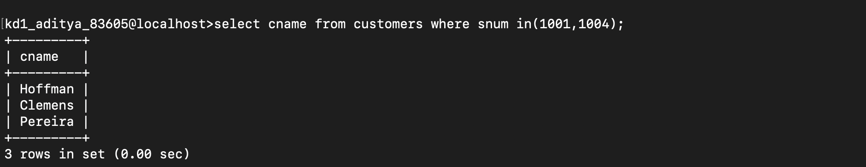

select cname from customers where snum in (1001,1004);

or

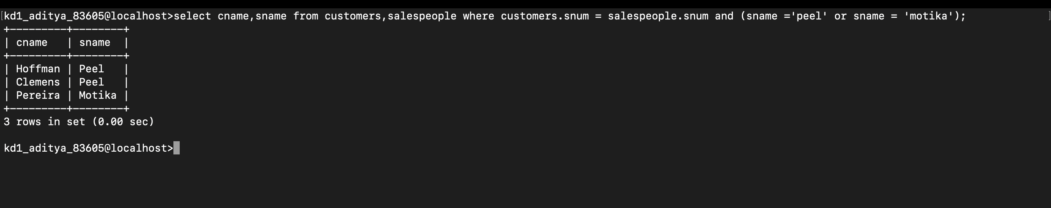

using equijoin → select cname, sname from customers, salespeople where customers. snum = salespeople.snum and (sname ='peel' or sname = 'motika');

Q3) Write a query that will produce all the customers whose names begin with a letter from ‘A’ to ‘G’

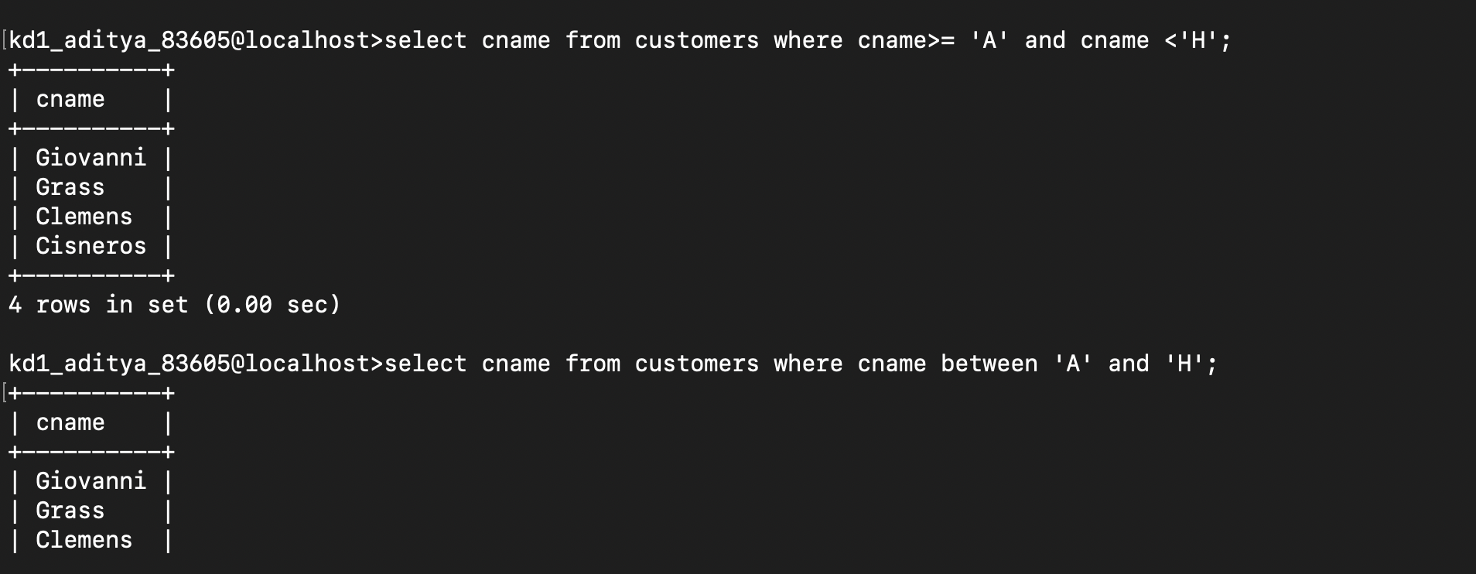
select cname from customers where cname>= 'A' and cname ‹'H';

or

select cname from customers where cname between 'A' and 'H';

Q4) Write a query that selects all customers whose names begin with letter ‘C’

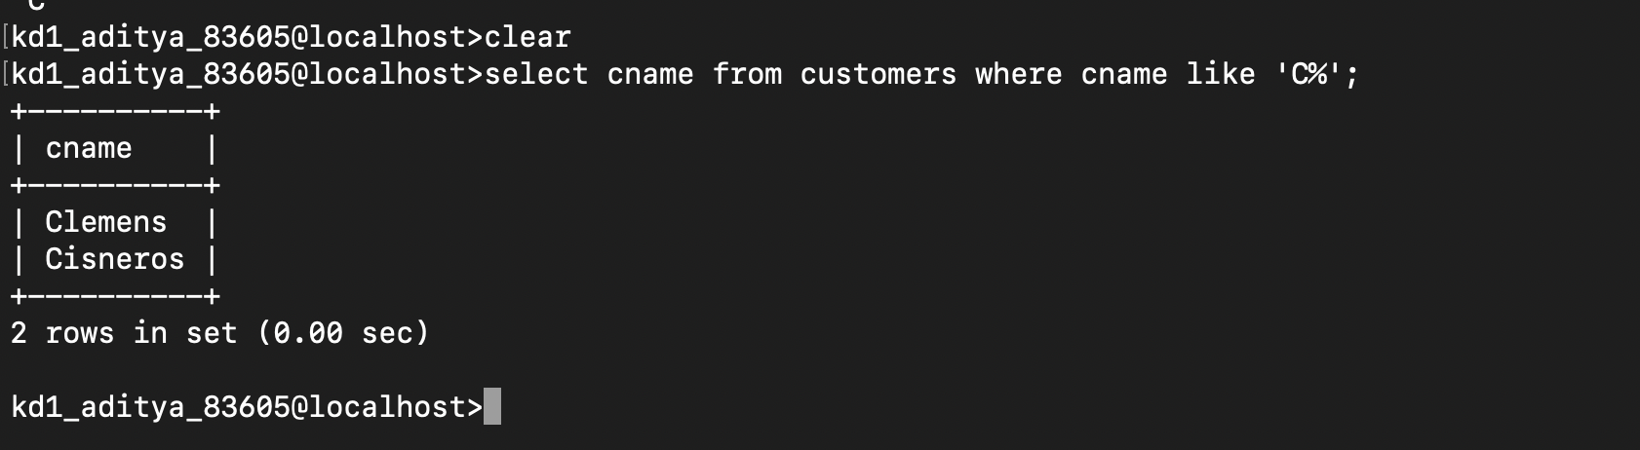

select cname from customers where cname like 'C%' ;

Q5) Write a query that selects all orders except those with zeroes or nulls in the amt field

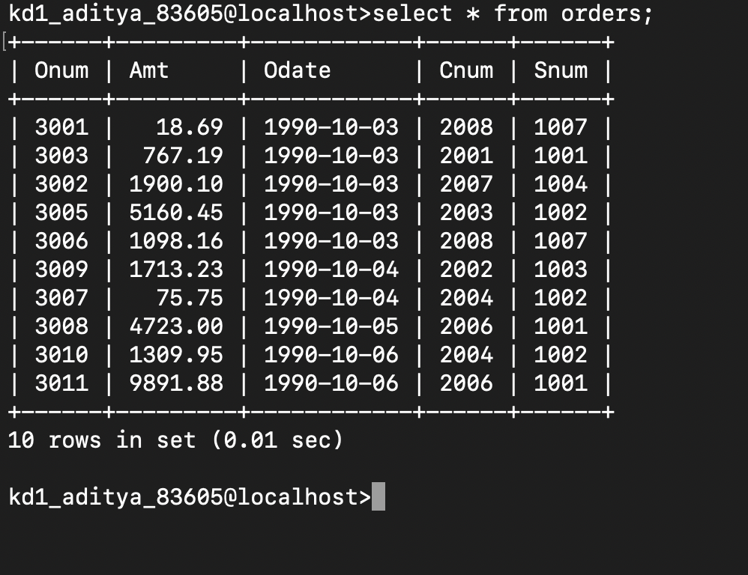
returns all the values

