SQL Assignment 1

ADITYA DEVCHAKKE
KD-1

Creating sample tables and inserting values. Create the following tables with the given structures and insert sample data as specified :

A) SALESPEOPLE

Snum int (4)
Sname varchar(10)
City varchar(10)
Comm float (3,2)

Data:
SALES PEOPLE

SNUM SNAME CITY COMM
1001 Peel London .12
1002 Serres San Jose .13
1004 Motika London .11
1007 Rifkin Barcelona .15
1003 Axelrod New York .10

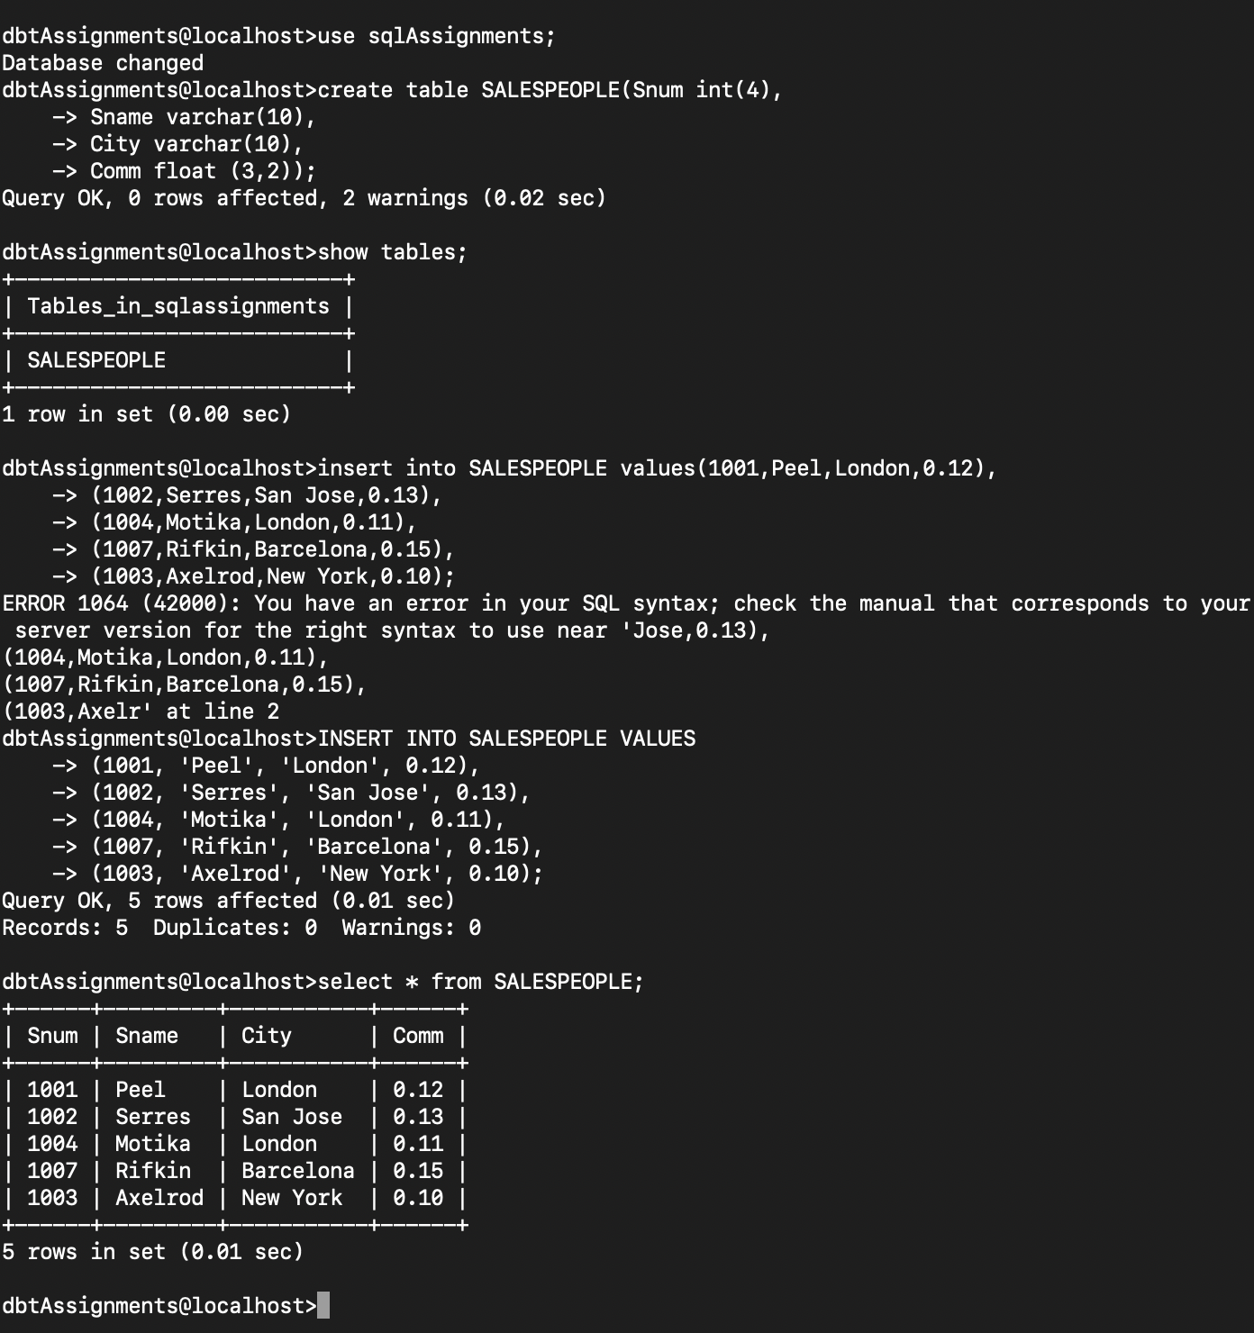

INSERT INTO SALESPEOPLE VALUES
(1001, 'Peel', 'London', 0.12),
(1002, 'Serres', 'San Jose', 0.13),
(1004,'Motika', 'London', 0.11),
(1007,'Rifkin', 'Barcelona', 0.15),
(1003, 'Axelrod', 'New York', 0.10);

B) CUSTOMERS
Cnum int (4)
Cname varchar(10)
City varchar(10)
Rating int (4)
Snum int (4)

CUSTOMERS

CNUM CNAME CITY RATING SNUM
2001 Hoffman London 100 1001
2002 Giovanni Rome 200 1003
2003 Liu San Jose 200 1002
2004 Grass Berlin 300 1002
2006 Clemens London 100 1001
2008 Cisneros San Jose 300 1007
2007 Pereira Rome 100 1004

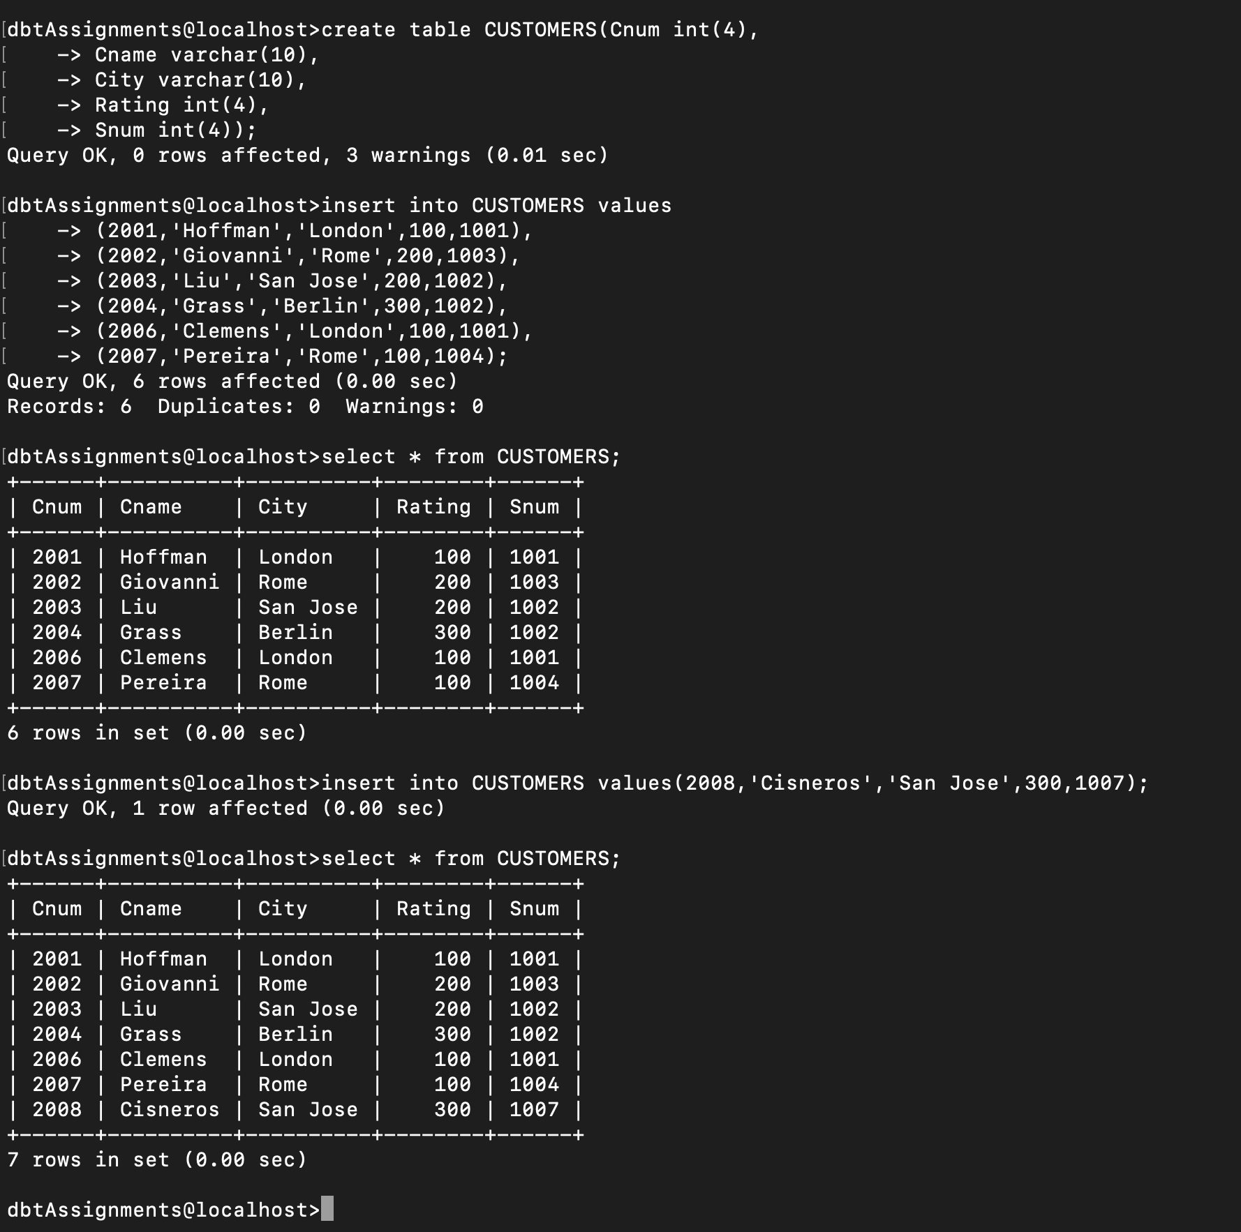

C) ORDERS

Onum int (4)
Amt float (7,2)
Odate date
Cnum int (4)
Snum int (4)

ONUM AMT ODATE CNUM SNUM
3001 18.69 03-OCT-1990 2008 1007
3003 767.19 03-OCT-1990 2001 1001
3002 1900.10 03-OCT-1990 2007 1004
3005 5160.45 03- OCT -1990 2003 1002
3006 1098.16 03- OCT -1990 2008 1007
3009 1713.23 04- OCT -1990 2002 1003
3007 75.75 04-OCT-1990 2004 1002
3008 4723.00 05-OCT-1990 2006 1001
3010 1309.95 06-OCT-1990 2004 1002
3011 9891.88 06-OCT-1990 2006 1001

