ASSIGNMENT 11

ADITYA DEVCHAKKE
KD-1

Q1) Write a query that uses a subquery to obtain all orders for the customer named cisneros. Assume you do not know his customer number



Q2) Write a query that produces the names and ratings of all customers who have above avergae
orders

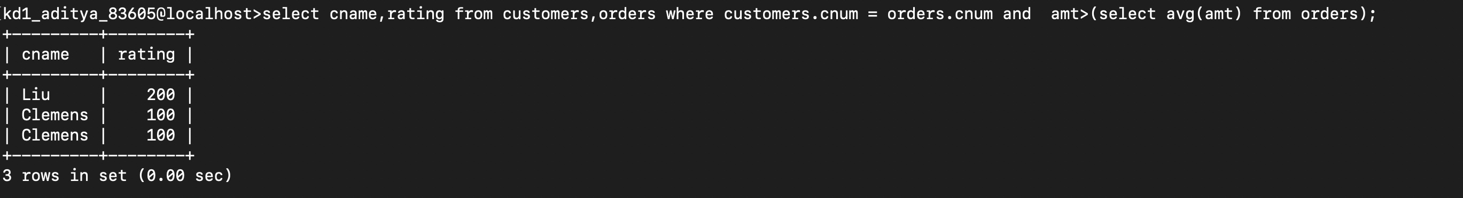

Q3) Write a query that selects the total amount in orders for each salesperson for whom this total is greater than the amount of largest order in the table

