ASSIGNMENT 12

ADITYA DEVCHAKKE
KD-1

Q1) Write a query that selects all customers whose ratings are equal to or greater than any of serres

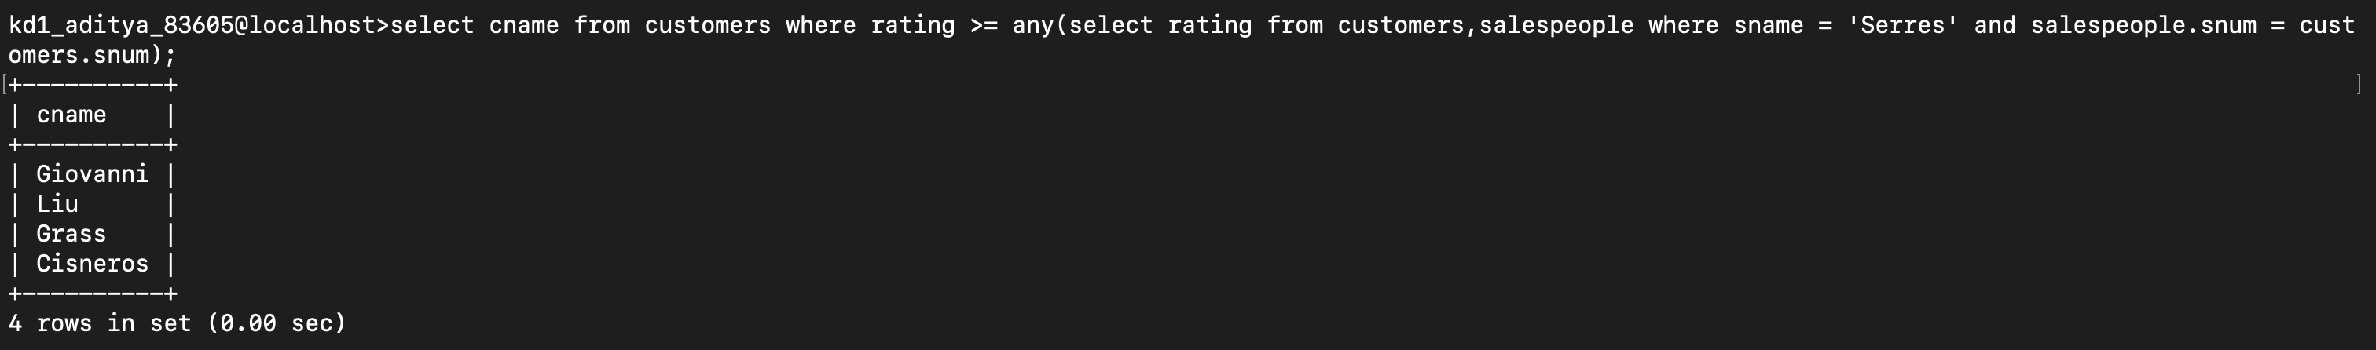

Q2) Write a query using any or all that will find all salespeople who have no customers located in their city



Q3) Write a query that selects all orders for amounts greater than any for the customers in london.

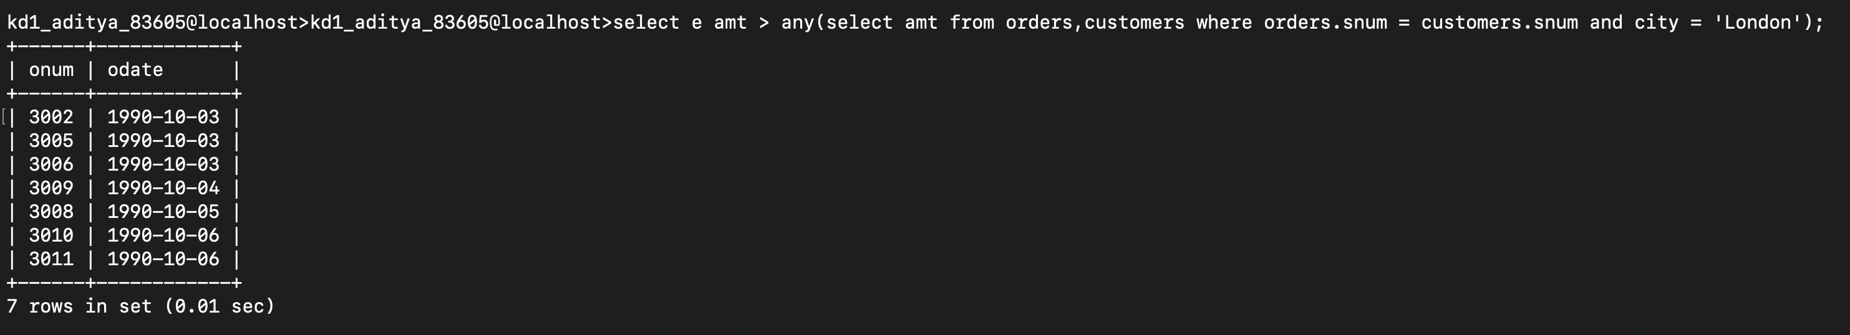

Q4) Write the above query using min or max

