ASSIGNMENT 13

ADITYA DEVCHAKKE
KD-1

Q1) Create a union of two queries that shows the names,cities and ratings of all customers. Those with rating of 200 or greater will also have the words ‘high rating’ while others will have ‘low rating’

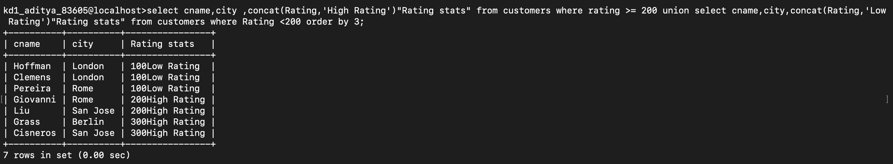

Q3) Form a union of three queries. Have the first select the snums of all salespeople in san jose; second the cnums of all customers in san jose and third the onums of all orders on oct 3. Retain duplicates between the last two queries but eliminate any redundancies between either of them and the first

