ASSIGNMENT 14

ADITYA DEVCHAKKE
KD-1

Q1) Write a command that puts the following values in order into the salespeople table;
city – san jose,name – blanco,comm – null ,cnum -1100

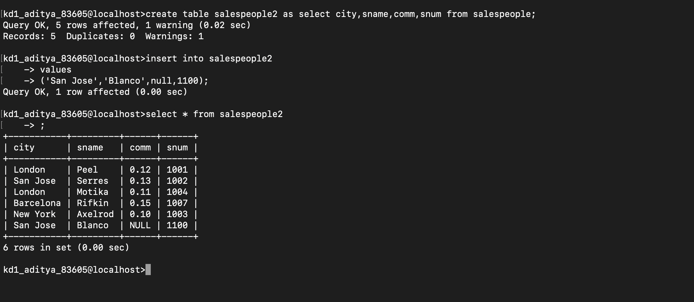

Q2) Write a command that removes all orders from customer clemens from the orders table;
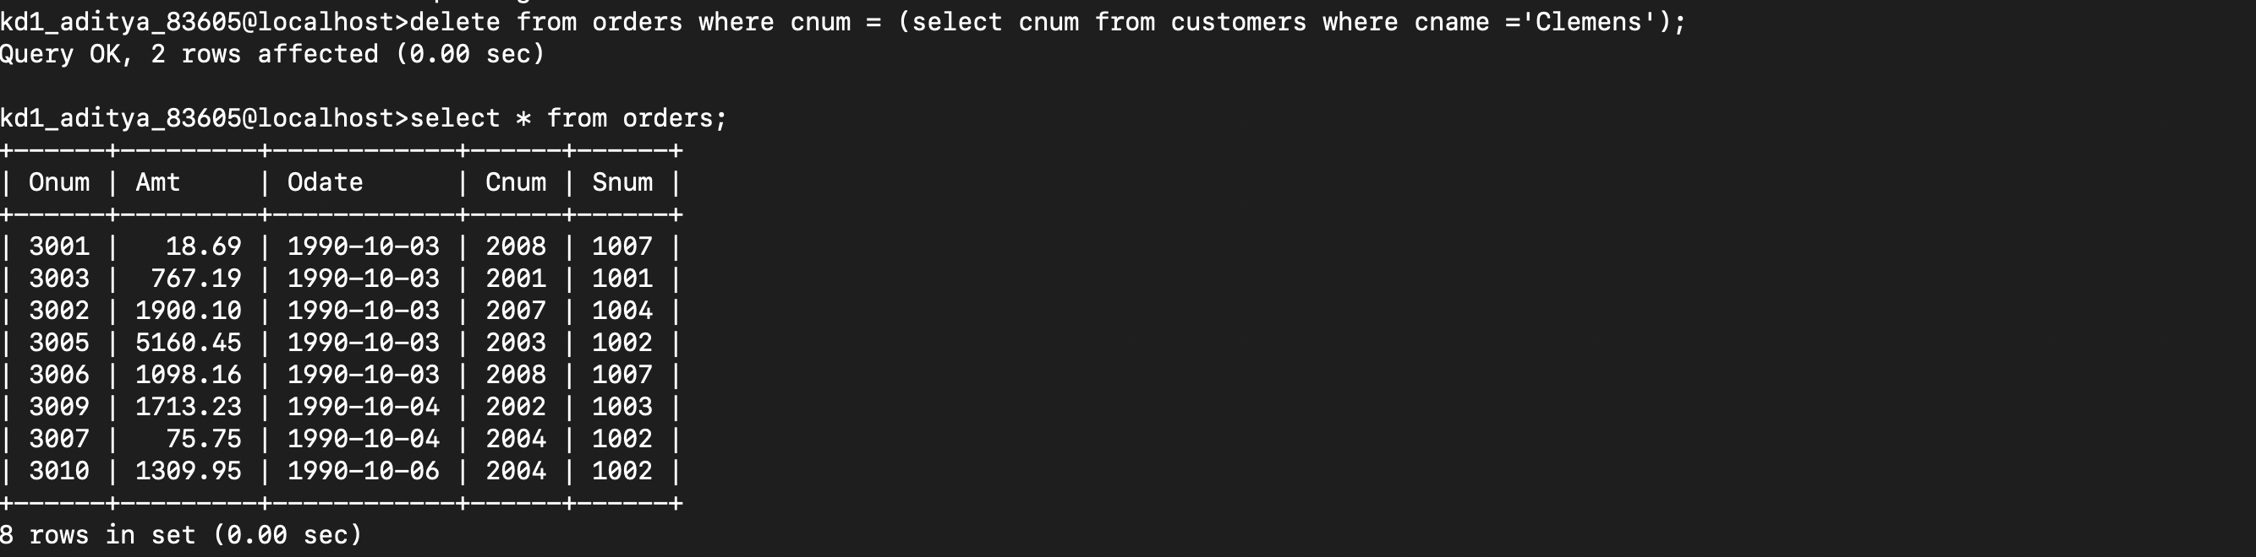

Q3) Write a command that increases the rating of all customers in rome by 100

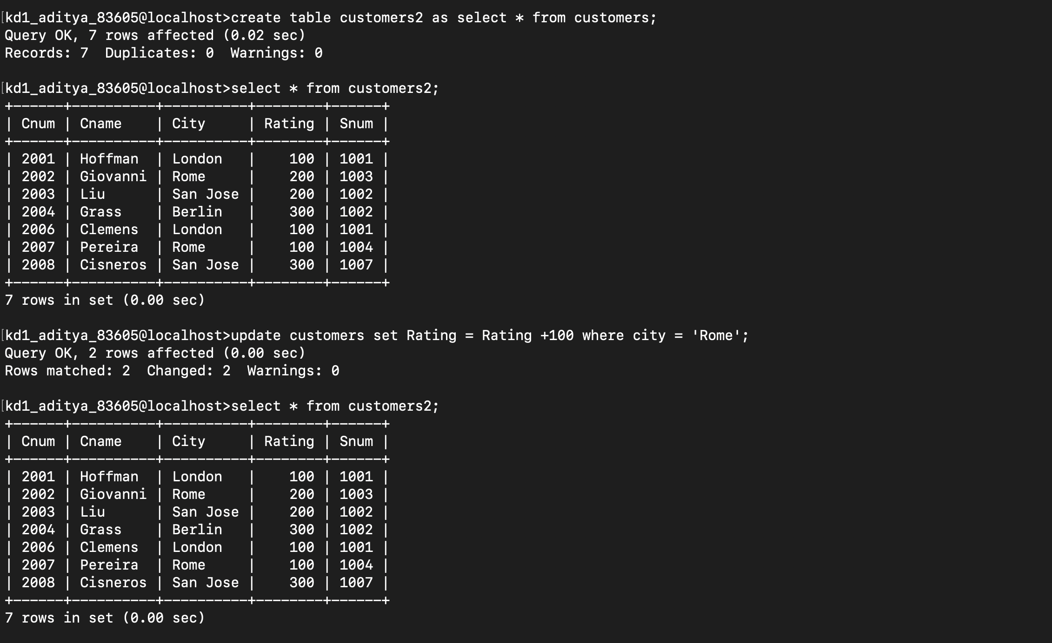
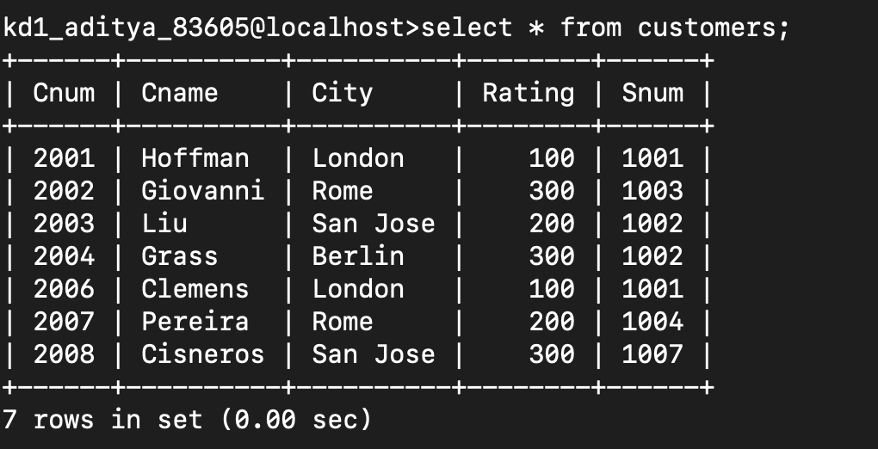

Q4) Salespersons serres has left the company.assign her customers to motika;

