ASSIGNMENT 15

ADITYA DEVCHAKKE
KD1

Q1) Assume there is a table called multicust,with all of the same column definitions as salespeople.Write a command that inserts all salespeople with more than one customer into this table;
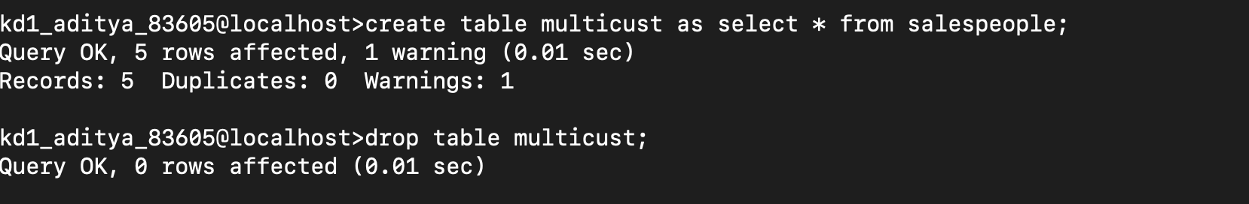
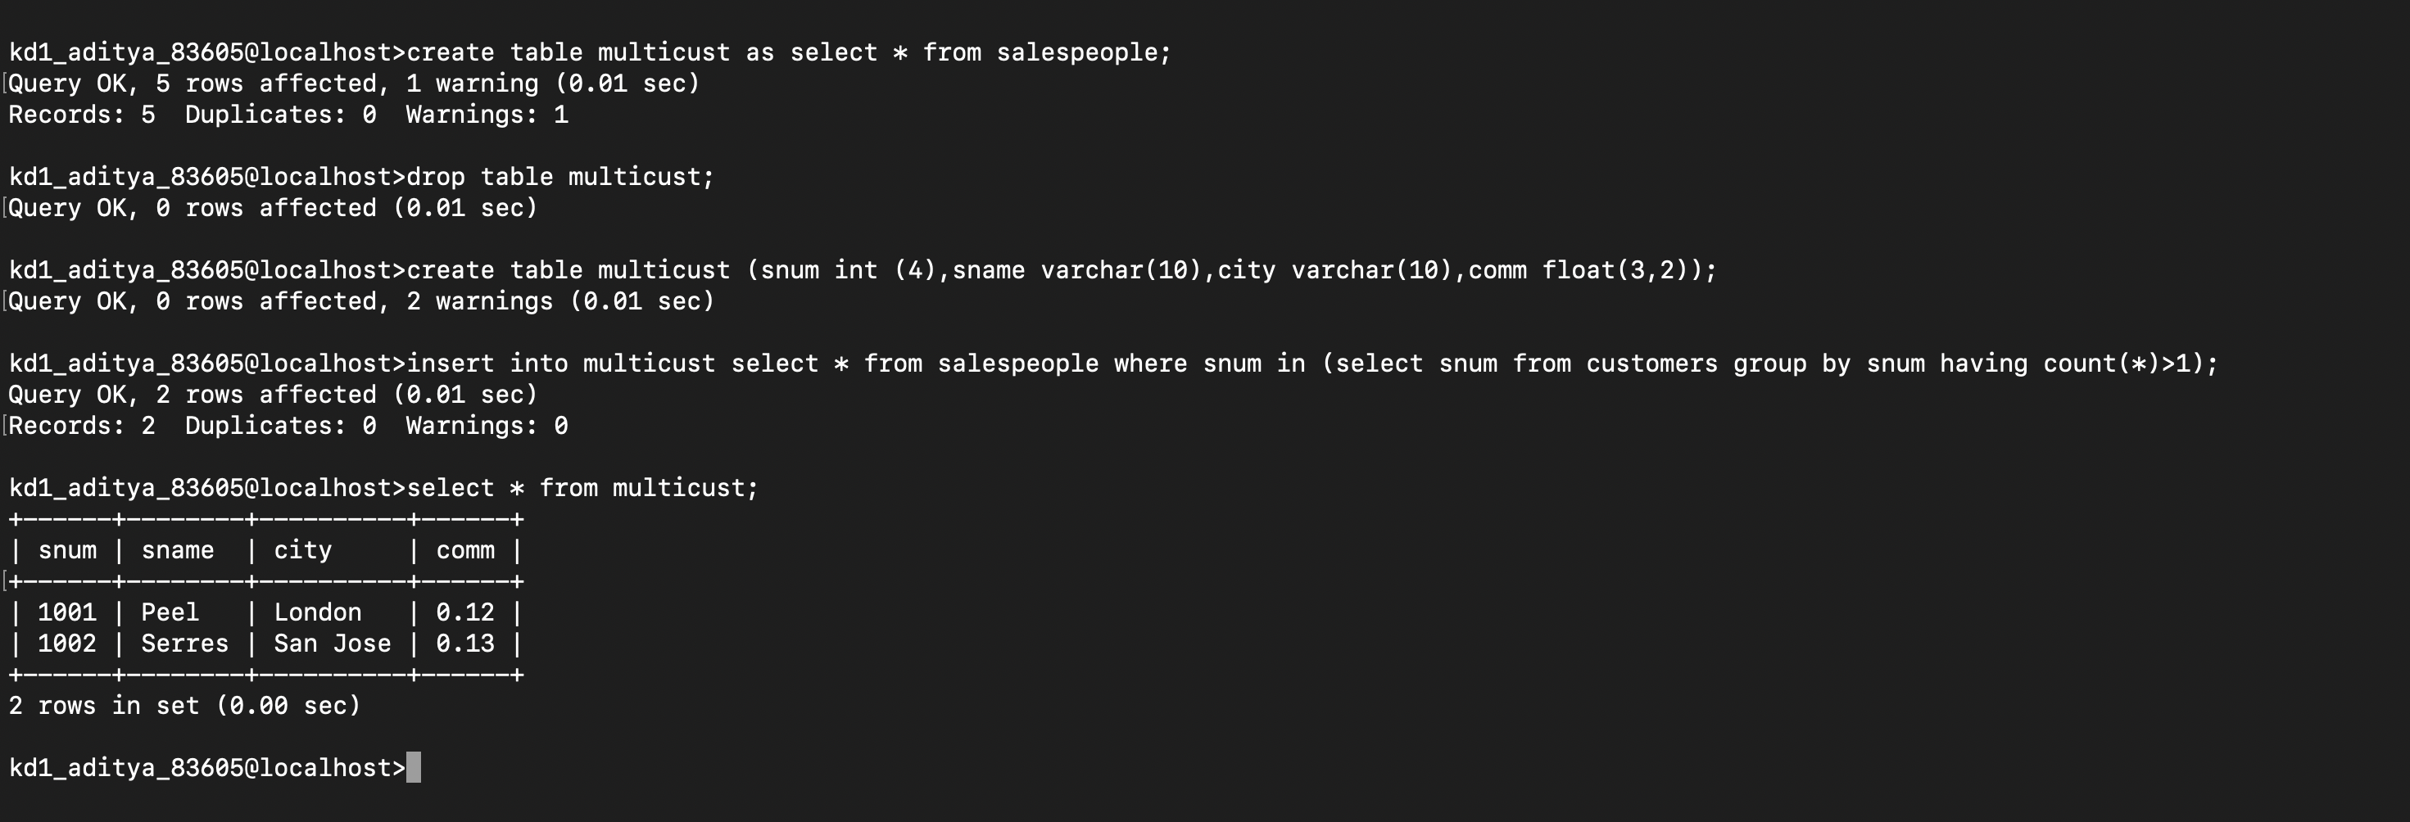

Q2) Write a command that deletes all customers with no current orders

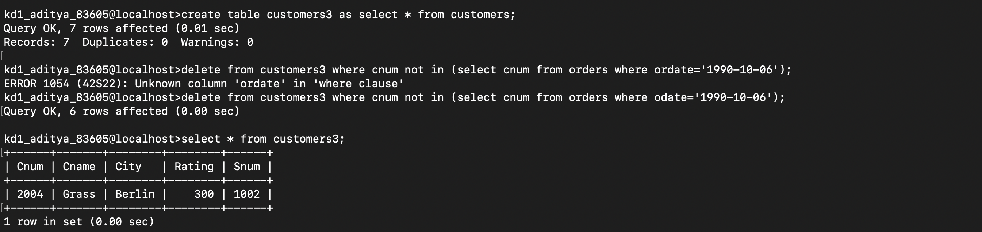

Q3) Write a command that increases by 20% the commissions of all salespeople with total orders above 3000 rs
