ASSIGNMENT 9
ADITYA DEVCHAKKE
KD-1

Q1) Write a query that lists each order number followed by name of customer who made the order

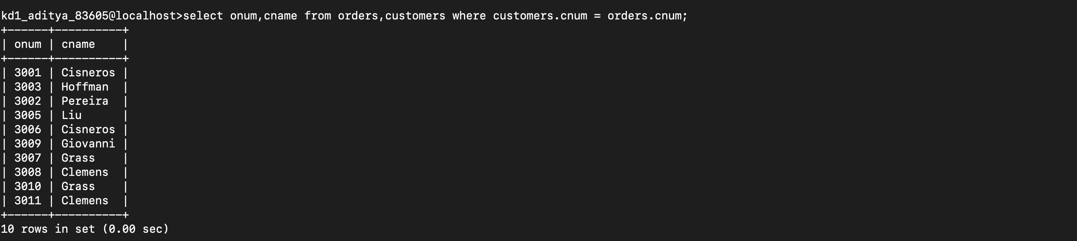

Q2) Write a query that gives the names of both the salesperson and customer for each order along with the order number

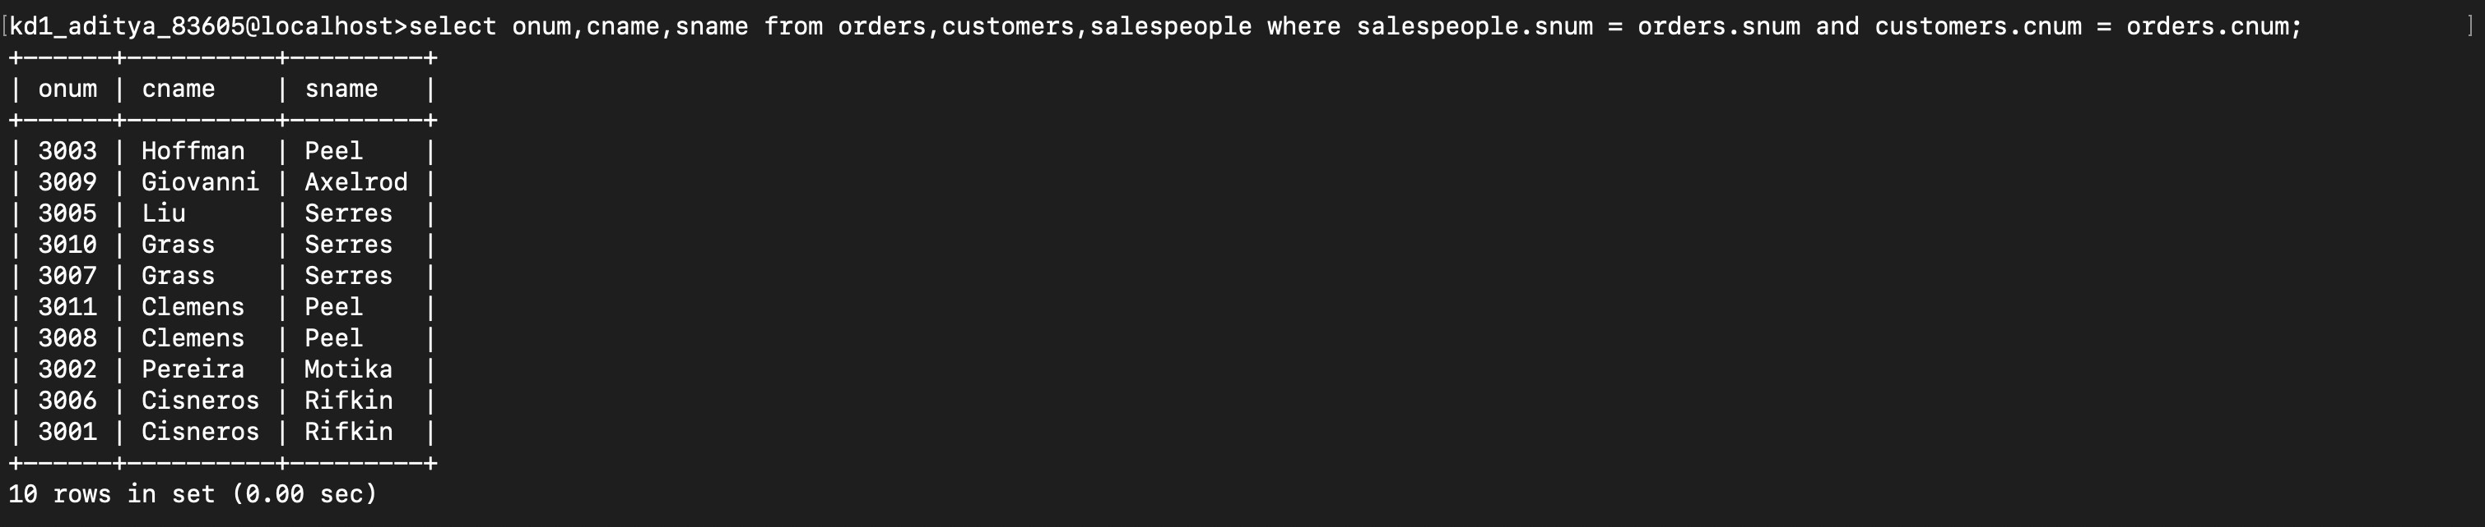

Q3) Write a query that produces all customers serviced by salespeople with a commission abov4e 12 % . Output the customers name and salespersons name and rate of commission

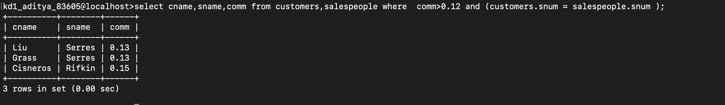

Q4) Write a query that calculates the amount of the salespersons commssion on each order by a customer with a rating above 100.

