MONGODB ASSIGNMENT
ADITYA DEVCHAKKE
KD-1

Q1) Install Mongodb server
Q2) Create directory to store mongoDB datafiles
Q3) Set necessary path environment variable
Q4) Startup mongoDb database
Q5) Connect to mongodb database through Command line interface
Q6) View list of available databases
Q7) Create new database named cdac and conncet to it
Q8) View list of available collections in cdac database
Q9) Create new collection by name of library

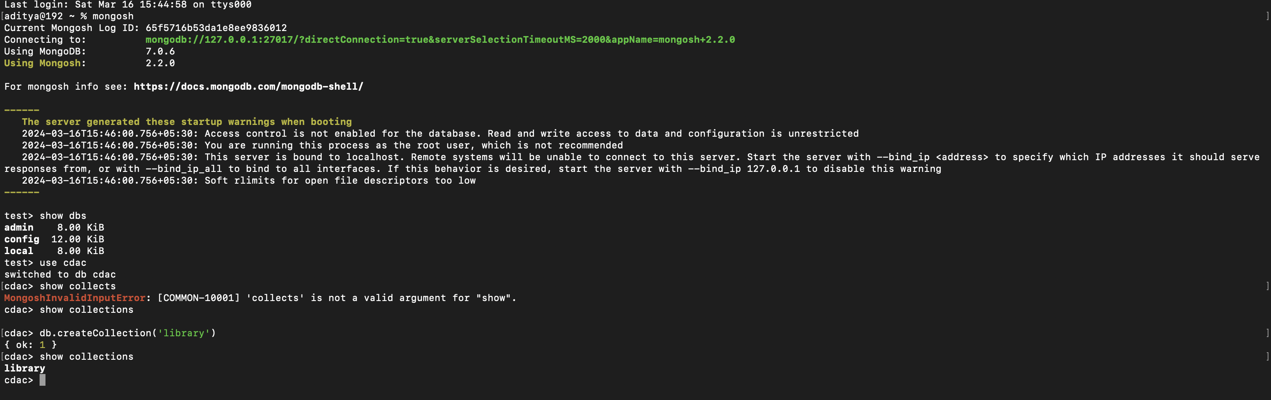
Q10) Insert the following document in library collection-
title:’MongoDB programming’,
author:’Sameer’,likes:100
Q11) View recently inserted document and note _id filed

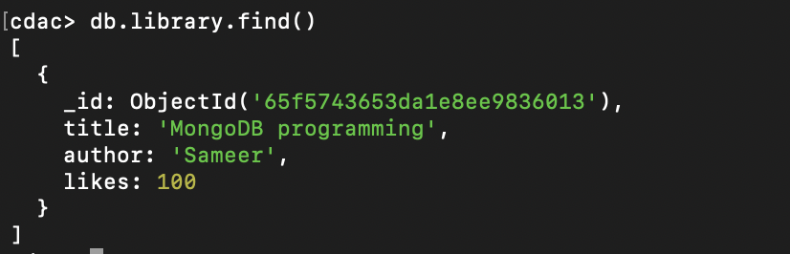
Q12) Insert another doc in library collection
title:’MongoDB programming’,
author: ‘Sameer’,’likes:100’;
Q13) View inserted documents
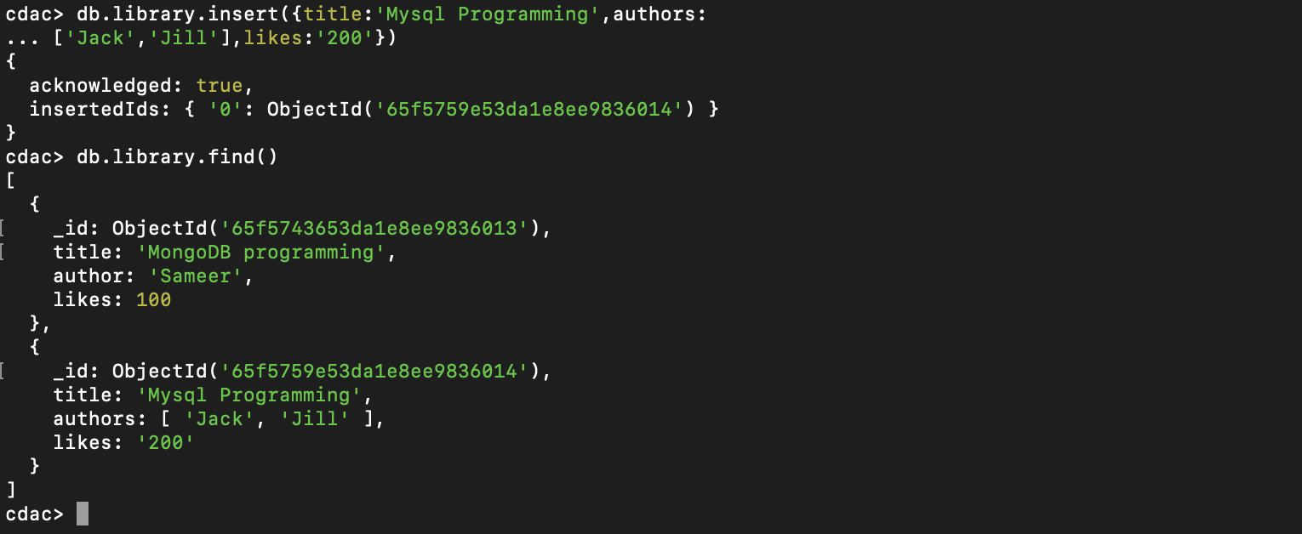

Q14) View only first inserted documents

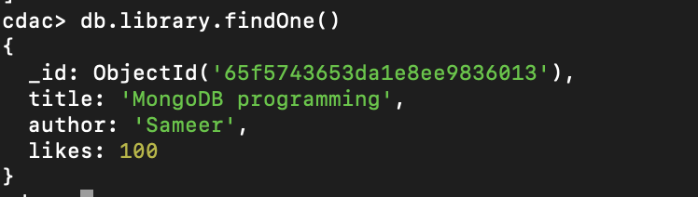

Q15) view with pretty () method

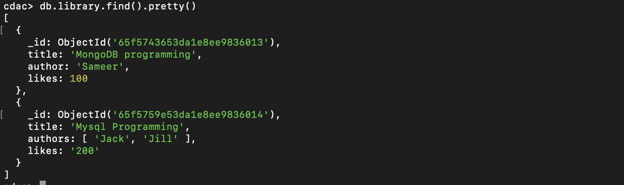

Q16) Update the document where author name sameer and change it to sameer dehadrai

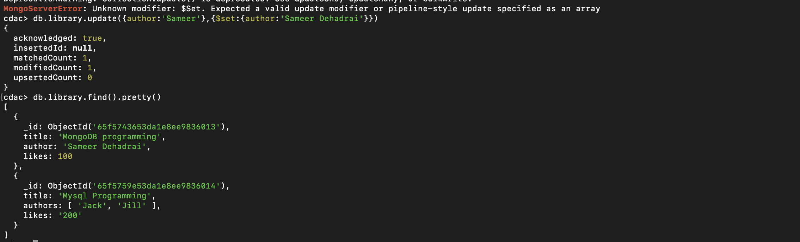
Q17) Delete all doc which have 100 likes

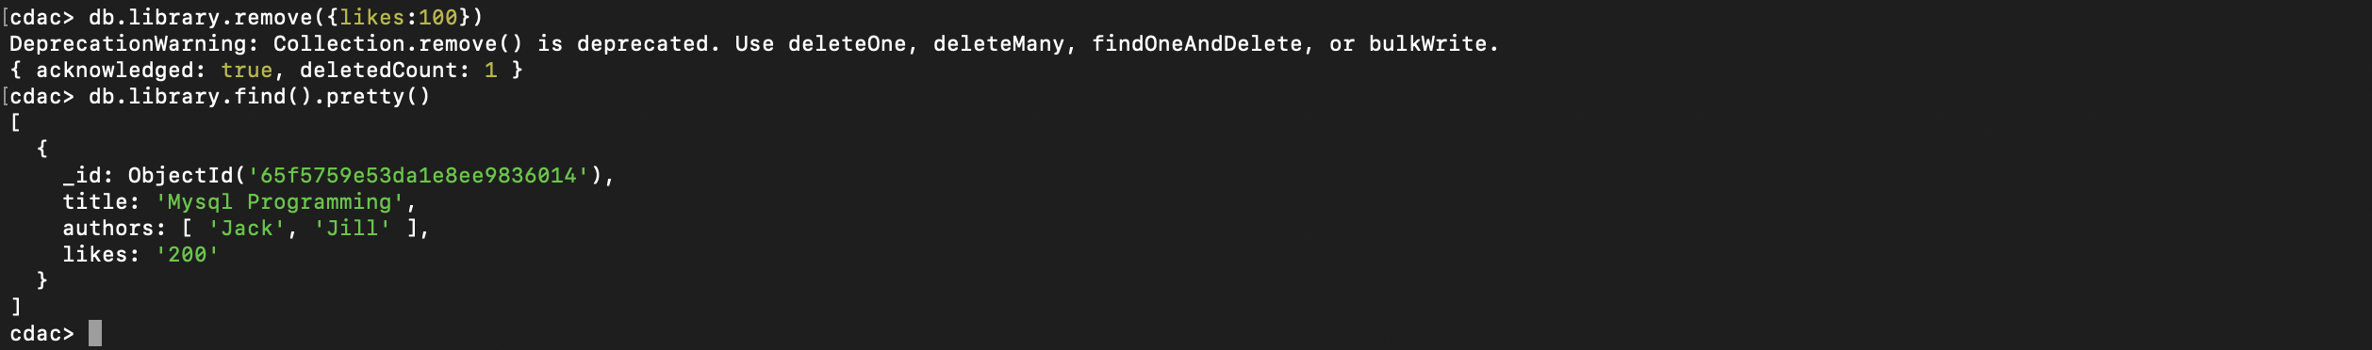
Q18) Drop library colllection

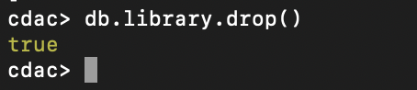

Q19) Drop cdac database

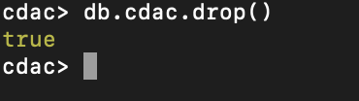

Q20) exit from mngo shell
Q21) Stop the server

