ASSIGNMENT 7

ADITYA DEVCHAKKE
KD-1

Q1) Write a query that counts all orders for October 3

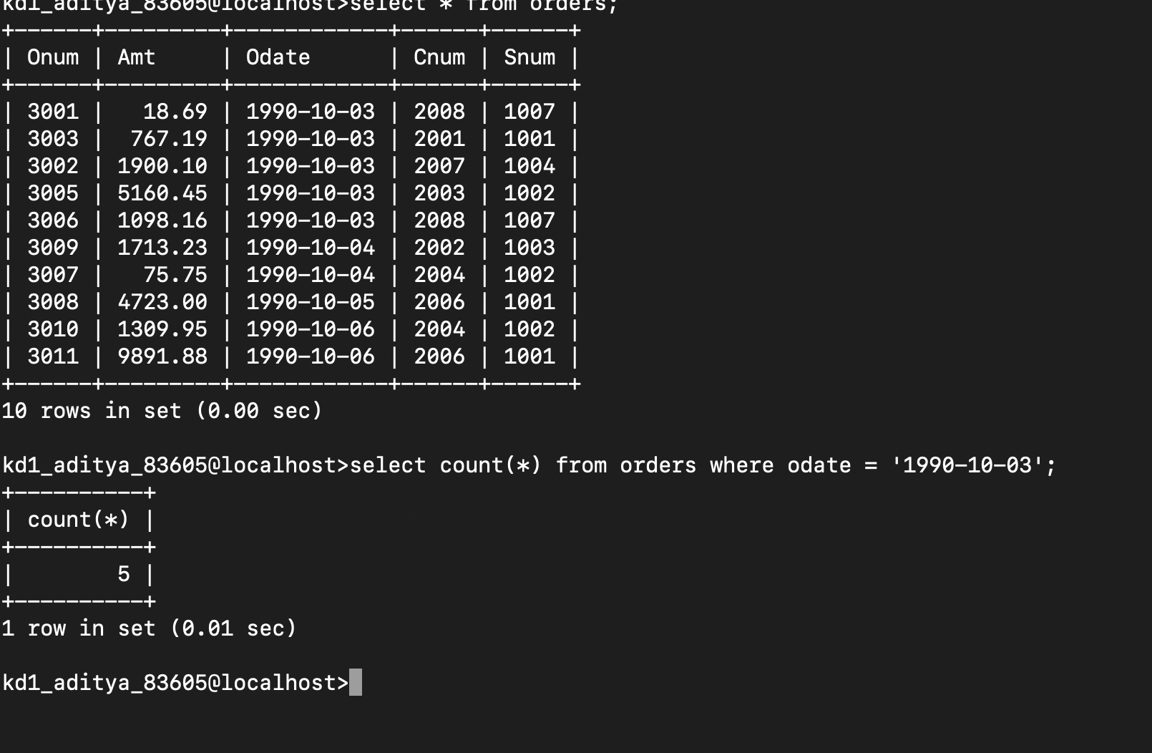
→
select count(*) from orders where odate = '1990-10-03';

Q2) Write a query that counts number of different non null city values in the customers table
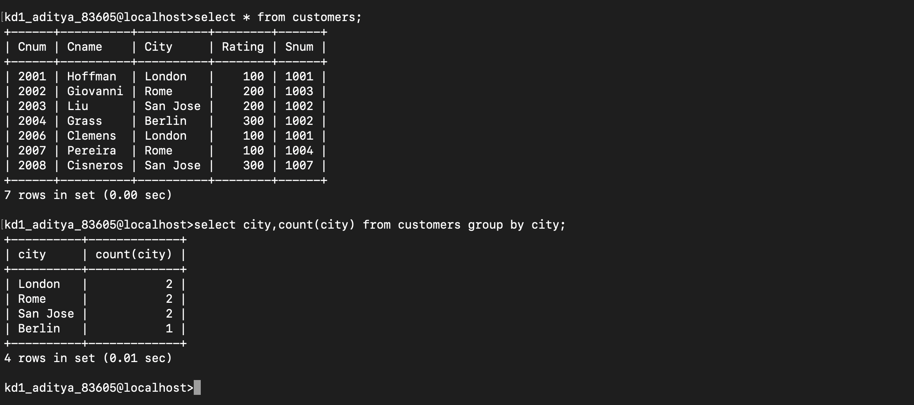
→
select city, count (city) from customers group by city;

Q3) Write a query that selects each customers smallest order
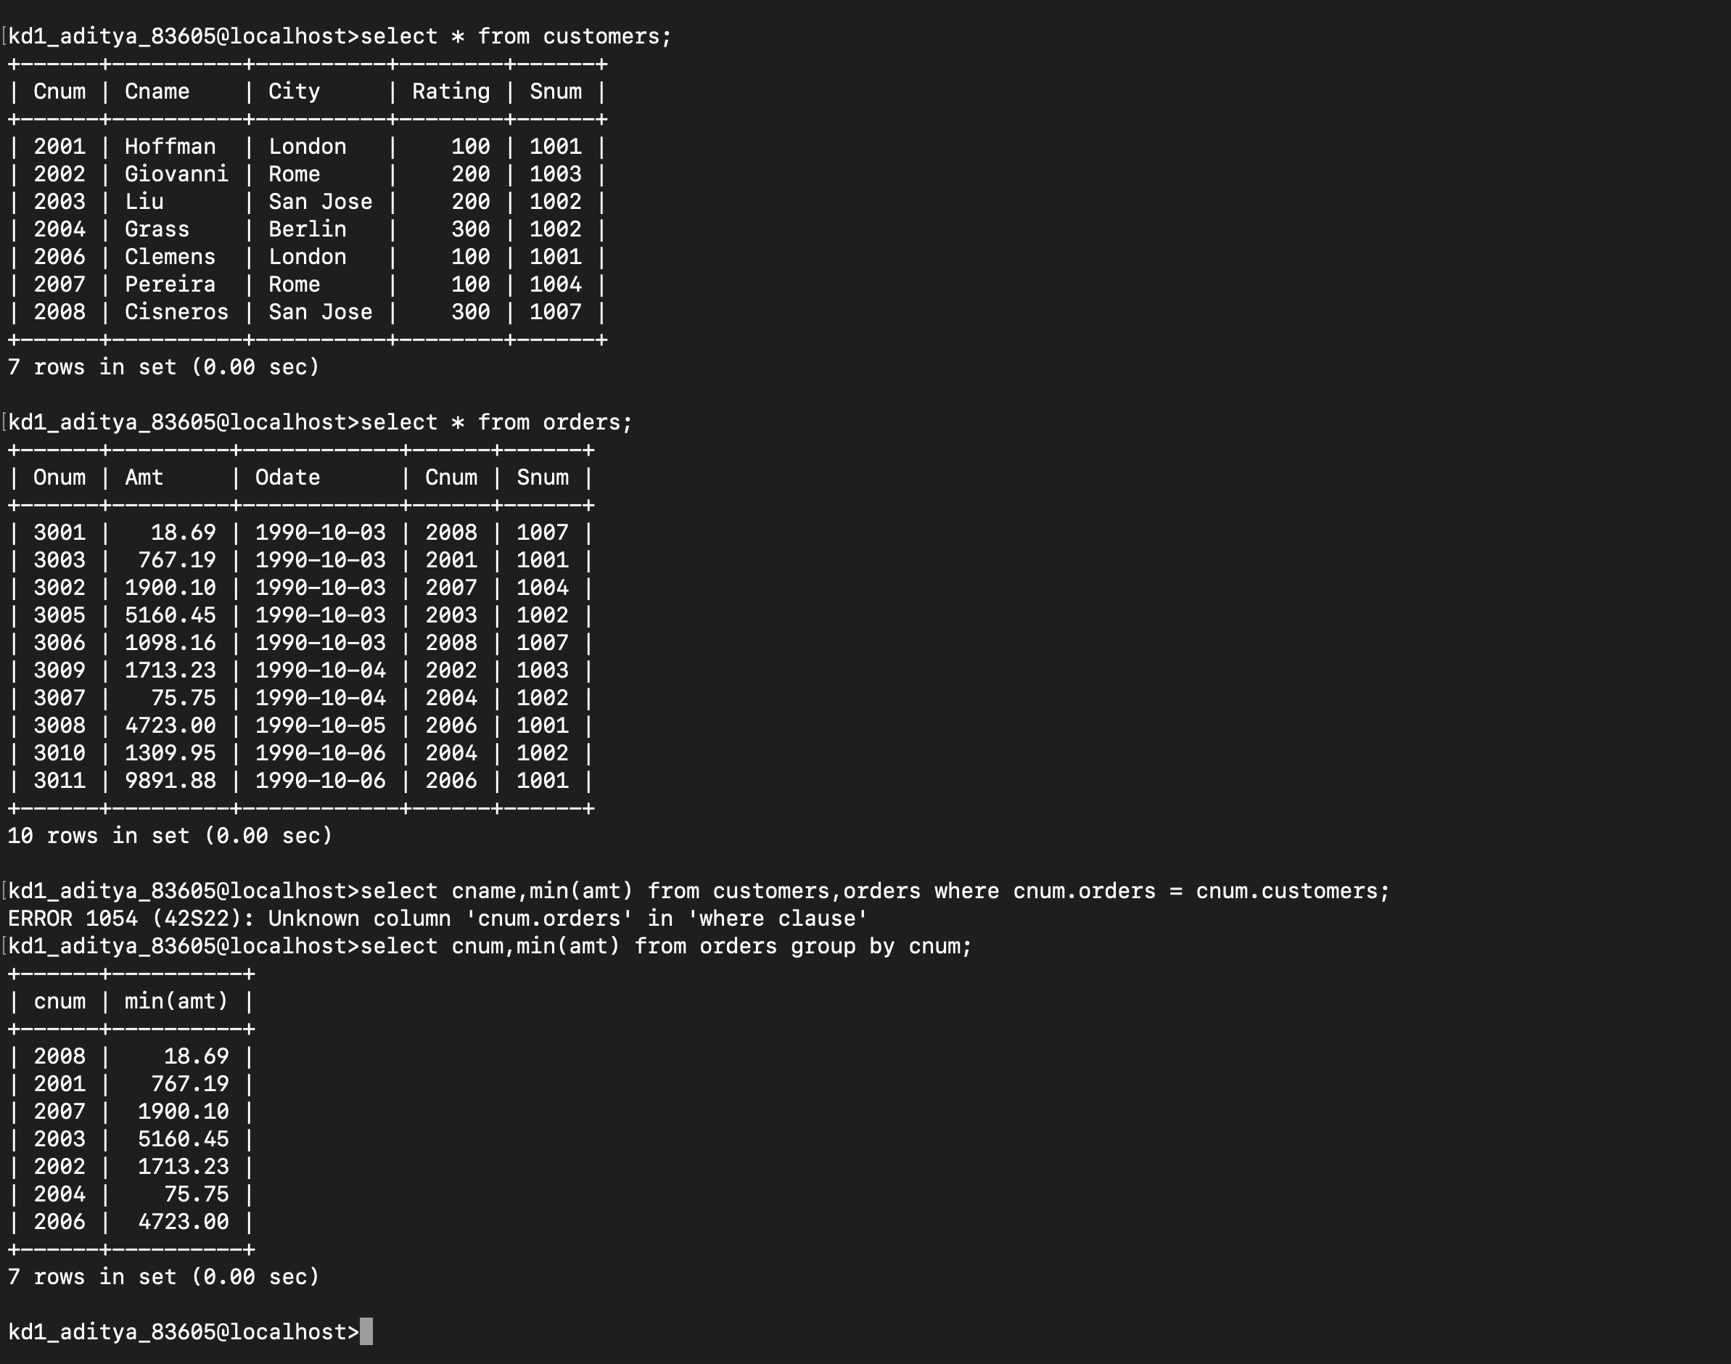
→
select cnum, min (amt) from orders group by cnum;

Q4) Write a query that selects the first customer in alphabetical order,whose name begins with G
→

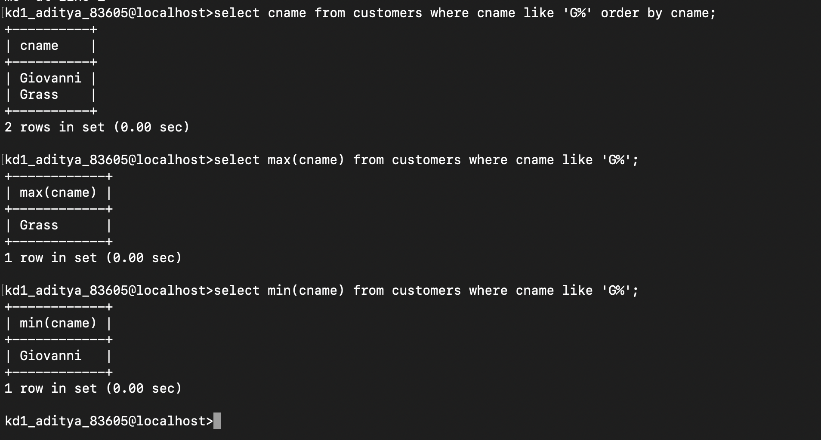

select min(cname) from customers where cname like 'G%';

Q5)Write a query that selects highest rating in each city

→
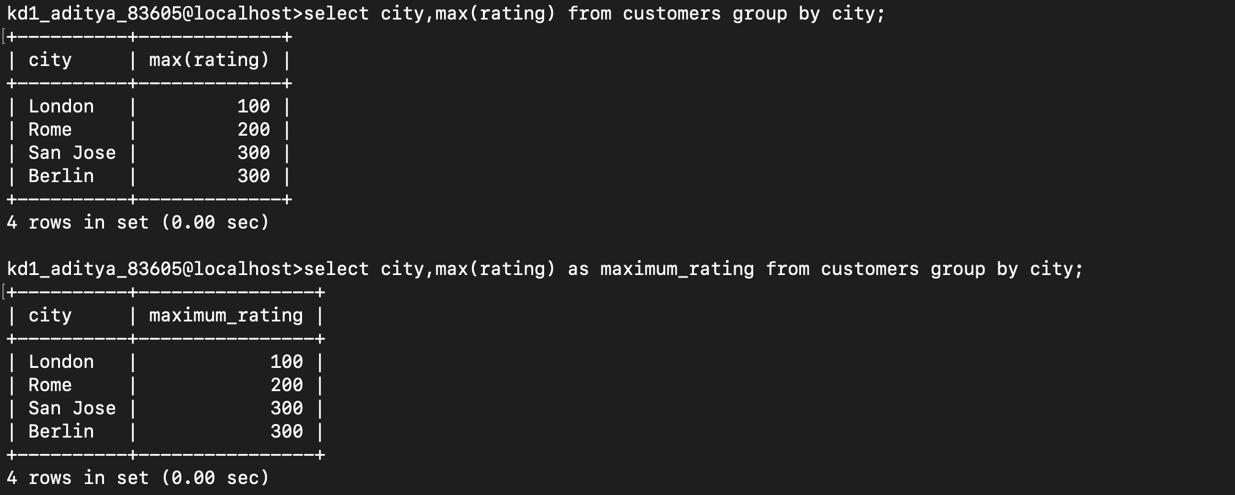
select city,max(rating) as maximum_rating from customers group by city;

Q6) Write a query that counts number of salespeople registering orders for each day(if salespeople has more than one order on given day he should be counted once)

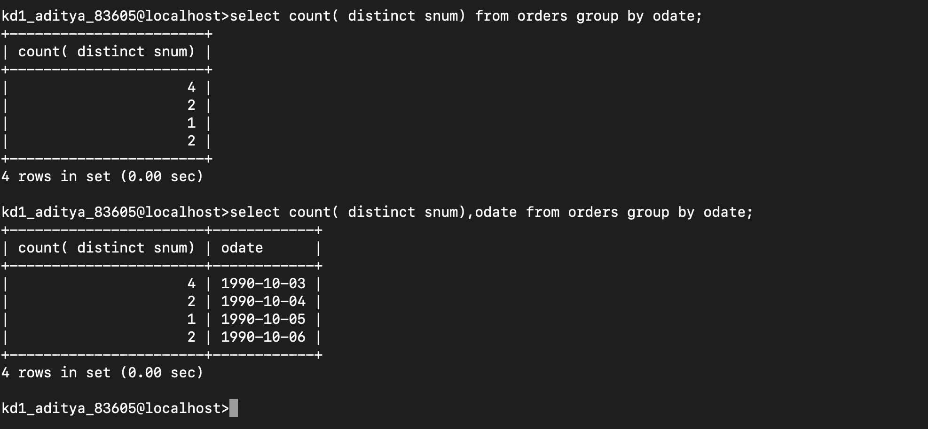
→
select count( distinct snum), odate from orders group by odate;

