SQL ASSIGNMENT-11

Question 1:

Query:

Select * from ORDERS
where Cnum = (Select Cnum from CUSTOMERS WHERE Cname="Cisneros");

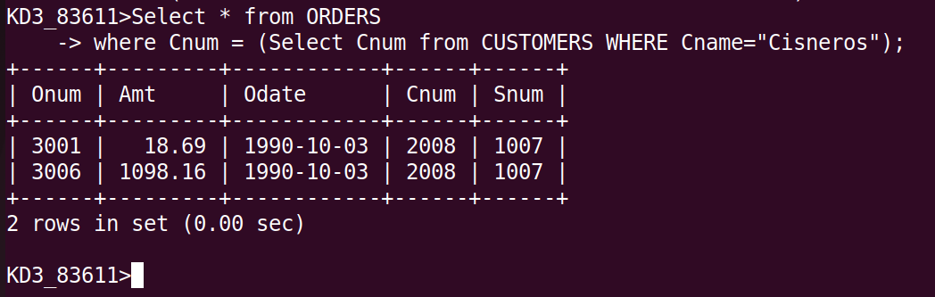

Question 2:

Query:

Select Cname, Rating from CUSTOMERS
Where Cnum in (Select Cnum from ORDERS GROUP BY Cnum HAVING sum(Amt)>(Select avg(Amt)from ORDERS));

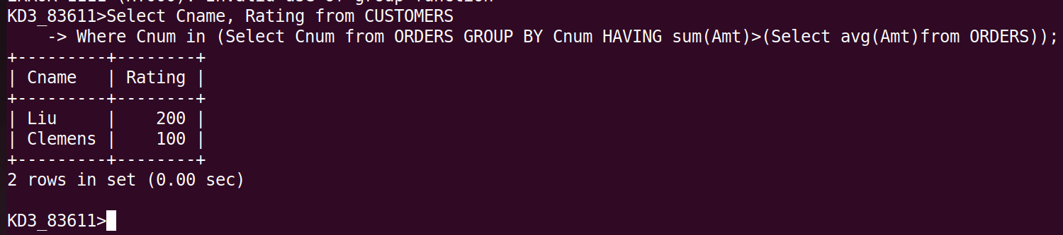

Question 3:

Query:

Select Sname, SUM(Amt) from ORDERS, SALESPEOPLE Where SALESPEOPLE.Snum =ORDERS.Snum group by Sname Having sum(Amt)>(Select max(Amt)from ORDERS);

