SQL ASSIGNMENT-4

Question 1:

Query:

Select Onum, Amt, Odate from ORDERS;

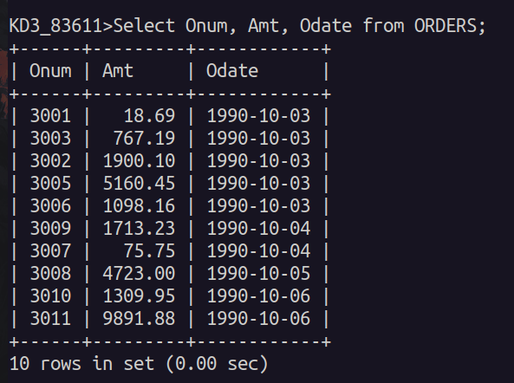

Question 2:

Query:

Select * from CUSTOMERS
where Snum = 1001;

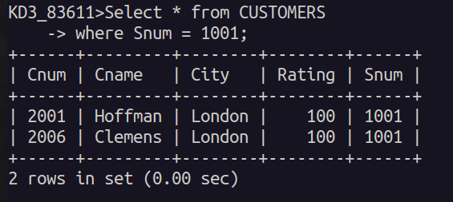

Question 3:

Query:

Select City, Sname, Snum, Comm from SALESPEOPLE;
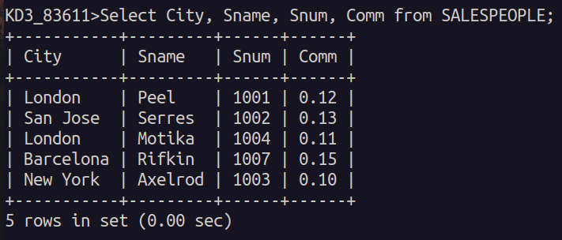

Question 4:

Query:

Select Rating, Cname from CUSTOMERS
where City = 'San Jose';

