SQL ASSIGNMENT-5

Question 1:

Query:

Select * from ORDERS
where Amt > 1000;

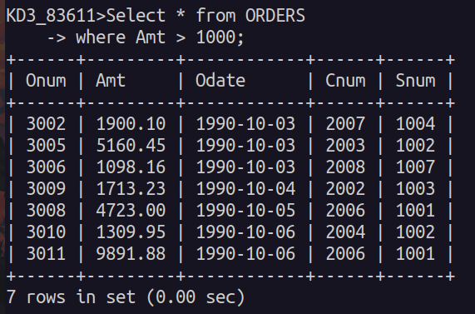

Question 2:

Query:

Select Snum, City from SALESPEOPLE
where Comm > .10 AND City='London';

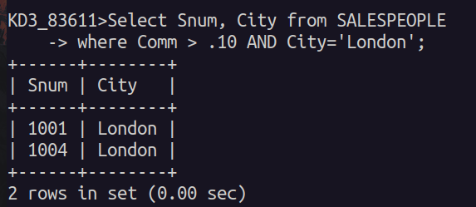

Question 3:

Query:

Select * from CUSTOMERS
where NOT Rating<=100 OR City='Rome';

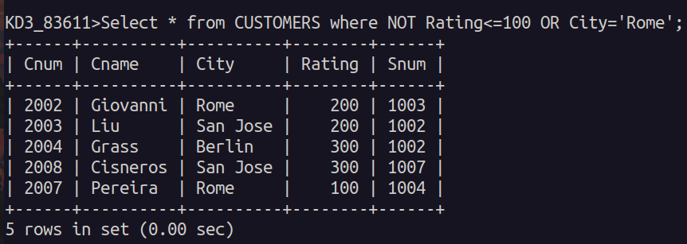

Question 4:

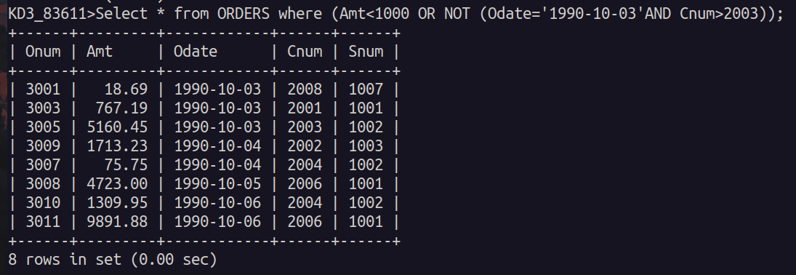

Question 5:

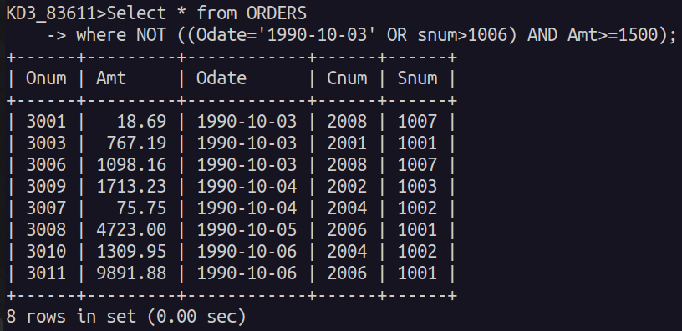
Question 6:

Query:

Select * from SALESPEOPLE
where Comm BETWEEN .12 AND .14;

