SQL ASSIGNMENT-6

Question 1:

Query: (Method-1)

Select * from ORDERS
where Odate='1990-10-03'OR Odate='1990-10-04';

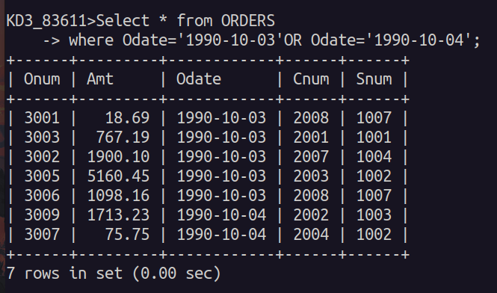

Query: (Method-2)

Select * from ORDERS
where Odate BETWEEN '1990-10-03'AND'1990-10-04';

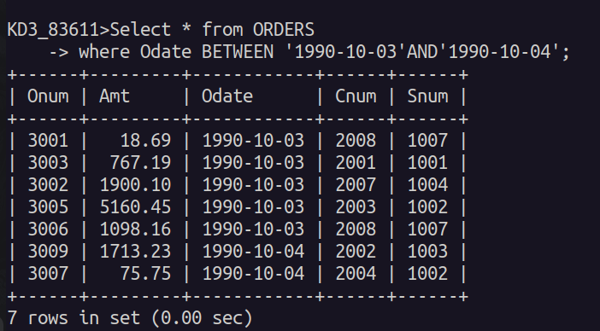

Question 2:

Query:

Select * from CUSTOMERS
where Snum in (Select Snum from SALESPEOPLE
where Sname = 'Peel' or Sname = 'Motika');

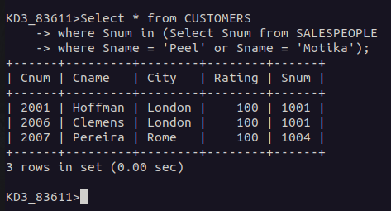

Question 3:

Query:

Select * from CUSTOMERS
WHERE Cname like'A%' OR Cname like'B%' OR Cname like'C%' OR Cname like'D%' OR Cname like'E%' OR Cname like'F%' OR Cname like'G%'
ORDER BY Cname;

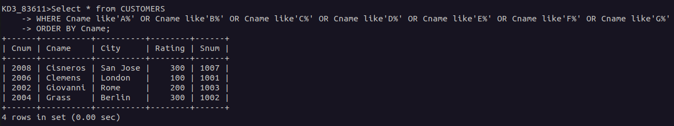

Question 4:

Query:

Select * from CUSTOMERS
WHERE Cname like'C%'
ORDER BY Cname;

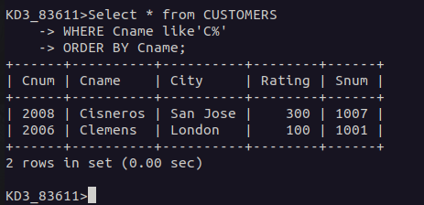

Question 5:

Query:

Select * from ORDERS
WHERE Amt NOT like'0' OR ' '
ORDER BY Amt;
