SQL ASSIGNMENT-12

Question 1:

Query:

Select Cname, Rating from SALESPEOPLE, CUSTOMERS WHERE Rating>=any(select Rating from CUSTOMERS where SALESPEOPLE.Snum=CUSTOMERS.Snum and Sname='Serres');

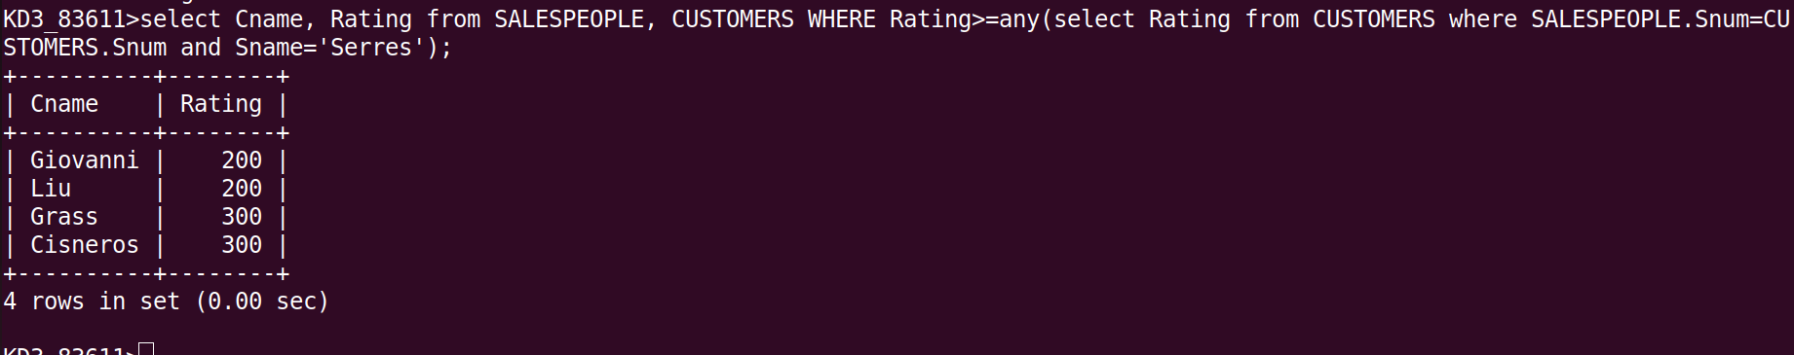

Question 2:

Query:

select Snum, Sname, City from SALESPEOPLE where Snum=any(select SALESPEOPLE.Snum from SALESPEOPLE,CUSTOMERS where SALESPEOPLE.Snum=CUSTOMERS.Snum and SALESPEOPLE.City!=CUSTOMERS.City);

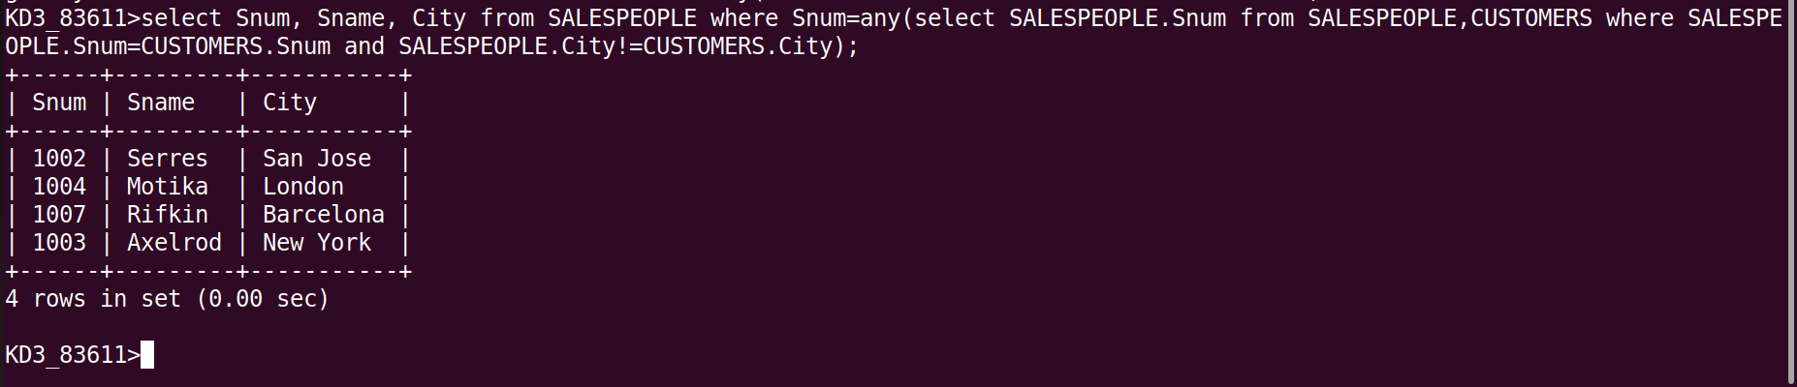

Question 3:

Query:

Select * from ORDERS Where Amt > any (select ORDERS.Amt from
ORDERS,CUSTOMERS where ORDERS.Cnum = CUSTOMERS.Cnum and CUSTOMERS.City = 'London');

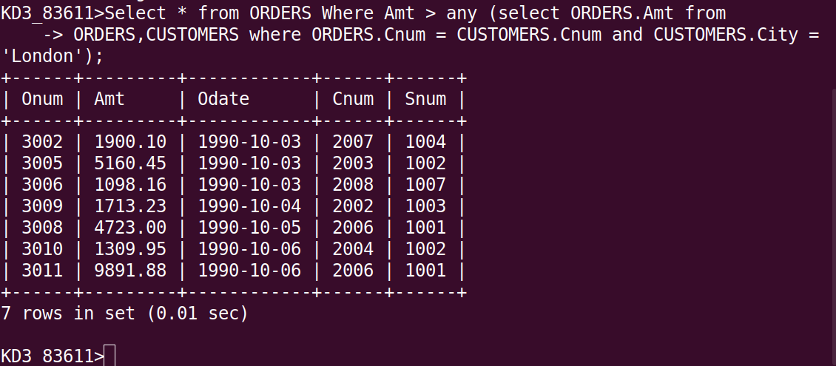

Question 4:

Query:

SELECT * FROM ORDERS WHERE amt > ANY(SELECT MIN(ORDERS.Amt) FROM ORDERS, CUSTOMERS WHERE (CUSTOMERS.Cnum=ORDERS.Cnum AND CUSTOMERS.City='London'));

