SQL ASSIGNMENT-13

Question 1:

Query:

SELECT Cname,City,Rating,'High Rating' from CUSTOMERS WHERE Rating>=200 UNION SELECT Cname,City,Rating,'Low Rating' FROM CUSTOMERS WHERE Rating<200;

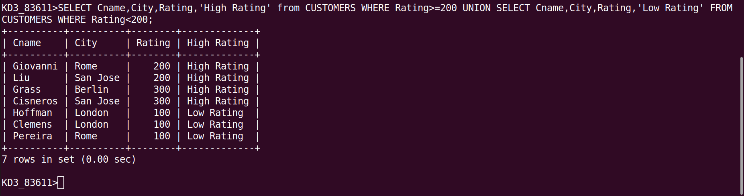

Question 2:

Query:

select Cnum, Cname from CUSTOMERS where Cnum=any(select Cnum from ORDERS group by Cnum having count(Cnum)>1) union select Snum, Sname from SALESPEOPLE where Snum=any(select Snum from ORDERS group by Snum having count(Snum)>1) order by 2;

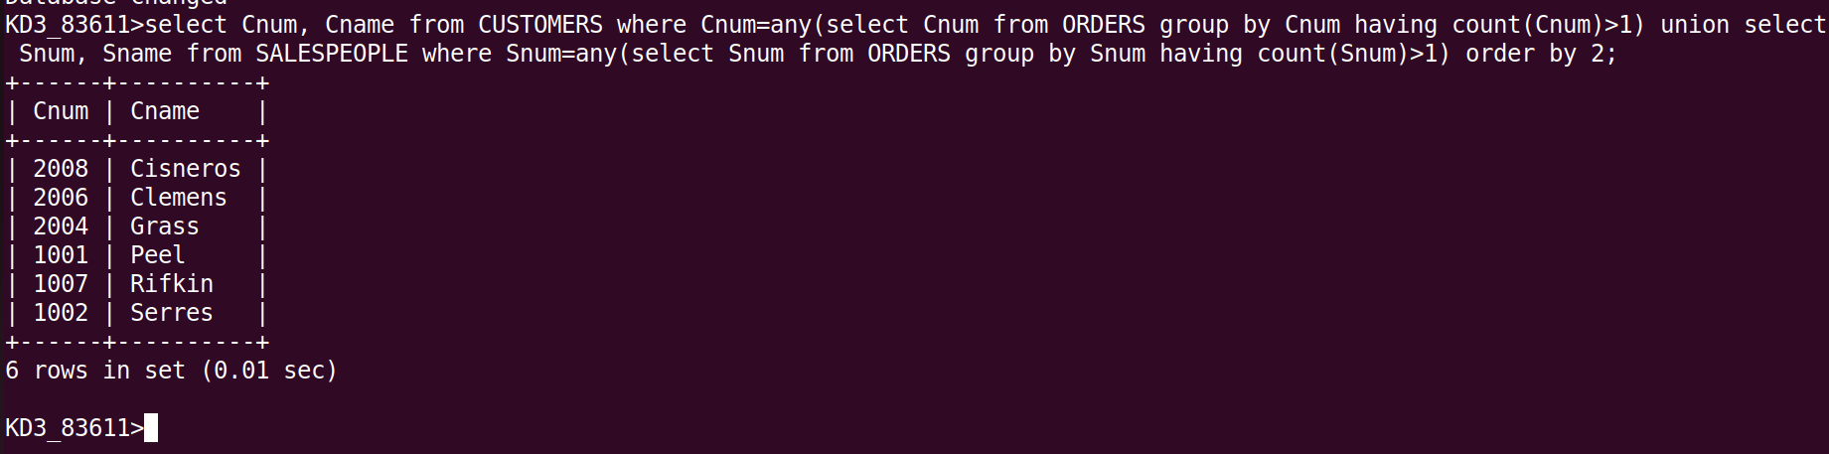

Question 3:

Query:

(Select Snum from SALESPEOPLE where City = 'San Jose') union (Select DISTINCT Cnum from CUSTOMERS where City = 'San Jose') union (Select Onum from ORDERS where Odate LIKE '1990-10-03');
