MONGODB ASSIGNMENT

Question 6:

Query:

show dbs

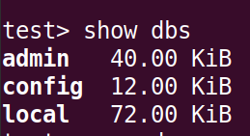

Question 7:

Query:

use cdac

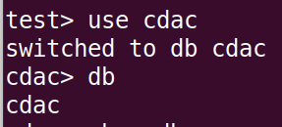

Question 8:

Query:

show collections;

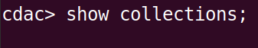

Question 9:

Query:

db.createCollection("Library")

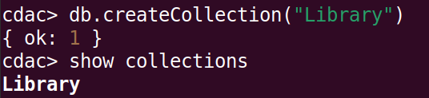

Question 10:
Query:

db.Library.insert({title:'MongoDB programming',author:'Sameer',likes:100})
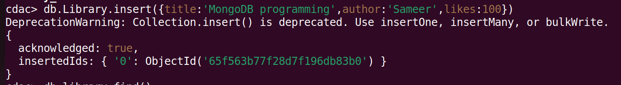

Question 11:

Query:

db.Library.find()

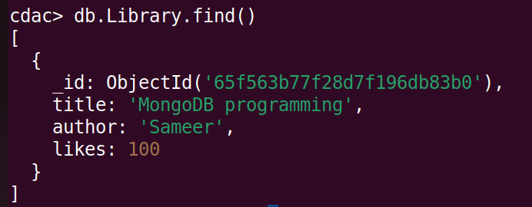

Question 12:

Query:

db.Library.insert({title:'MySQL programming',authors:['Jack','Jill'],likes:200})
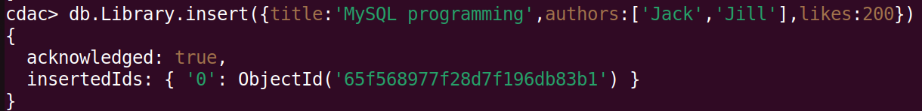

Question 13:

Query:

db.Library.find()

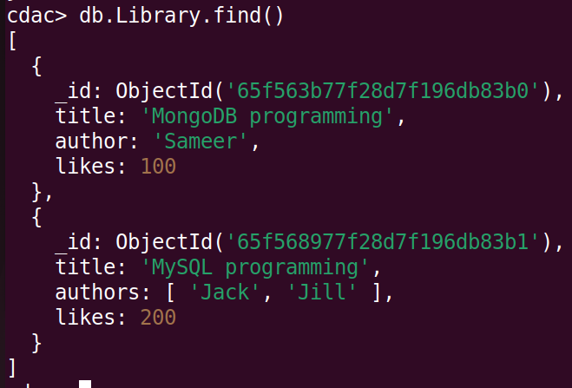

Question 14:

Query:

db.Library.findOne()

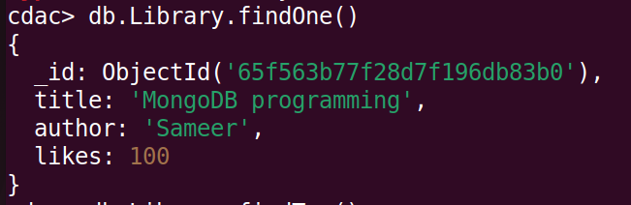

Question 15:

Query:

db.Library.find().pretty()

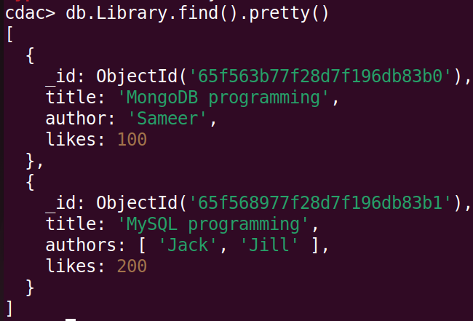

Question 16:

Query:

db.Library.update({author:'Sameer'},{$set:{author:'Sameer Dehadrai'}})

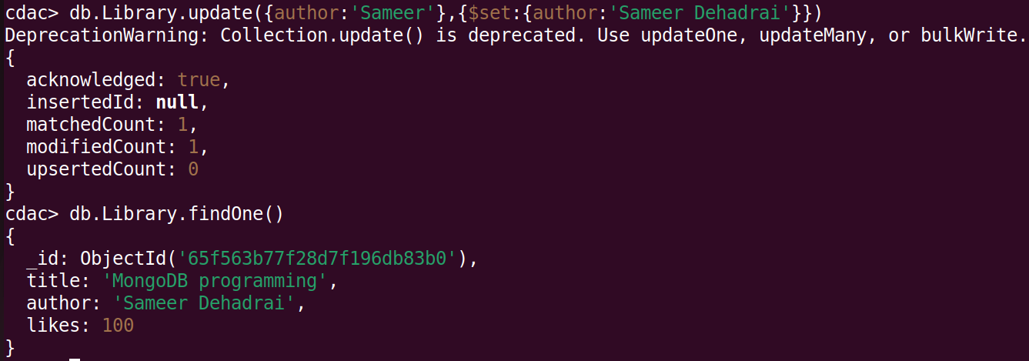

Question 17:

Query:

db.Library.remove({likes:100})

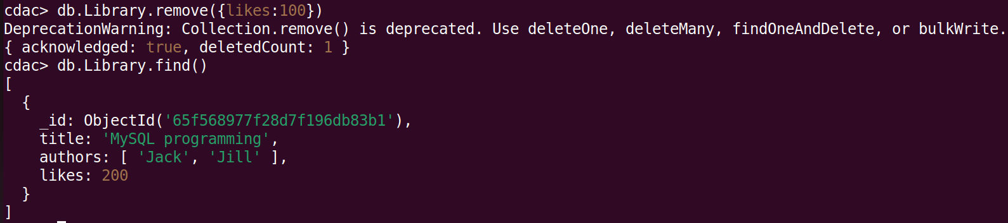

Question 18:

Query:

db.Library.drop()
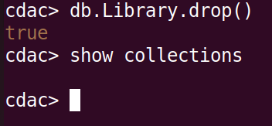

Question 19:

Query:

db.Library.drop()

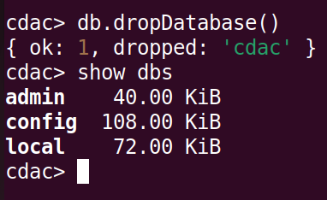

Question 20:

Query:

ctrl+c or .exit
