SQL ASSIGNMENT-10

Question 1:

Query:

select a.Sname,b.Sname,a.City from SALESPEOPLE a,SALESPEOPLE b where a.City=b.City and a.Sname>b.Sname;

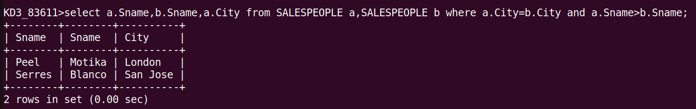

Question 2:

Query:

select Cname, City from CUSTOMERS
where Rating=(Select Rating from CUSTOMERS where Cname='Hoffman');

