SQL ASSIGNMENT-15

Question 1:

Query:

CREATE TABLE Multicast
SELECT * FROM SALESPEOPLE
WHERE snum IN (
SELECT snum FROM CUSTOMERS
GROUP BY snum
HAVING count(snum)>1
);

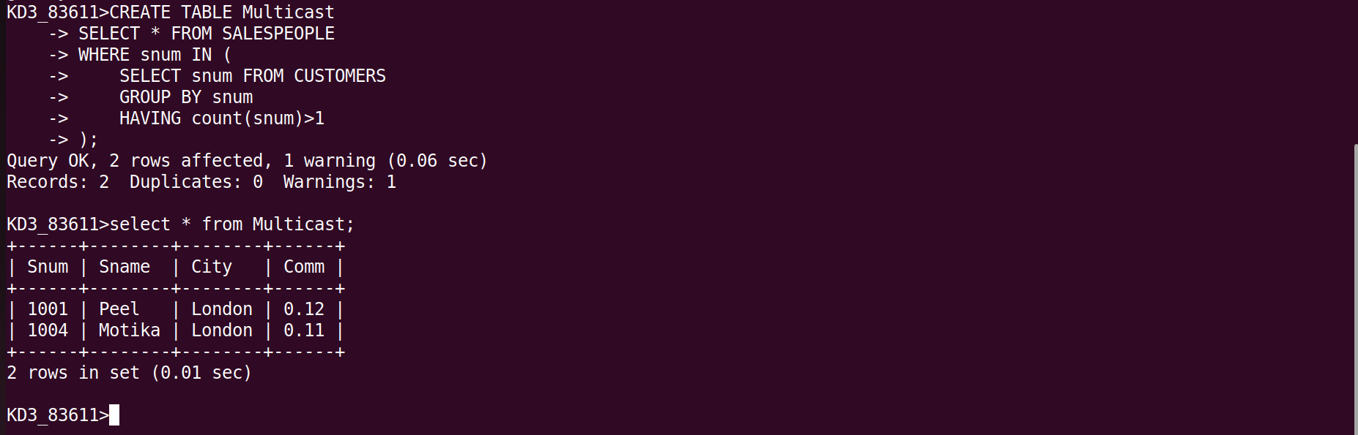

Question 2:

Query:

DELETE FROM CUSTOMERS
WHERE Cnum NOT IN
(SELECT Cnum
FROM ORDERS);

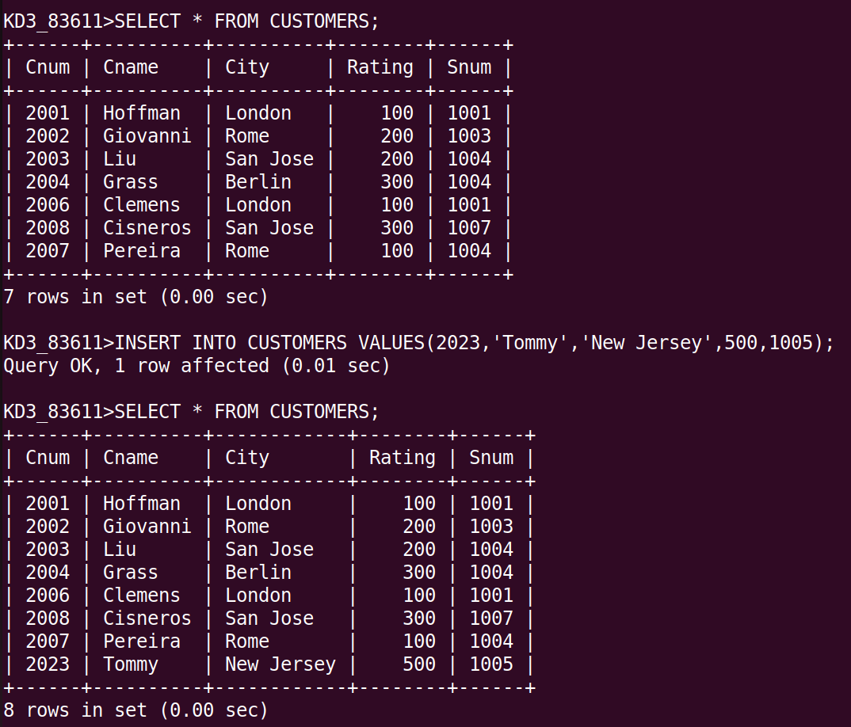

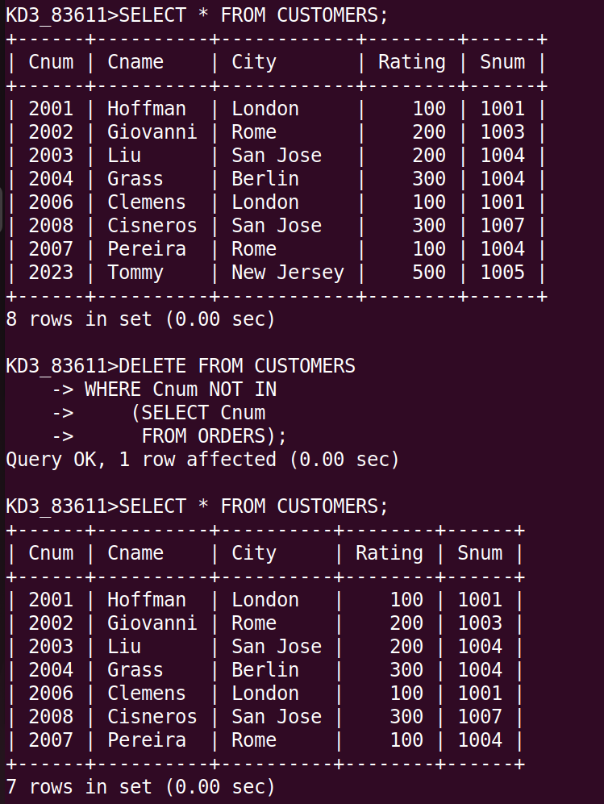

Question 3:

Query:

UPDATE SALESPEOPLE SET Comm=Comm*1.20 WHERE Snum IN (SELECT Snum FROM ORDERS WHERE Amt>3000);

