SQL ASSIGNMENT-14

Question 1:

Query:

Insert into SALESPEOPLE (City,Sname,Comm,Snum) Values ('San Jose','Blanco',NULL,1100);

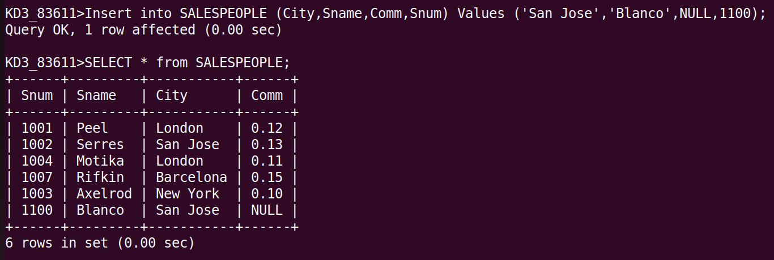

Question 2:

Query:

DELETE from ORDERS where Cnum = (Select Cnum from CUSTOMERS where Cname ='Clemens');

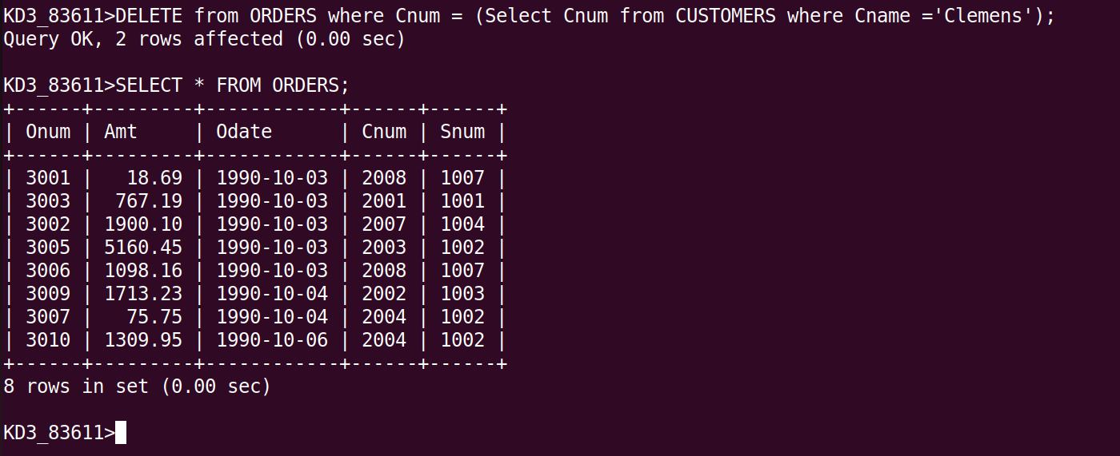

Question 3:

Query:

UPDATE CUSTOMERS Set Rating = Rating+100 where City = 'Rome';

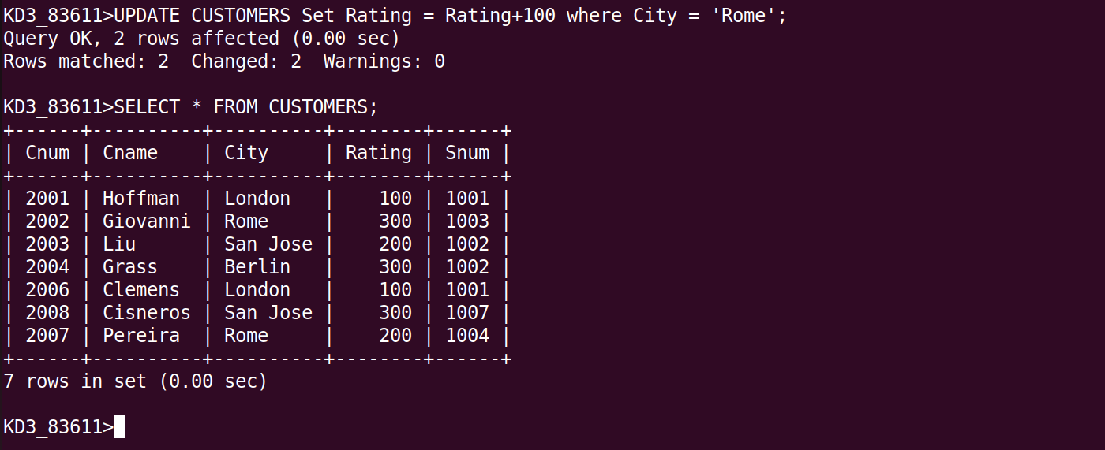

Question 4:

Query:

Update CUSTOMERS Set Snum = (Select Snum from SALESPEOPLE where Sname = 'Motika') where Snum =(Select Snum from SALESPEOPLE where Sname ='Serres');

BEFORE :


AFTER :

