SQL ASSIGNMENT-9

Question 1:

Query:

Select Onum,Cname from ORDERS,CUSTOMERS
Where ORDERS.Cnum=CUSTOMERS.Cnum;

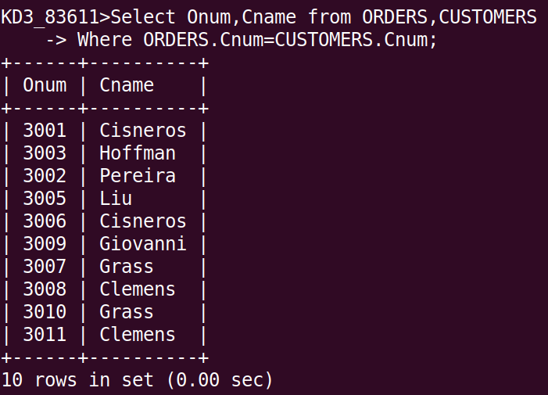

Question 2:

Query:

Select Sname,Cname,Onum from SALESPEOPLE,CUSTOMERS,ORDERS where SALESPEOPLE.Snum=CUSTOMERS.Snum AND CUSTOMERS.Snum=ORDERS.Snum;

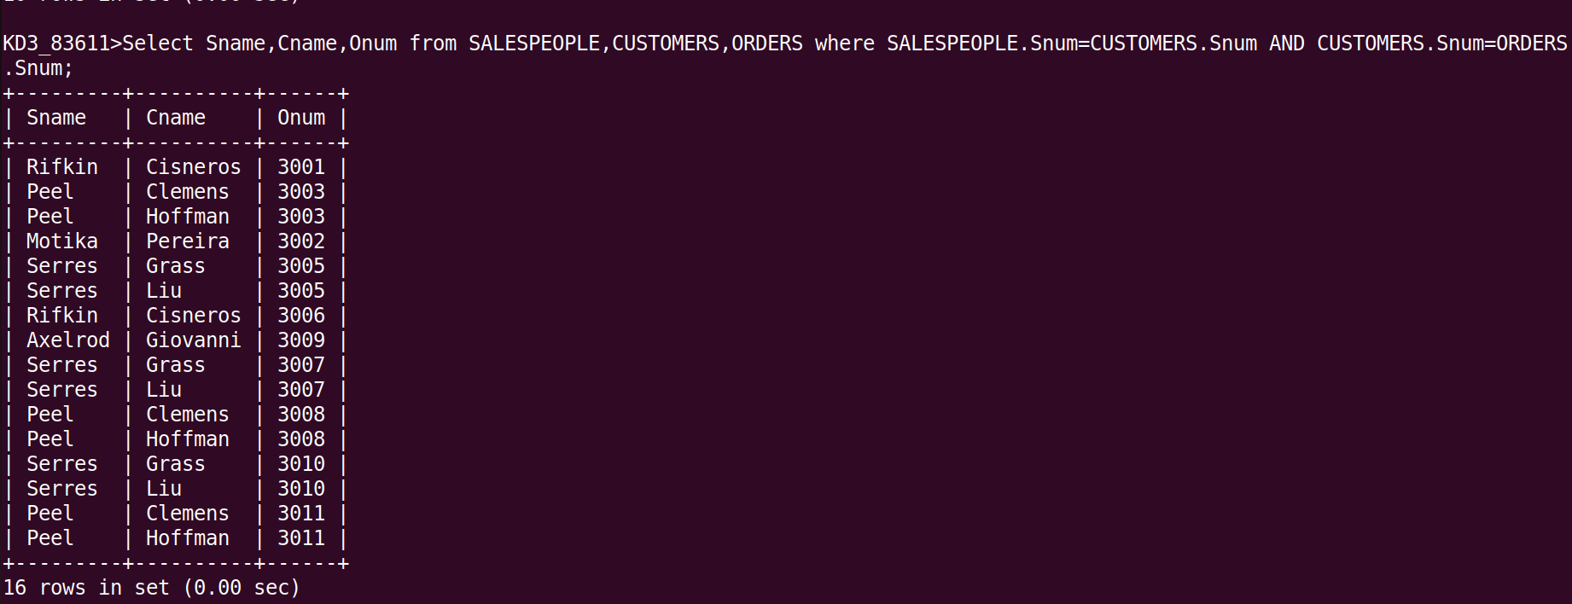

Question 3:

Query:

Select Cname,Sname,Comm from CUSTOMERS,SALESPEOPLE
Where SALESPEOPLE.Snum=CUSTOMERS.Snum and Comm>0.12;

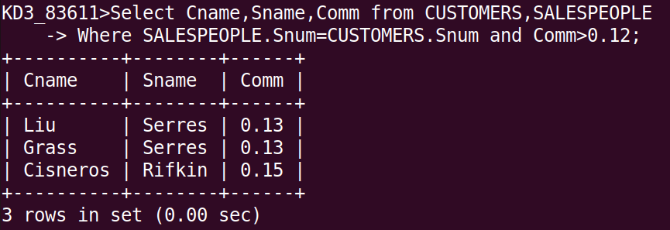

Question 4:

Query:

Select Sname, Cname, Rating, Onum, Amt, Amt*Comm FROM ORDERS, CUSTOMERS, SALESPEOPLE
WHERE ORDERS.Snum=CUSTOMERS.Snum AND CUSTOMERS.Snum=SALESPEOPLE.Snum AND Rating>100;

