SQL ASSIGNMENT-7

Question 1:

Query:

Select count(*) from ORDERS
WHERE Odate like'1990-10-03';

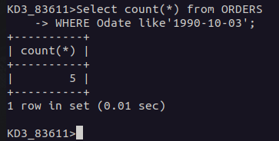

Question 2:

Query:

Select count(DISTINCT City) from CUSTOMERS
WHERE City NOT in(' ');
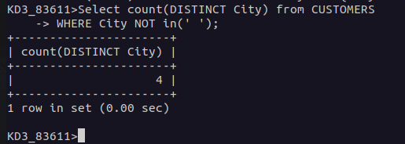

Question 3:

Query:

Select Cnum,min(Amt) from ORDERS group by Cnum;

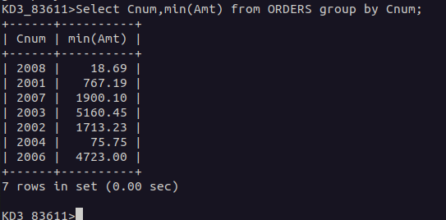

Question 4:

Query:

Select Cname from CUSTOMERS
where Cname like 'G%'
order by Cname
limit 1;

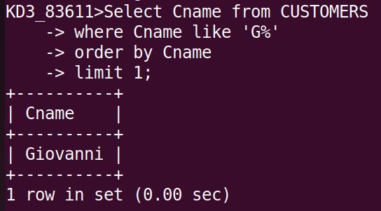

Question 5:

Query:

Select City,max(Rating) as "Highest Ratings" from CUSTOMERS group by City;

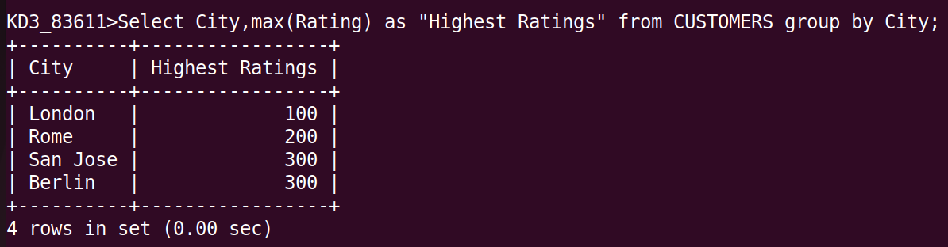

Question 6:

Query:

Select Odate,count(DISTINCT SNUM) from ORDERS
GROUP BY 1;

