SQL ASSIGNMENT-8

Question 1:

Query:

Select Onum,Snum,Amt*0.12 as "Amount including commission" from ORDERS;

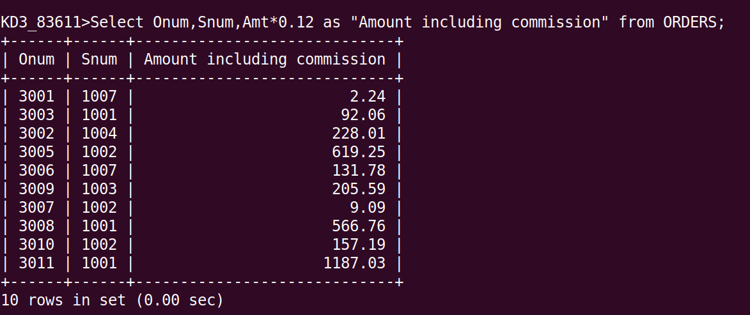

Question 2:

Query:

Select City, MAX(Rating) as "Highest Rating" from CUSTOMERS GROUP BY City;

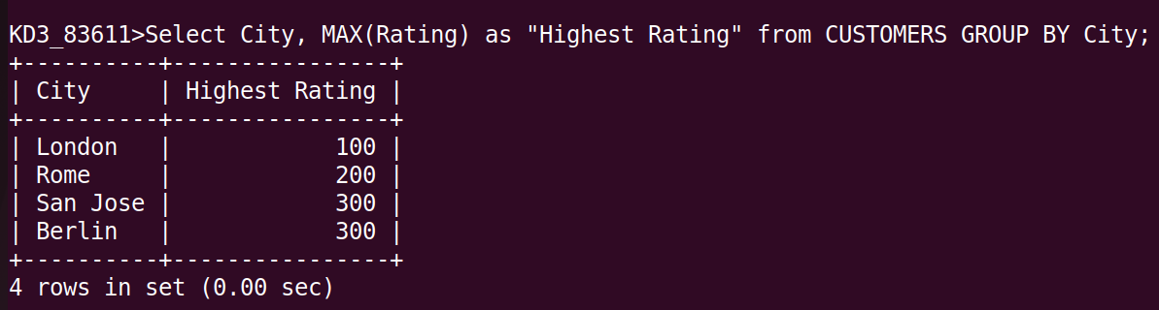

Question 3:

Query:

Select Rating,Cname,Cnum from CUSTOMERS
ORDER BY Rating desc;

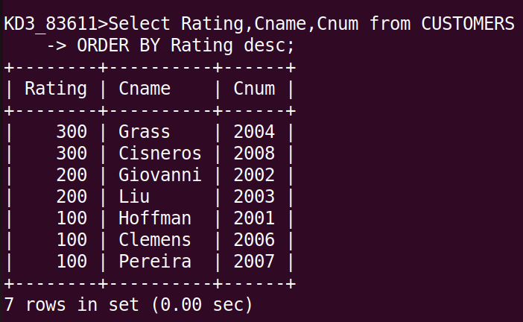

Question 4:

Query:

Select Count(Onum) as "Count of Orders", Odate from ORDERS
Group BY Odate
Order By Count(Onum) desc;

