Assignment – 4

Q1.

wc data.txt

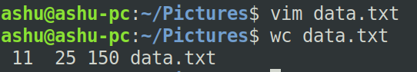

Q2.

grep "files" data.txt

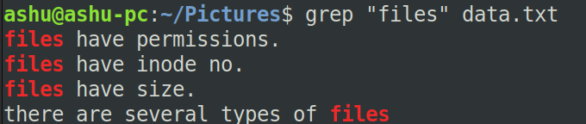

Q3.

grep "file" data.txt

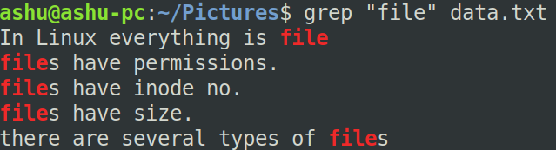

Q4.

grep -v "files" data.txt

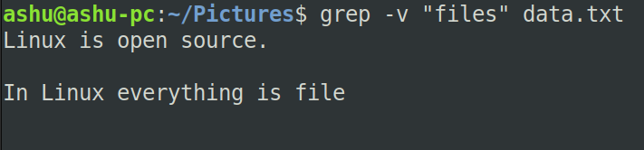

Q5.

grep "have" data.txt

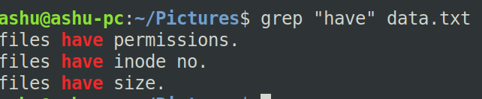

Q6.

grep "^f" data.txt

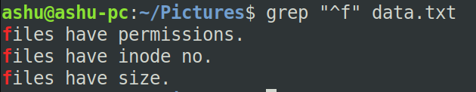

Q7.

grep "\.$" data.txt

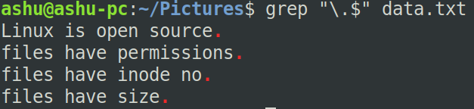

Q8.

head -n 2 data.txt

Q9.

tail -n 3 data.txt

Q10.

head -n 5 data.txt | tail -n 3

