Assignment -3

Q.1

echo "Login Name: $LOGNAME"
echo "Home Directory: $HOME"

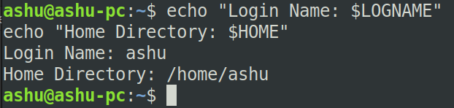

Q2.

while true; do
echo "Enter 1. for Date"
echo "Enter 2. for Cal"
echo "Enter 3. for Ls"
echo "Enter 4. for Pwd"
echo "Enter 5. to Exit"
echo "Enter your choice: "
read choice
case $choice in
1) date ;;
2) cal ;;
3) ls ;;
4) pwd ;;
5) exit ;;
*) echo "Invalid choice, please select a number from 1 to 5." ;;
esac
done

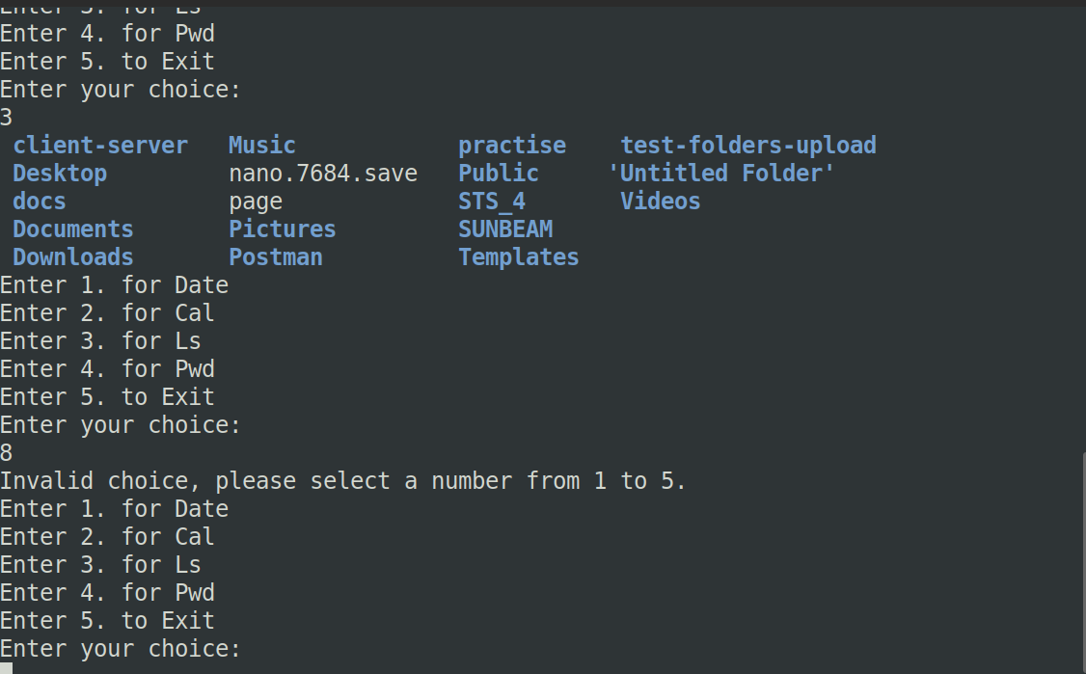

Q3.

echo "Enter a name: "
read name
if [ -f "$name" ]; then
echo "$name is a file & size = $(ls -l) bytes."
elif [ -d "$name" ]; then
echo "$name is a directory.contents are:"
ls "$name"
else
echo "$name is neither a file nor a directory."
fi

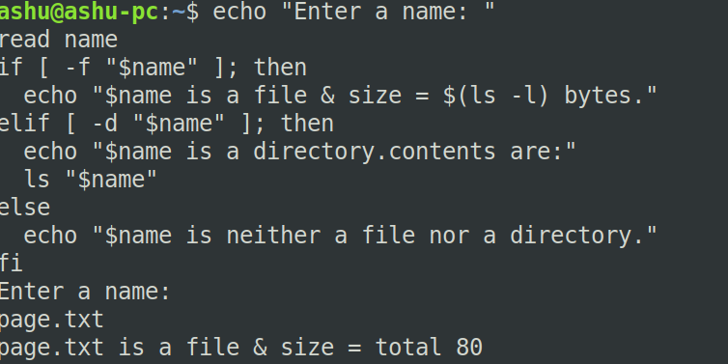

Q4.

echo "Enter a number: "
read num
isprime=1

for ((i=2; i<=num/2; i++)); do
if [ $((num%i)) -eq 0 ]; then
isprime=0
break
fi
done

if [ $isprime -eq 1 ]; then
echo "$num is a prime number."
else
echo "$num is not a prime number."
fi

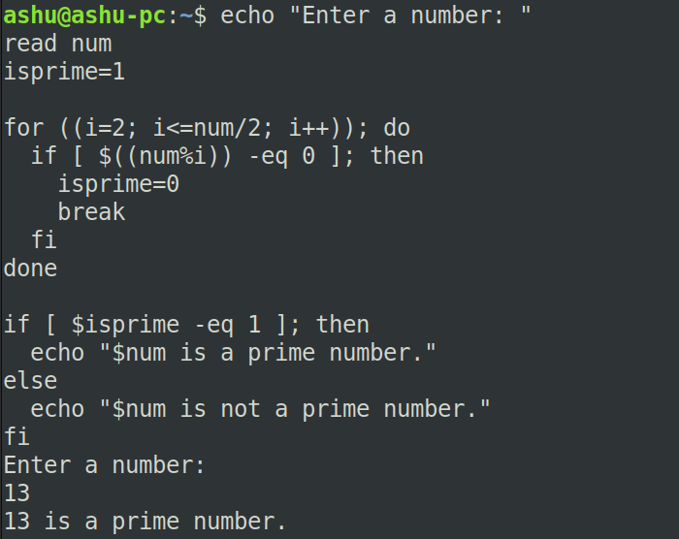

Q5.

echo "Enter three numbers: "
read a b c
if [ "$a" -ge "$b" ] && [ "$a" -ge "$c" ]; then
echo "$a is the greatest."
elif [ "$b" -ge "$a" ] && [ "$b" -ge "$c" ]; then
echo "$b is the greatest."
else
echo "$c is the greatest."
fi

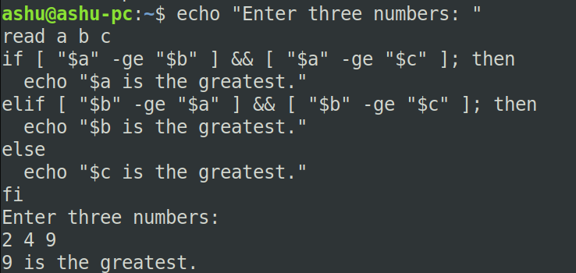

Q6.

echo "Enter a year: "
read year
if (( (year % 4 == 0 && year % 100 != 0) || (year % 400 == 0) )); then
echo "$year is a leap year."
else
echo "$year is not a leap year."
fi

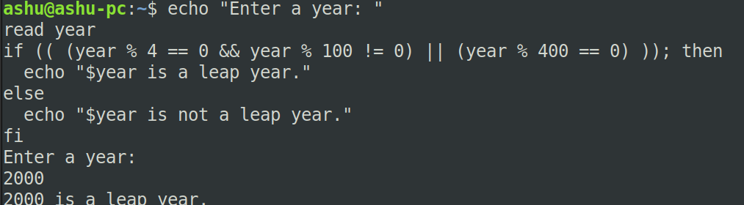

Q7.

echo "Enter a number: "
read num
if [ "$num" -gt 0 ]; then
echo "$num is positive."
elif [ "$num" -lt 0 ]; then
echo "$num is negative."
else
echo "$num is zero."
fi

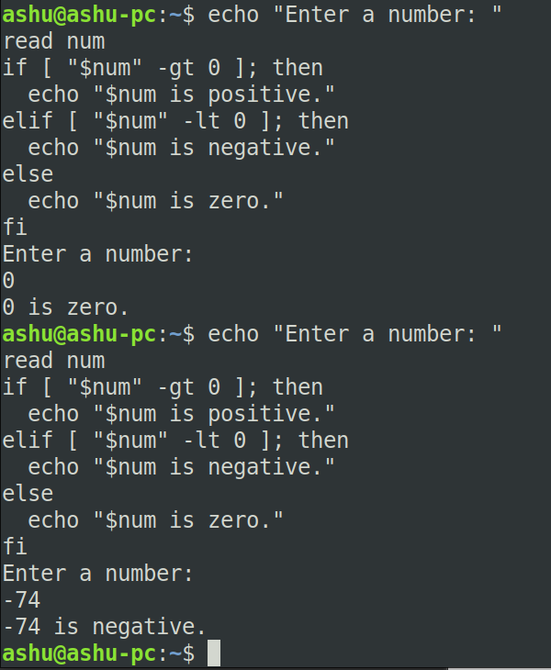

Q8.

echo "Enter a number: "
read num
for i in 1 2 3 4 5 6 7 8 9 10; do
echo "$num * $i = $((num * i))"
done

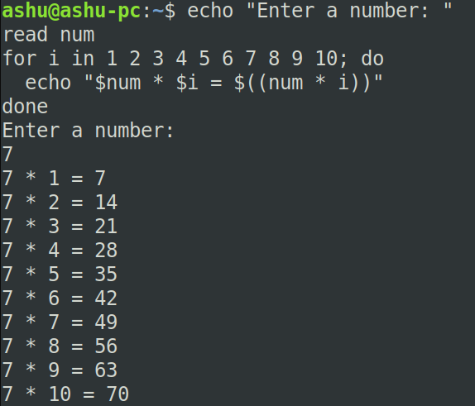

Q9.

echo "Enter a number: "
read num
fact=1
for ((i=1; i<=num; i++)); do
fact=$((fact * i))
done
echo "Factorial is $fact"

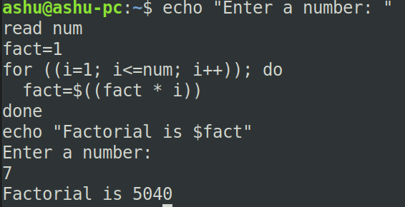

Q10.

echo "Enter the number of terms: "
read n
a=0
b=1
echo "Fibonacci series up to $n terms:"
for ((i=0; i<n; i++)); do
echo "$a "
fn=$((a + b))
a=$b
b=$fn
done
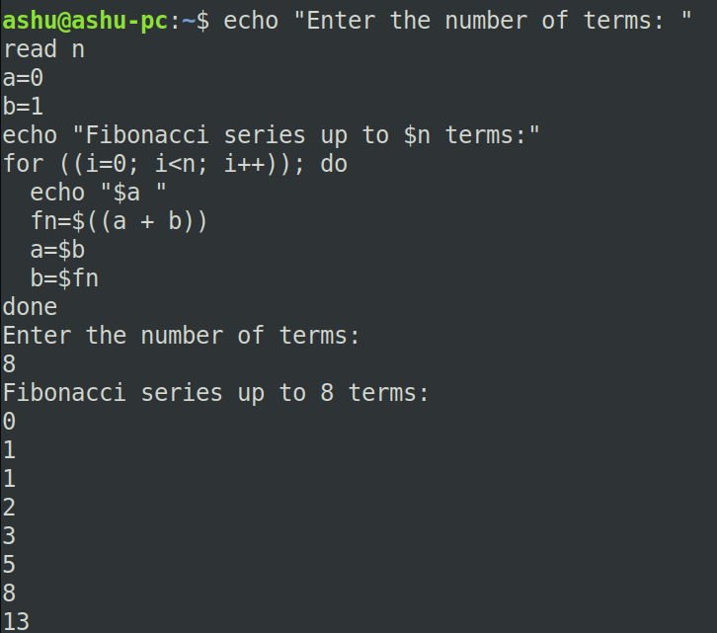

Q11.

echo "Enter the basic salary: "
read basic
da=$(echo "0.4 * $basic" | bc)
hra=$(echo "0.2 * $basic" | bc)
gross=$(echo "$basic + $da + $hra" | bc)
echo "Gross salary is $gross"

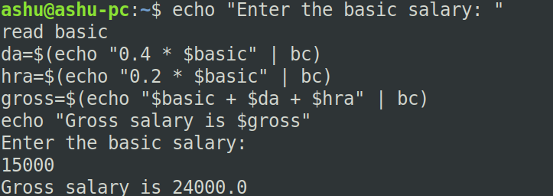

Q12.

echo "Enter the file name: "
read para
if [ -f "$para" ]; then
modifdate=$(date -r "$para")
echo "Last modification date of $para is: $modifdate"
else
echo "$para does not exist."
fi

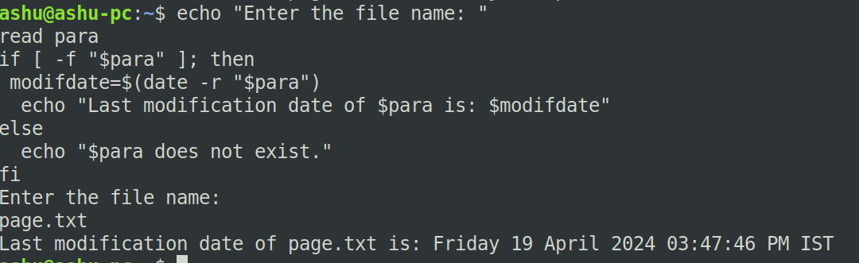

Q13.

echo "hidden files are:"
ls -A .*

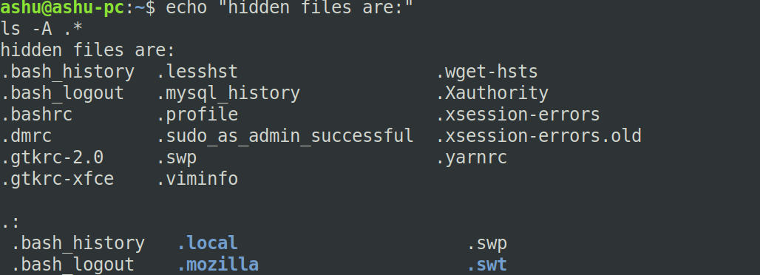

Q14.

for filename in *; do
if [ -x "$filename" ]; then
echo "$filename"
fi
done

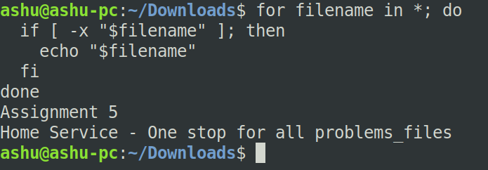

Q17.

for ((i=1; i<=5; i++)); do
for ((j=1; j<=i; j++)); do
echo -n "* "
done
echo
done

