Assignment-2

Q1.

ls -t

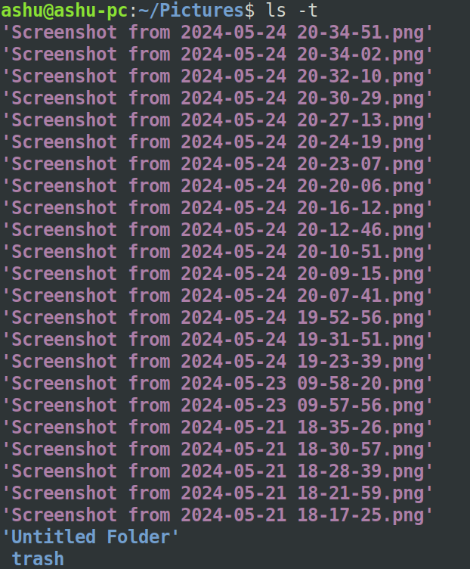
Q2.

ls -lS

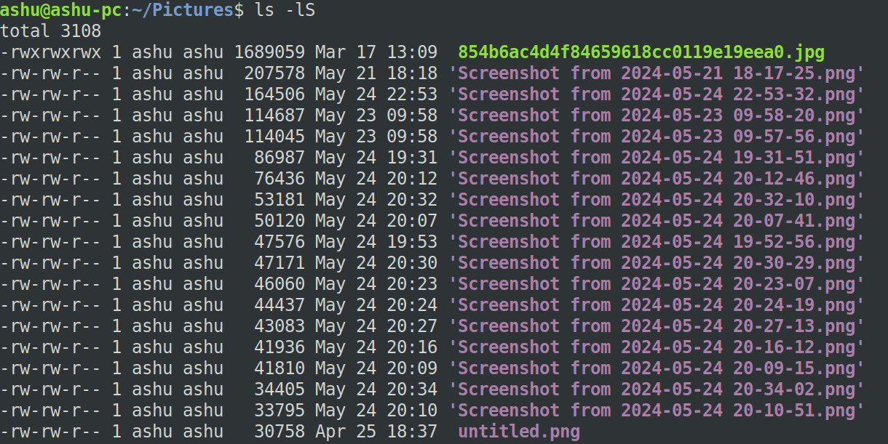

Q3.

ls -i

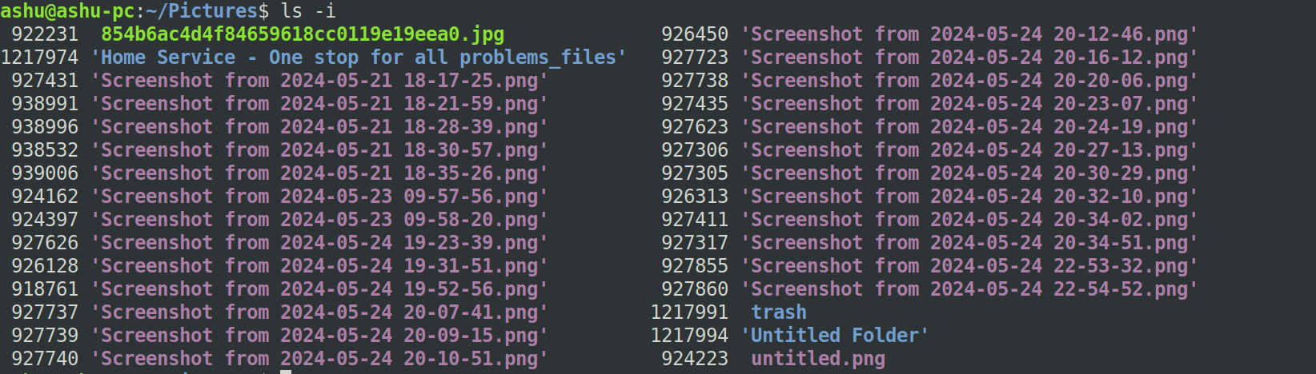

Q4.

ls trash/

Q5.

echo "Vikram Chandra" > namefile.txt
vim namefile.txt
cat namefile.txt

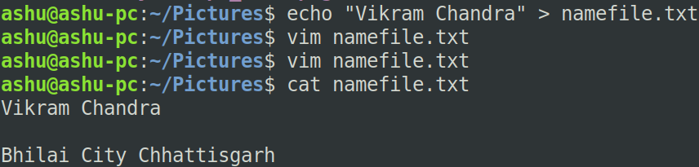

Q6.

$ touch -t 197112310934.52 namefile.txt

Q7.

mkdir one
cd one
touch 1.txt 11.txt 111.txt
mkdir two
cd two
touch 2.txt 22.txt 222.txt
mkdir three
cd three
touch 3.txt 33.txt 333.txt
mkdir four
cd four
touch 4.txt 44.txt 444.txt
mkdir five
cd five
touch 5.txt 55.txt 555.txt
cd ~

Q 8.

1.)

ls one/five

2.)

echo "ashu@ashu-pc" > one/four/44.txt

3.)

rm one/five/555.txt

4.)

cd one/two/three/four/five

5.)

cat ../../../three/3.txt

6.)

ls ../../two

7.)

rm ../../two/222.txt

9.)

rm -f one/five/*

10.)

rmdir one/five

11.)

rm -rf one/four

12.)

cd ~

Q9.

touch one/three/3.txt

