ASSIGNMENT – 4

i. count the no. of words ,characters and lines from above 2 file.(man wc)
-->

ii. list the lines having word "files" (man grep)
-->

iii. list the lines having word "file" (man grep)
-->

iv. list the lines which don't have word "files" (man grep)
-->

v. list the lines having word "have" . (man grep)
-->


vi. list the lines starts with letter "f" (man grep)
-->

vii. list the lines ends with "." (man grep)
-->
viii. list only first two lines.(man head)
-->
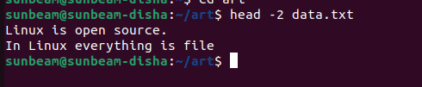

ix. list only last three lines.(man tail)
-->
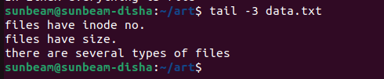

x. list line no.3,4 and 5 . (man head and tail)
-->
