A)

Gitea do support LFS, some major step is showed below:

1. Download and start gitea on docker

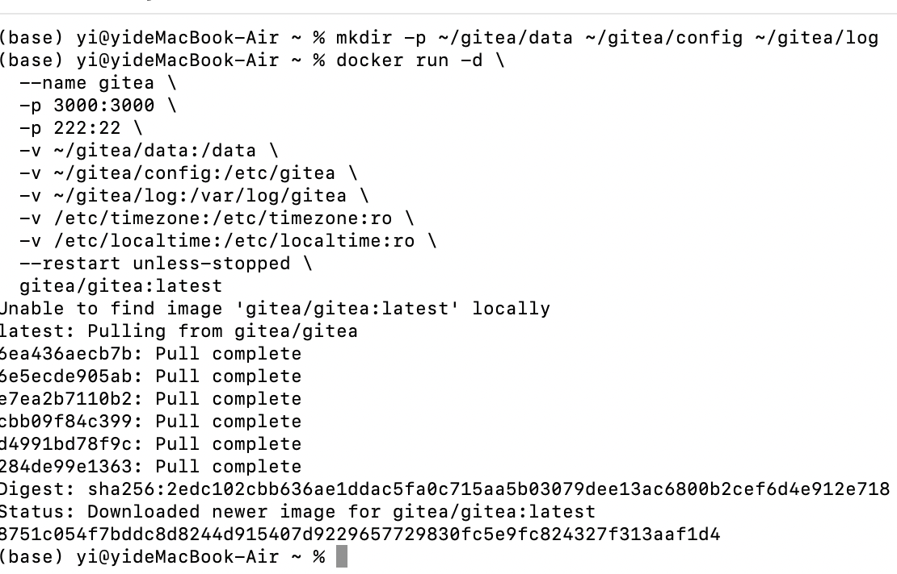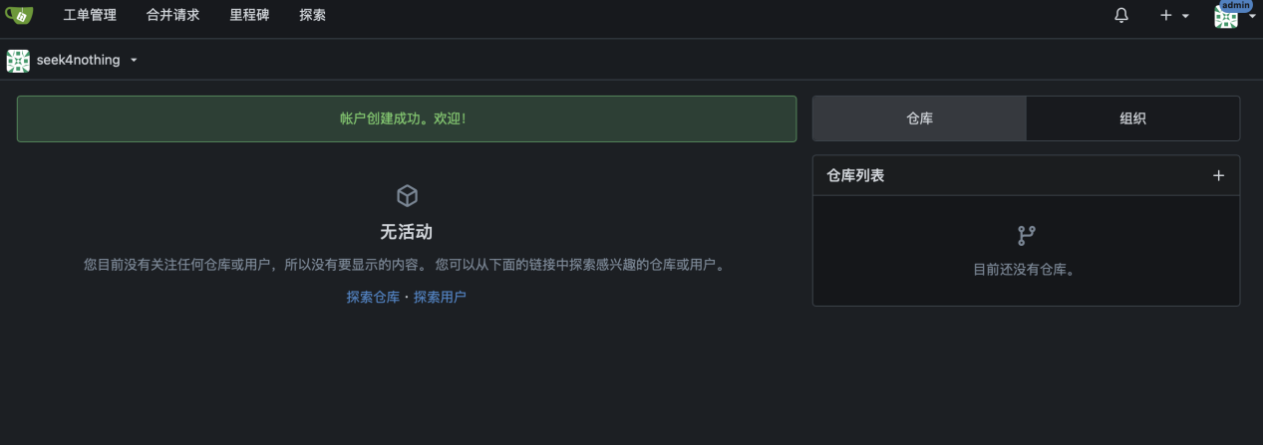

2 Upload a 1GB file to gitea and check if it uses LFS:

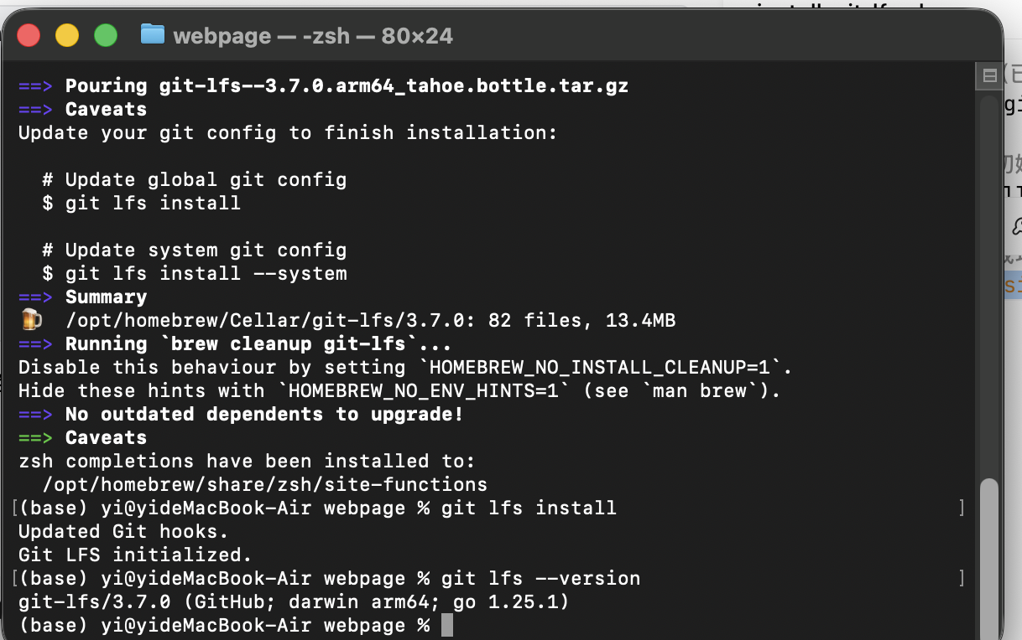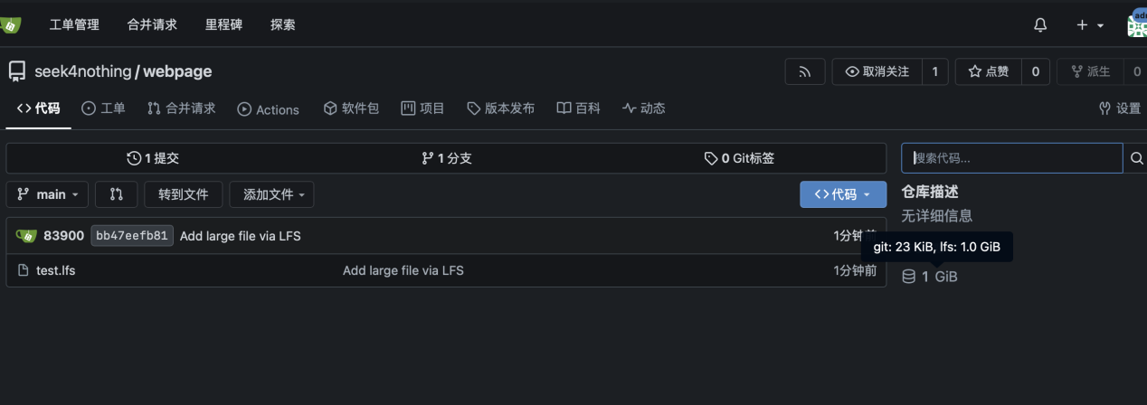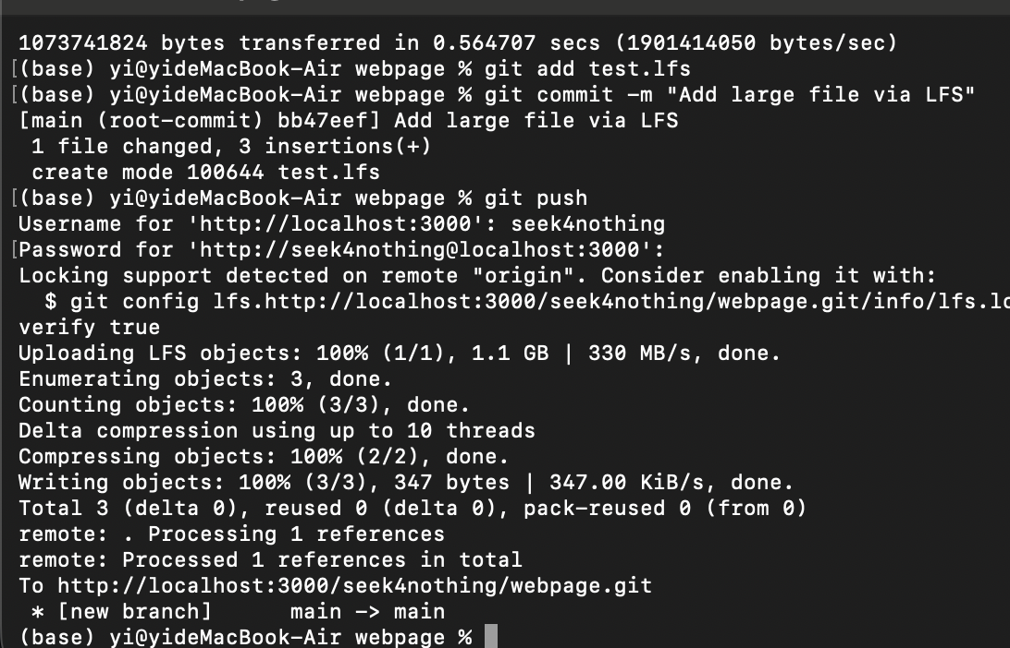

1. See same screenshot above
2. Local gitea without docker is download and started,with lab uploaded:

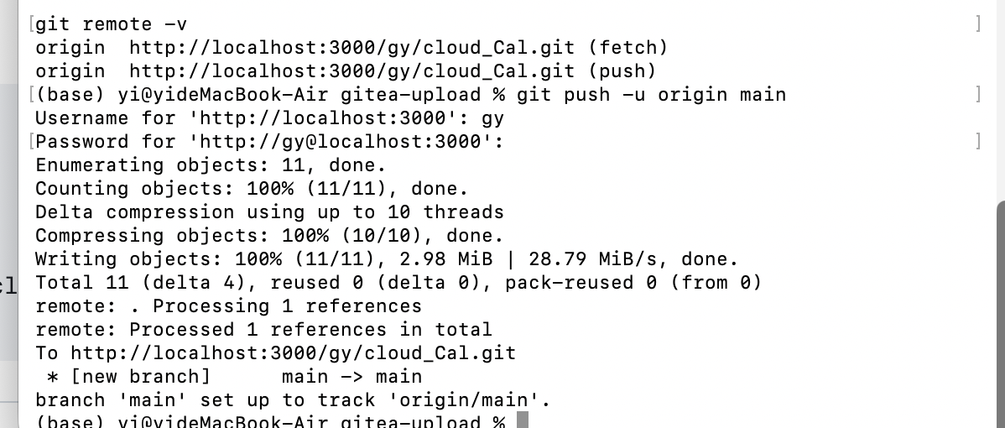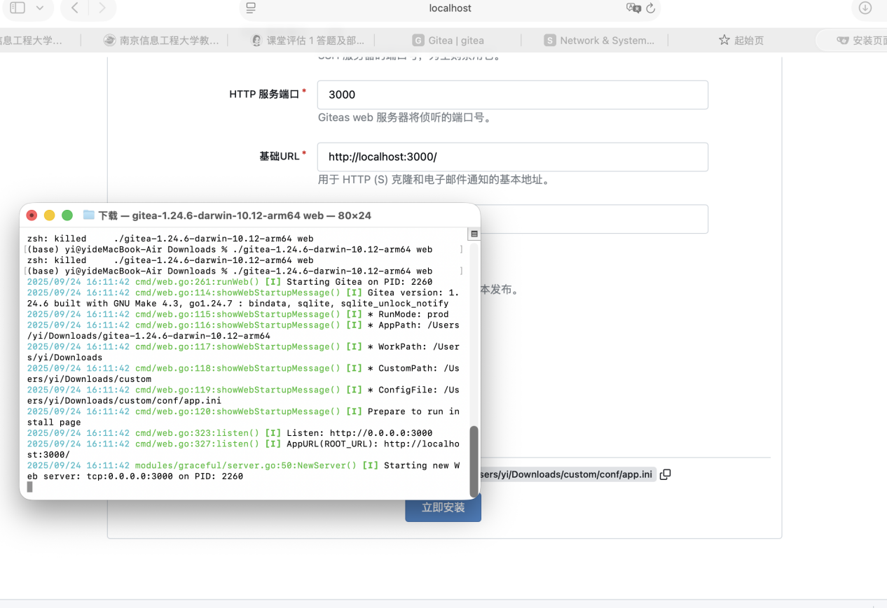

Gitea rero link:http://localhost:3000/gy/cloud_Cal.git