ASSIGNMENT 3
KD1-Sneha-83911

_____________________________________________

1

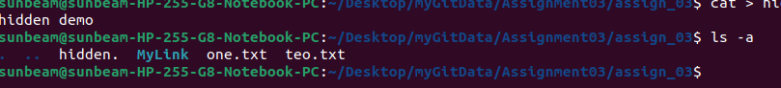

2

3
ln /home/sunbeam/Desktop/myGitData/CPP MyLink2
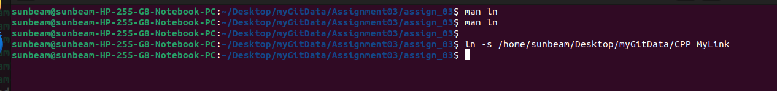

4

5 stat -c '%y' one.txt
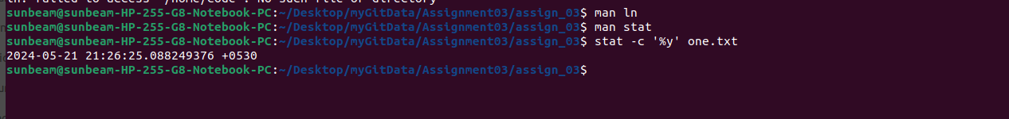

6

7

8
tail -n +5 one.txt

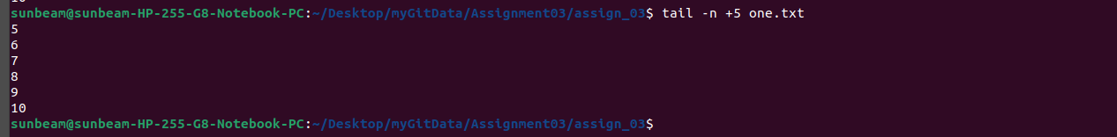

9

10

11

12

13
tty

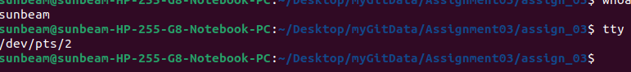

14
whoami

16
who

15
w

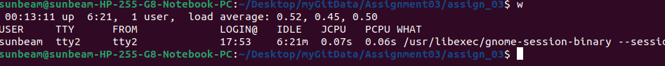

17

18

19

20

21

22

23

24

