Project Report
On
Hotel Booking System

Submitted by:

Aayush (2401010042)
Vansh Sharma (2401010045)
Hrishit Kaushal(2501722016)

Department of
Computer Science and Engineering
School of Engineering and Technology
- R. Mangalam University, Gurugram- 122003

Hotel Booking System - Web Project Report

PROJECT REPORT

Hotel Booking System

Abstract
The Hotel Room Booking System is a full-stack Django web application developed to simplify and automate hotel room reservation processes. It allows users to register, log in, browse room listings with images, and book available rooms through a secure and user-friendly interface. The system uses Django’s built-in authentication for secure login management and SQLite3 as the development database. A robust booking logic prevents double-bookings and ensures accurate room availability. The admin panel enables efficient management of users, rooms, and bookings. Built using modular architecture and best practices in static/media handling and version control via GitHub, this project demonstrates how modern web technologies can create a scalable, maintainable, and reliable hotel booking platform.

1. Introduction
A hotel booking system is essential for both customers and hotel managers in today’s digital world. People often prefer online systems because they save time, provide transparency, and allow booking from anywhere. Hotels also benefit by reducing manual errors, improving customer experience, and keeping digital records of rooms and bookings.
This project aims to create an efficient, user-friendly online platform where customers can check room details, view photos, and book rooms securely. The system also helps hotels manage their rooms, track bookings, and update availability. The combination of Django’s backend power and a clean frontend interface makes this system reliable and scalable.

2. Project Overview
The Hotel Room Booking System is a Django-based web application designed to provide an easy, fast, and reliable way for people to book hotel rooms online.
It allows users to create accounts, log in, browse rooms with images, view availability, and book them instantly.
Hotel administrators can manage rooms, bookings, and user information using the Django admin panel.The objective is to offer a smooth, secure, and efficient booking experience for users, while also simplifying management for hotel staff.

Features
- User registration, login, and logout are handled securely through Django’s authentication system.
ii. Users can view all hotel rooms along with images, descriptions, and pricing details.
iii. Rooms are displayed in categories such as Available Rooms, Unavailable Rooms, and My Rooms for easy navigation.
iv. The system checks room availability in real-time and prevents double-booking of already reserved rooms.
v. Users can book rooms directly through a clean and user-friendly interface.
vi. Administrators can manage rooms, bookings, and users through the Django Admin Panel.
vii. Admins can upload and update room images using Django’s media management system.

4. Technologies Used
• Python 3.x
• Django 5.2
• SQLite3
• HTML5, CSS3
• Git & GitHub
• PowerShell / Command-Line Interface

5. GitHub Integration
The project is hosted on GitHub for collaboration and version control.

Repository:
https://github.com/83Aayush/Web_Hotel_Management

Workflow for contributors
• git pull origin main
• Modify/update the code
• git add .
• git commit -m "update message"
• git push origin main

This ensures smooth teamwork and clear version control history.

Good Practices Followed
• Separate apps for authentication (accounts) and core logic (home)
• Proper use of Django static and media file handling
• Clean and modular project structure for easy maintenance
• Clear and user-friendly UI/UX design
• Custom logic used to prevent double booking of rooms
• Use of GitHub for efficient versioning and project tracking

Database Design

Tables:
• Users – Stores registered user information
• Rooms – Stores room details and images
• Bookings – Stores booking records
• Categories – (Optional) Stores room type information
Booking Logic:
• System checks room availability before confirming a booking
• If a room is already booked, duplicate booking is prevented
• If a room is available, the booking is successfully created

- Photos / Screenshots Section
• Homepage Screenshot
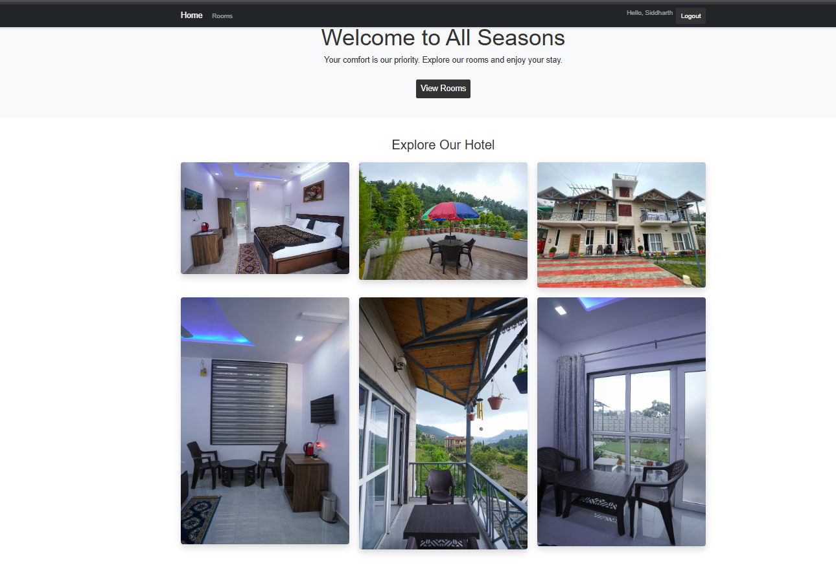

• Room Listing Page Screenshot
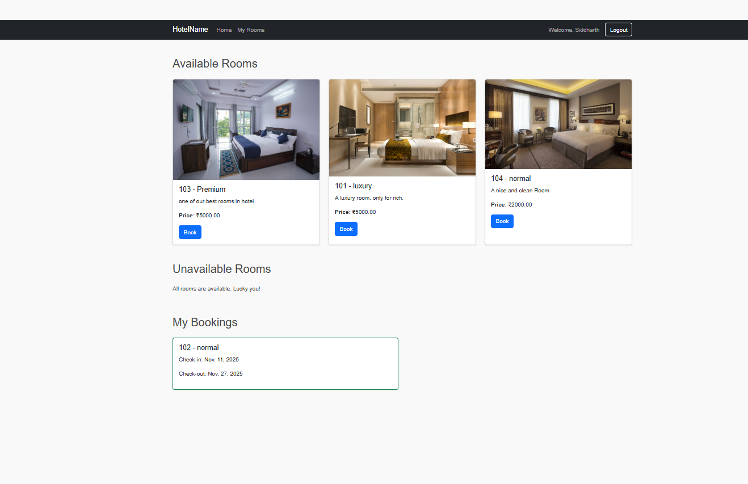

• Admin Panel Screenshot
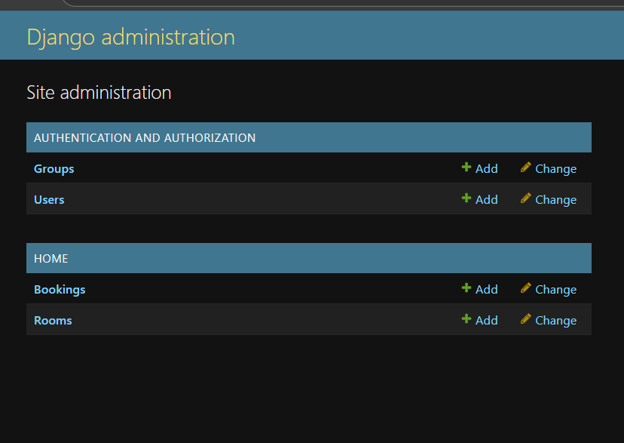
• Room Details Page Screenshot

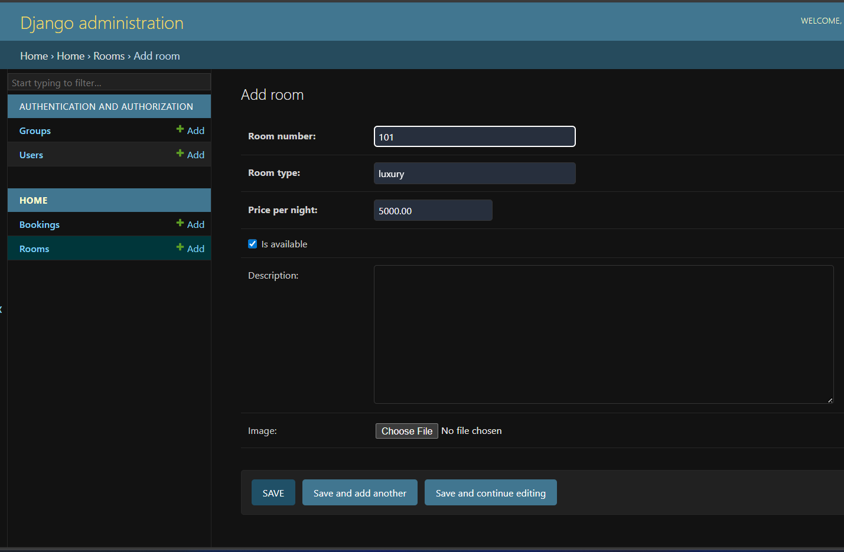

9. System Workflow
• User registers or logs in
• User views available rooms
• User checks room images and details
• User books an available room
• Booked rooms appear under My Rooms
• Admin manages rooms, bookings, and user data from Django Admin

10. Conclusion
The Hotel Room Booking System is a complete and efficient Django-based web application that simplifies the process of hotel room reservations. It ensures a fast, reliable, and secure experience for both users and administrators through features like media handling, secure authentication, and double-booking prevention.
This project demonstrates strong full-stack development skills, efficient backend logic, clean frontend design, real-world problem-solving ability, and proper version control through GitHub.
The system can be extended further with advanced features such as:
• Online payment integration
• Email/SMS booking confirmations
• Multi-hotel support
• Customer reviews and ratings

