《数据库系统》实验报告

实验名称：__MIS系统开发__
成 绩：________________
专业班级：__ 11503106_____
姓 名：____王方帅______
学 号：__1150310620____

实 验 日 期 ： 2018年 5月 13日
实验报告日期： 2018年 5月 13日

一、实验目的
通过高级语言和嵌入式sql开发MIS系统，对MIS应用系统进行分析和数据库设计，绘制出E-R/IDEFIX图。
二、实验内容
1） MIS系统的题目和内容自选(如学生学籍管理系统，医疗档案管理系统，图书管理系统等等)。
2） 根据MIS系统的需求确定用到的实体，属性和联系。该系统至少包括8个实体和7个联系（包括一对一联系、一对多联系、多对多联系）。设计中体现关系完整性约束（包括主键约束、外键约束和空值约束）。
3） 有交互式界面，能通过界面插入、修改和删除数据，能够实现查询操作，包括连接查询、嵌套查询、分组查询。 插入、删除操作能体现关系表的完整性约束，例如插入空值、删除有外键约束的数据时给出提示。
三、实验结果
- 给出MIS系统的ER图：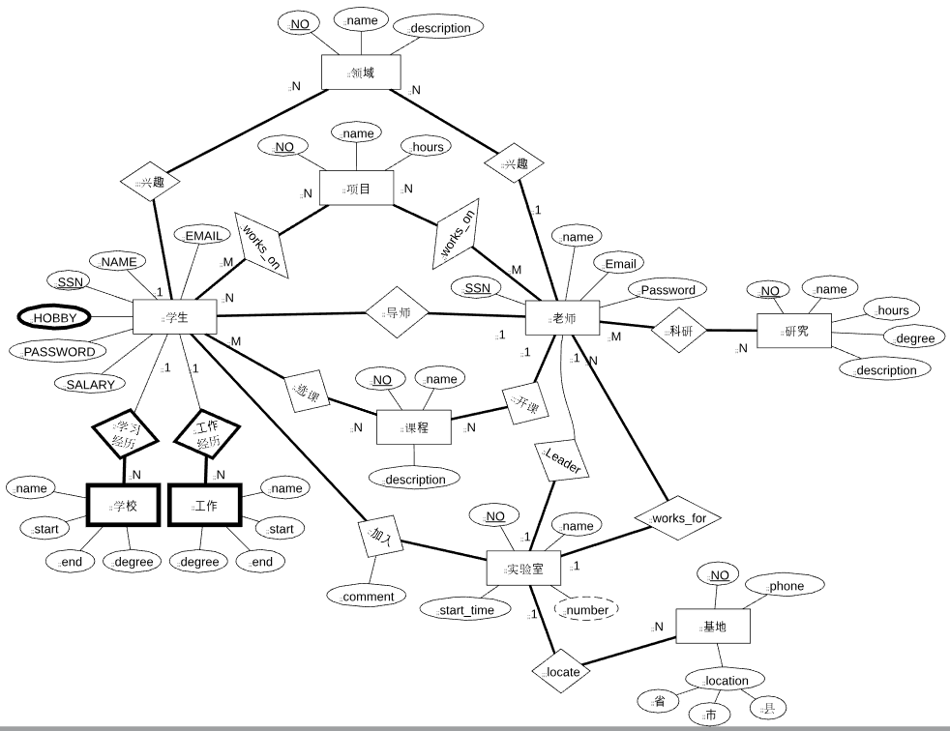
- 设计的数据库表结构：
  - 课程表cource
CREATE TABLE `course` (
`NO` int(11) NOT NULL,
`NAME` varchar(255) COLLATE utf8_bin NOT NULL,
`DESCRIPTION` varchar(255) COLLATE utf8_bin DEFAULT NULL,
`SSN` int(11) NOT NULL,
PRIMARY KEY (`NO`),
KEY `SSN` (`SSN`),
CONSTRAINT `course_ibfk_1` FOREIGN KEY (`SSN`) REFERENCES `teacher` (`SSN`) ON DELETE NO ACTION ON UPDATE CASCADE
) ENGINE=InnoDB DEFAULT CHARSET=utf8 COLLATE=utf8_bin;
  - 教育经历表education
CREATE TABLE `education` (
`SSN` int(11) NOT NULL,
`STARTDATE` varchar(30) COLLATE utf8_bin NOT NULL,
`ENDDATE` varchar(30) COLLATE utf8_bin NOT NULL,
`SCHOOLNAME` varchar(255) COLLATE utf8_bin NOT NULL,
`DEGREE` varchar(255) COLLATE utf8_bin NOT NULL,
PRIMARY KEY (`SSN`,`STARTDATE`,`ENDDATE`),
CONSTRAINT `education_ibfk_1` FOREIGN KEY (`SSN`) REFERENCES `student` (`SSN`) ON DELETE NO ACTION ON UPDATE CASCADE
) ENGINE=InnoDB DEFAULT CHARSET=utf8 COLLATE=utf8_bin;
  - 知识领域表field
CREATE TABLE `field` (
`NO` int(11) NOT NULL,
`NAME` varchar(255) COLLATE utf8_bin NOT NULL,
`DESCRIPTION` varchar(255) COLLATE utf8_bin DEFAULT NULL,
PRIMARY KEY (`NO`)
) ENGINE=InnoDB DEFAULT CHARSET=utf8 COLLATE=utf8_bin;
  - 兴趣表hobby
CREATE TABLE `hobby` (
`SSN` int(11) NOT NULL,
`CONTENT` varchar(255) COLLATE utf8_bin NOT NULL,
PRIMARY KEY (`SSN`,`CONTENT`),
CONSTRAINT `hobby_ibfk_1` FOREIGN KEY (`SSN`) REFERENCES `student` (`SSN`) ON DELETE NO ACTION ON UPDATE CASCADE
) ENGINE=InnoDB DEFAULT CHARSET=utf8 COLLATE=utf8_bin;

  - 学生选择实验室表
CREATE TABLE `impression` (
`LABORATORYNO` int(11) NOT NULL,
`CONTENT` text COLLATE utf8_bin NOT NULL,
`SSN` int(11) NOT NULL,
PRIMARY KEY (`LABORATORYNO`,`SSN`),
KEY `SSN` (`SSN`),
CONSTRAINT `impression_ibfk_1` FOREIGN KEY (`LABORATORYNO`) REFERENCES `laboratory` (`NO`) ON DELETE NO ACTION ON UPDATE CASCADE,
CONSTRAINT `impression_ibfk_2` FOREIGN KEY (`SSN`) REFERENCES `student` (`SSN`) ON DELETE NO ACTION ON UPDATE CASCADE
) ENGINE=InnoDB DEFAULT CHARSET=utf8 COLLATE=utf8_bin;
  - 工作经历表job
CREATE TABLE `job` (
`SSN` int(11) NOT NULL,
`DEPARTMENT` varchar(255) COLLATE utf8_bin NOT NULL,
`APPOINTMENT` varchar(255) COLLATE utf8_bin NOT NULL,
`STARTDATE` varchar(30) COLLATE utf8_bin NOT NULL,
`ENDDATE` varchar(30) COLLATE utf8_bin NOT NULL,
PRIMARY KEY (`SSN`,`STARTDATE`,`ENDDATE`),
CONSTRAINT `job_ibfk_1` FOREIGN KEY (`SSN`) REFERENCES `student` (`SSN`) ON DELETE NO ACTION ON UPDATE CASCADE
) ENGINE=InnoDB DEFAULT CHARSET=utf8 COLLATE=utf8_bin;
  - 实验室表laboratory
CREATE TABLE `laboratory` (
`NO` int(11) NOT NULL,
`NAME` varchar(255) COLLATE utf8_bin NOT NULL,
`STARTDATE` datetime NOT NULL,
`NUMBER` int(11) NOT NULL DEFAULT '0',
`SUPERVISORSSN` int(11) NOT NULL,
PRIMARY KEY (`NO`)
) ENGINE=InnoDB DEFAULT CHARSET=utf8 COLLATE=utf8_bin;
  - 实验室信息表location
CREATE TABLE `location` (
`NO` int(11) NOT NULL,
`LABNO` int(11) NOT NULL,
`PHONE` varchar(255) COLLATE utf8_bin DEFAULT NULL,
`LOCATION_P` varchar(255) COLLATE utf8_bin DEFAULT NULL,
`LOCATION_C` varchar(255) COLLATE utf8_bin DEFAULT NULL,
`LOCATION_A` varchar(255) COLLATE utf8_bin DEFAULT NULL,
PRIMARY KEY (`NO`),
KEY `LABNO` (`LABNO`),
CONSTRAINT `location_ibfk_1` FOREIGN KEY (`LABNO`) REFERENCES `laboratory` (`NO`) ON DELETE NO ACTION ON UPDATE CASCADE
) ENGINE=InnoDB DEFAULT CHARSET=utf8 COLLATE=utf8_bin;
  - 感兴趣的领域表love
CREATE TABLE `love` (
`SSN` int(11) NOT NULL,
`FIELDNO` int(11) NOT NULL,
PRIMARY KEY (`SSN`,`FIELDNO`),
KEY `love_ibfk_1` (`FIELDNO`),
CONSTRAINT `love_ibfk_1` FOREIGN KEY (`FIELDNO`) REFERENCES `field` (`NO`) ON DELETE NO ACTION ON UPDATE CASCADE
) ENGINE=InnoDB DEFAULT CHARSET=utf8 COLLATE=utf8_bin;
  - 项目表project
CREATE TABLE `project` (
`NO` int(11) NOT NULL,
`NAME` varchar(255) COLLATE utf8_bin NOT NULL,
`HOURS` varchar(255) COLLATE utf8_bin NOT NULL DEFAULT '0',
PRIMARY KEY (`NO`)
) ENGINE=InnoDB DEFAULT CHARSET=utf8 COLLATE=utf8_bin;
  - 研究课题表research
CREATE TABLE `research` (
`NAME` varchar(255) COLLATE utf8_bin NOT NULL,
`NO` int(11) unsigned zerofill NOT NULL AUTO_INCREMENT,
`HOURS` varchar(255) COLLATE utf8_bin DEFAULT NULL,
`DEGREE` varchar(255) COLLATE utf8_bin DEFAULT NULL,
`DESCRIPTION` varchar(255) COLLATE utf8_bin DEFAULT NULL,
`SSN` int(11) NOT NULL,
PRIMARY KEY (`NO`),
KEY `SSN` (`SSN`),
CONSTRAINT `research_ibfk_1` FOREIGN KEY (`SSN`) REFERENCES `teacher` (`SSN`) ON DELETE NO ACTION ON UPDATE CASCADE
) ENGINE=InnoDB AUTO_INCREMENT=100113 DEFAULT CHARSET=utf8 COLLATE=utf8_bin;
  - 学生表student
CREATE TABLE `student` (
`SSN` int(11) NOT NULL,
`NAME` varchar(255) COLLATE utf8_bin DEFAULT NULL,
`SALARY` decimal(10,0) DEFAULT '0',
`EMAIL` varchar(255) COLLATE utf8_bin NOT NULL,
`TUTORSSN` int(11),
`LABORATORYNO` int(11) DEFAULT NULL,
`PASSWORD` varchar(255) COLLATE utf8_bin NOT NULL,
PRIMARY KEY (`SSN`),
KEY `TUTORSSN` (`TUTORSSN`),
KEY `TUTORSSN_2` (`TUTORSSN`),
KEY `TUTORSSN_3` (`TUTORSSN`),
KEY `TUTORSSN_4` (`TUTORSSN`)
) ENGINE=InnoDB DEFAULT CHARSET=utf8 COLLATE=utf8_bin;
  - 选课表study
CREATE TABLE `study` (
`SSN` int(11) NOT NULL,
`COURSENO` int(11) NOT NULL,
PRIMARY KEY (`SSN`,`COURSENO`),
KEY `COURSENO` (`COURSENO`),
CONSTRAINT `study_ibfk_1` FOREIGN KEY (`COURSENO`) REFERENCES `course` (`NO`) ON DELETE NO ACTION ON UPDATE CASCADE,
CONSTRAINT `study_ibfk_2` FOREIGN KEY (`SSN`) REFERENCES `student` (`SSN`) ON DELETE NO ACTION ON UPDATE CASCADE
) ENGINE=InnoDB DEFAULT CHARSET=utf8 COLLATE=utf8_bin;
  - 教师表teacher
CREATE TABLE `teacher` (
`SSN` int(11) NOT NULL,
`NAME` varchar(255) COLLATE utf8_bin NOT NULL,
`EMAIL` varchar(255) COLLATE utf8_bin NOT NULL,
`LABORATORYNO` int(11) NOT NULL,
`PASSWORD` varchar(255) COLLATE utf8_bin NOT NULL,
PRIMARY KEY (`SSN`),
KEY `LABORATORYNO` (`LABORATORYNO`),
KEY `LABORATORYNO_2` (`LABORATORYNO`),
KEY `LABORATORYNO_3` (`LABORATORYNO`),
KEY `LABORATORYNO_4` (`LABORATORYNO`)
) ENGINE=InnoDB DEFAULT CHARSET=utf8 COLLATE=utf8_bin;
  - 教师参与科研表works_for
CREATE TABLE `works_for` (
`SSN` int(11) NOT NULL,
`RESEARCHNO` int(11) NOT NULL,
PRIMARY KEY (`SSN`,`RESEARCHNO`),
KEY `RESEARCHNO` (`RESEARCHNO`),
KEY `RESEARCHNO_2` (`RESEARCHNO`),
KEY `RESEARCHNO_3` (`RESEARCHNO`),
KEY `RESEARCHNO_4` (`RESEARCHNO`),
CONSTRAINT `works_for_ibfk_1` FOREIGN KEY (`SSN`) REFERENCES `teacher` (`SSN`) ON DELETE NO ACTION ON UPDATE CASCADE
) ENGINE=InnoDB DEFAULT CHARSET=utf8 COLLATE=utf8_bin;
  - 项目参与人员表works_on
CREATE TABLE `works_on` (
`SSN` int(11) NOT NULL,
`PROJECTNO` int(11) NOT NULL,
PRIMARY KEY (`SSN`,`PROJECTNO`),
KEY `PROJECTNO` (`PROJECTNO`),
CONSTRAINT `works_on_ibfk_1` FOREIGN KEY (`PROJECTNO`) REFERENCES `project` (`NO`) ON DELETE NO ACTION ON UPDATE CASCADE
) ENGINE=InnoDB DEFAULT CHARSET=utf8 COLLATE=utf8_bin;
- 操作界面和操作结果
  - 系统登录界面
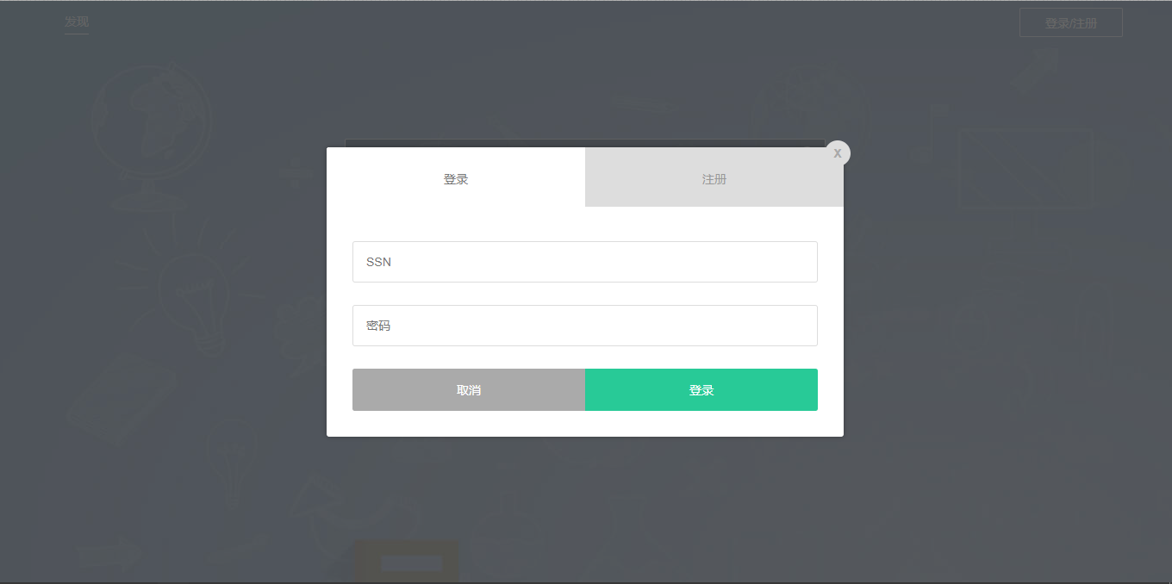
  - 学生个人主页面
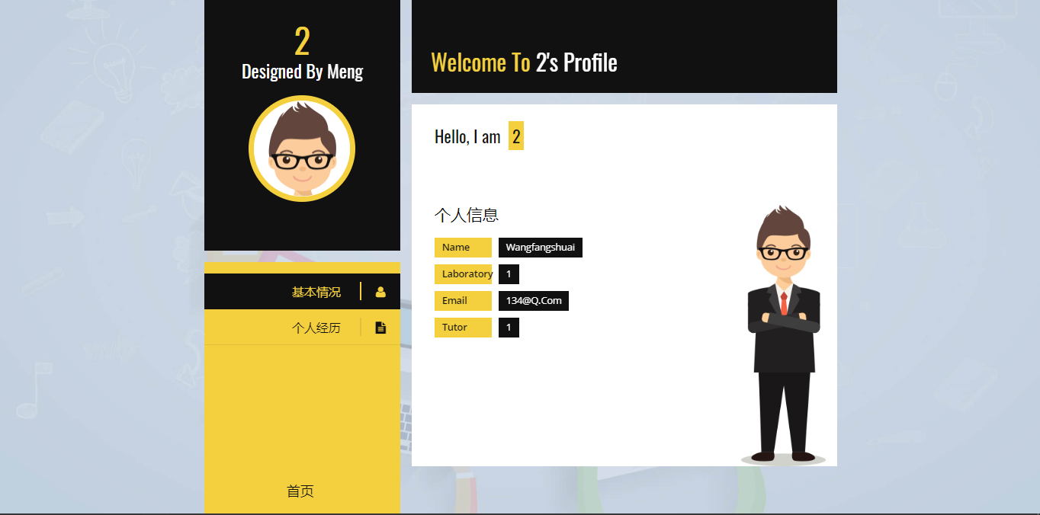
  - 数据库插入——添加个人教育经历
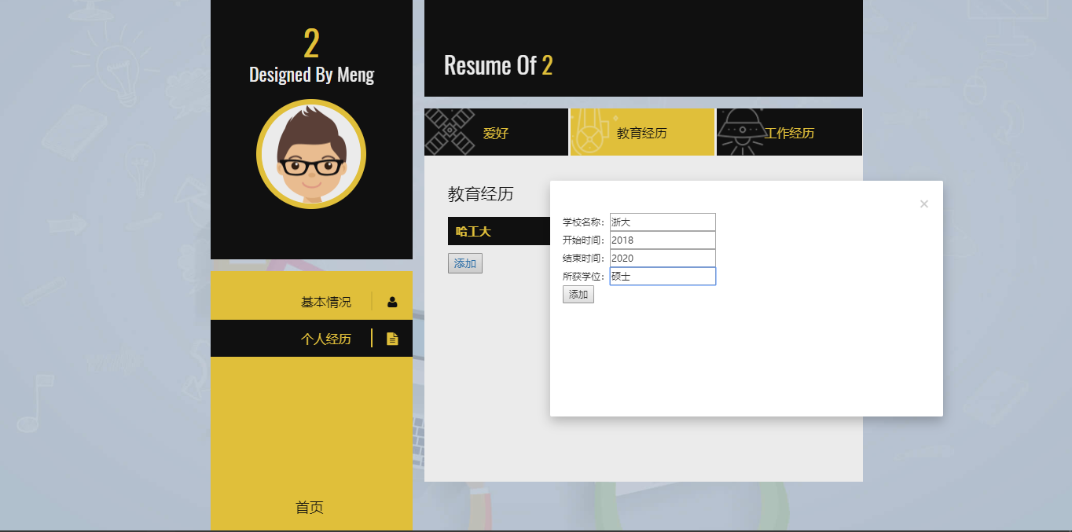
  - 单表查看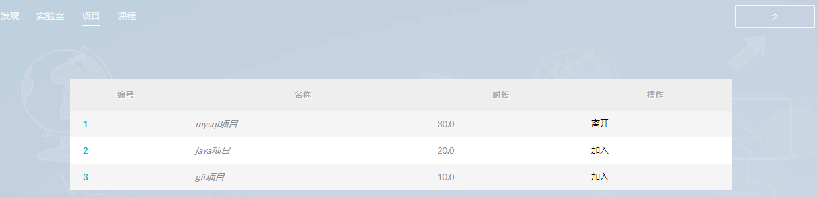
  - 多表查询——查询某兴趣爱好的全部同学（hobby_query 跑步）
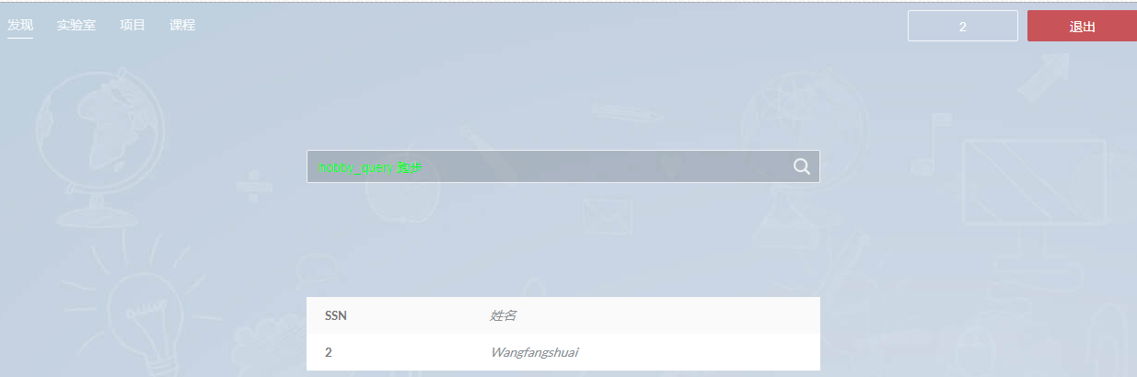
  - 多表查询——查询某导师的全部学生（student_query1 1）
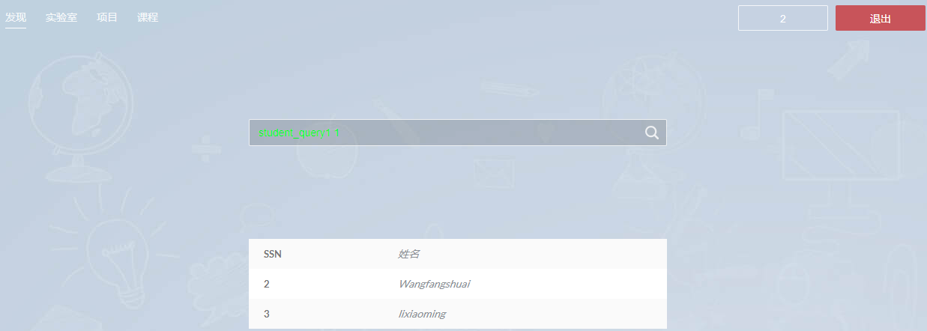
  - 连接查询——查询某项目全部学生(all 1)
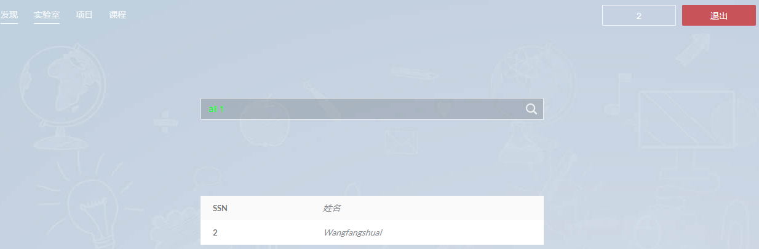
  - 嵌套查询——查询不在某项目的全部学生(notin 1)
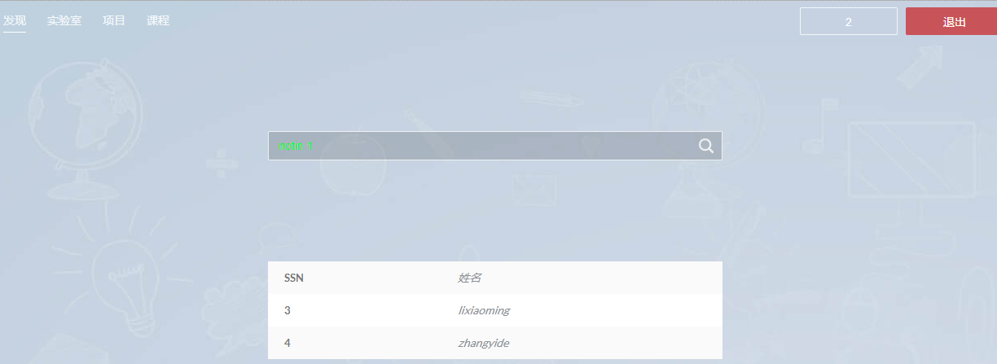
  - 分组查询——查询导师所有学生平均工资低于某值的导师(team 600)
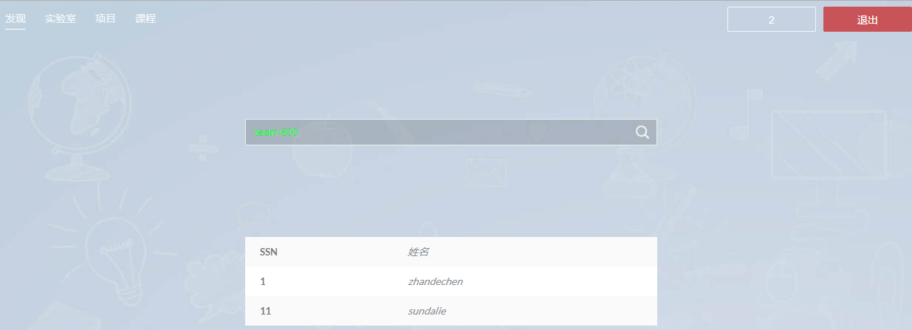
四、程序代码
- 前端查询核心代码
$(function() {
$("#searchbtn").click(function() {
var params = $("#content").val();
if (params == '') {
alert("请输入查询内容！");
return false;
}
$.ajax({
url : "search",
dataType : "json",
data : {
name : $("#content").val()
},
success : function(data) {
$("#show").empty();
$("#show").append("<tr><td>SSN</td><td>姓名</td></tr>");
$.each(data, function(key, value) {
$("#show").append("<tr>");
$("#show tr:last").append("<td>" + key + "</td>");
$("#show tr:last").append("<td>" + value + "</td>");
$("#show").append("</tr>");
});
},
error:function() {
alert("查询失败！");
}
});
});
});
- 后端数据库连接代码
package db;
import java.sql.Connection;
import java.sql.DriverManager;
import java.sql.PreparedStatement;
import java.sql.SQLException;
public class DBHelper {
public static final String url = "jdbc:mysql://localhost:3306/laboratoryManager?characterEncoding=utf8&useSSL=false";
public static final String name = "com.mysql.jdbc.Driver";
public static final String user = "root";
public static final String password = "hbh828hbh";
public Connection conn = null;
public PreparedStatement pst = null;
public DBHelper(String sql) {
try {
Class.forName(name);//指定连接类型
conn = DriverManager.getConnection(url, user, password);//获取连接
pst = conn.prepareStatement(sql);//准备执行语句
} catch (Exception e) {
e.printStackTrace();
}
}
public void close() {
try {
this.conn.close();
this.pst.close();
} catch (SQLException e) {
e.printStackTrace();
}
}
}
- 后端查询SQL执行代码
import java.io.IOException;
import java.io.PrintWriter;
import java.sql.ResultSet;
import java.sql.SQLException;
import java.util.HashMap;
import java.util.Map;
import javax.servlet.http.HttpServletResponse;
import org.apache.struts2.ServletActionContext;
import com.google.gson.Gson;
import com.opensymphony.xwork2.ActionSupport;
import db.DBHelper;
public class search extends ActionSupport {
private static final long serialVersionUID = 1L;
private Map<String, Object> dataMap;
private String name;
static String sql = new String();
static DBHelper db = null;
static ResultSet ret = null;
static int retu = 0;
public String getName() {
return name;
}
public void setName(String name) {
this.name = name;
}
public search(){
dataMap = new HashMap<String, Object>();
}
public void dosearch() throws IOException, SQLException {
HttpServletResponse response = ServletActionContext.getResponse();
response.setContentType("text/html");
PrintWriter out;
out = response.getWriter();
name = name.replaceAll("\\s+", " ");
String EachCMD[] = new String[2];
int index = 0;
int head = 0;
for(int i =0;i<name.length();i++){
if(name.charAt(i) == ' ' && index < 1){
EachCMD[index] = name.substring(head,i);
head = i+1;
index++;
}else if(index == 1){
EachCMD[index] = name.substring(head,name.length());
}
}
String params[] = EachCMD[1].split("\\,");
if ("hobby_query".equals(EachCMD[0])) {
searchStudentHobby(params[0]);
} else if ("student_query1".equals(EachCMD[0])) {
searchTutorStudent(Integer.parseInt(params[0]));
} else if ("student_query2".equals(EachCMD[0])) {
searchProjectStudent(params[0]);
} else if ("all".equals(EachCMD[0])) {
searchALLProjectStudent(params[0]);
} else if ("notin".equals(EachCMD[0])) {
searchNOTProjectStudent(Integer.parseInt(params[0]));
} else if ("team".equals(EachCMD[0])) {
TeamSearch(Integer.parseInt(params[0]));
} else {
}
Gson gson = new Gson();
String data = gson.toJson(dataMap);
out.println(data);
out.flush();
out.close();
}
public Map<String, Object> getDataMap() {
return dataMap;
}
- 查询某兴趣爱好的全部同学（hobby_query [hobby]）
public void searchStudentHobby(String hobby){
sql = "select STUDENT.SSN,NAME from HOBBY,STUDENT where content like \'"+hobby+"\' and HOBBY.SSN = STUDENT.SSN";//SQL语句
db = new DBHelper(sql);//创建DBHelper对象
try {
ret = db.pst.executeQuery();//执行语句，得到结果集
while (ret.next()){
dataMap.put(String.valueOf(ret.getInt(1)),ret.getString(2));
}//显示数据
ret.close();
db.close();//关闭连接
} catch (SQLException e) {
e.printStackTrace();
}
}
- 查询某导师的全部学生（student_query1 [TeacherSSN]）
public void searchTutorStudent(int ssn){
sql = "select SSN,NAME from STUDENT WHERE TUTORSSN ="+ssn;//SQL语句
db = new DBHelper(sql);//创建DBHelper对象
try {
ret = db.pst.executeQuery();//执行语句，得到结果集
while (ret.next()){
dataMap.put(String.valueOf(ret.getInt(1)),ret.getString(2));
}//显示数据
ret.close();
db.close();//关闭连接
} catch (SQLException e) {
e.printStackTrace();
}
}
- 查询某项目全部学生(all [pronum])
public void searchALLProjectStudent(String pronum){
sql = " select SSN,NAME from STUDENT NATURAL join works_on where PROJECTNO="+pronum;//SQL语句
db = new DBHelper(sql);//创建DBHelper对象
try {
ret = db.pst.executeQuery();//执行语句，得到结果集
while (ret.next()){
dataMap.put(String.valueOf(ret.getInt(1)),ret.getString(2));
}//显示数据
ret.close();
db.close();//关闭连接
} catch (SQLException e){
e.printStackTrace();
}
}
- 查询不在某项目的全部学生(notin [num])
public void searchNOTProjectStudent(int num){
sql = " SELECT SSN,NAME from STUDENT where SSN not in ( select STUDENT.SSN from STUDENT, works_on where STUDENT.SSN=works_on.SSN and works_on.PROJECTNO="+num+")";//SQL语句
db = new DBHelper(sql);//创建DBHelper对象
try {
ret = db.pst.executeQuery();//执行语句，得到结果集
while (ret.next()){
dataMap.put(String.valueOf(ret.getInt(1)),ret.getString(2));
}//显示数据
ret.close();
db.close();//关闭连接
} catch (SQLException e){
e.printStackTrace();
}
}
- 查询导师所有学生平均工资低于某值的导师(team [SSN])
//分组查询
public void TeamSearch(int ssn){
sql = "select TEACHER.SSN,TEACHER.NAME from STUDENT,TEACHER where STUDENT.TUTORSSN =TEACHER.SSN group by TEACHER.SSN having avg(STUDENT.SALARY) <"+ssn;//SQL语句句
db = new DBHelper(sql);//创建DBHelper对象
try {
ret = db.pst.executeQuery();//执行语句，得到结果集
while (ret.next()){
dataMap.put(String.valueOf(ret.getInt(1)),ret.getString(2));
}//显示数据
ret.close();
db.close();//关闭连接
} catch (SQLException e){
e.printStackTrace();
}
}

