1.Explain the difference between spatial domain and frequency domain techniques in digital image processing. Provide examples of when you would use each technique.

解释在数字图像处理中的空间域技术与频域技术的区别，并提供在何种情况下使用每种技术的示例

Answer:

1. Spatial Domain Techniques

- Definition: In spatial domain techniques, image processing is applied directly to the pixel values of the image. These techniques manipulate the intensity values at each pixel or over a group of neighboring pixels.

- Examples :

- Smoothing/Blurring: A simple averaging filter can be applied to reduce noise by averaging pixel intensities in a local neighborhood.

- Edge Detection: Techniques like the Sobel operator apply a convolutional kernel over the pixel grid to detect edges based on intensity gradients.

- When to use Spatial Domain Techniques:

- Noise reduction using spatial filters like Gaussian or mean filters.

- Image enhancement for contrast adjustment through histogram equalization.

- Real-time applications where speed is critical because spatial techniques are typically faster.

2. Frequency Domain Techniques

- Definition: Frequency domain techniques operate on the image's frequency information rather than directly on pixel values. The image is transformed into a different representation (e.g., using Fourier Transform), where changes are made to its frequency components.

- Examples:

- Low-pass filtering: Useful for blurring the image or removing noise by filtering out high-frequency components.

- High-pass filtering: Helps in enhancing edges by preserving or enhancing high-frequency components and removing low-frequency content.

- Compression: JPEG image compression is based on frequency domain transformations like Discrete Cosine Transform (DCT).

- When to use Frequency Domain Techniques:

- When you need to remove specific frequencies, such as in periodic noise removal or sharpening using high-frequency emphasis.

- Image compression: For example, the JPEG format utilizes the frequency domain to reduce image file size.

- Advanced filtering that requires working with frequency components like in denoising or motion blur correction.

Key Differences

- Spatial domain directly works on pixel values, while frequency domain transforms the image into a different representation and processes frequency information.

- Spatial techniques are simpler and faster, whereas frequency domain methods allow for more global operations (like focusing on high or low frequencies) but are computationally more complex.

答案：

1. 空间域技术

- 定义：空间域技术是直接在图像的像素值上进行操作。这些技术通过改变每个像素或一组邻近像素的强度值来处理图像。

- 例子：

- 平滑/模糊处理：简单的均值滤波可以通过局部邻域中像素强度的平均值来减少噪声。

- 边缘检测：使用Sobel算子通过卷积核检测基于强度梯度的边缘。

- 何时使用空间域技术：

- 噪声减少：使用如高斯滤波或均值滤波器等空间滤波器来减少图像中的噪声。

- 图像增强：通过直方图均衡来调整图像的对比度。

- 实时应用：例如在对速度要求较高的场景下，空间技术通常速度较快。

2. 频域技术

- 定义：频域技术对图像的频率信息进行操作，而不是直接在像素值上工作。通过如傅里叶变换，将图像转换为不同的表示形式，然后对频率分量进行处理。

- 例子：

- 低通滤波：用于模糊图像或通过滤除高频成分来去除噪声。

- 高通滤波：通过增强高频成分并移除低频内容来增强图像边缘。

- 图像压缩：如JPEG压缩基于离散余弦变换（DCT）的频域变换。

- 何时使用频域技术：

- 需要移除特定频率时：例如在去除周期性噪声或通过强调高频分量进行图像锐化时。

- 图像压缩：如JPEG格式利用频域来减少图像文件大小。

- 高级滤波：例如去噪或运动模糊校正，需要在频率成分上进行操作时。

关键区别

- 空间域直接处理像素值，而频域将图像转换为不同的表示形式并处理其频率信息。

- 空间技术更简单且速度更快，而频域方法允许更全局的操作（如集中于高频或低频），但计算复杂性更高。

2.Apply a histogram equalization technique to enhance the contrast of a given grayscale image. Submit the code and the before-and-after images.

代码见work2.py

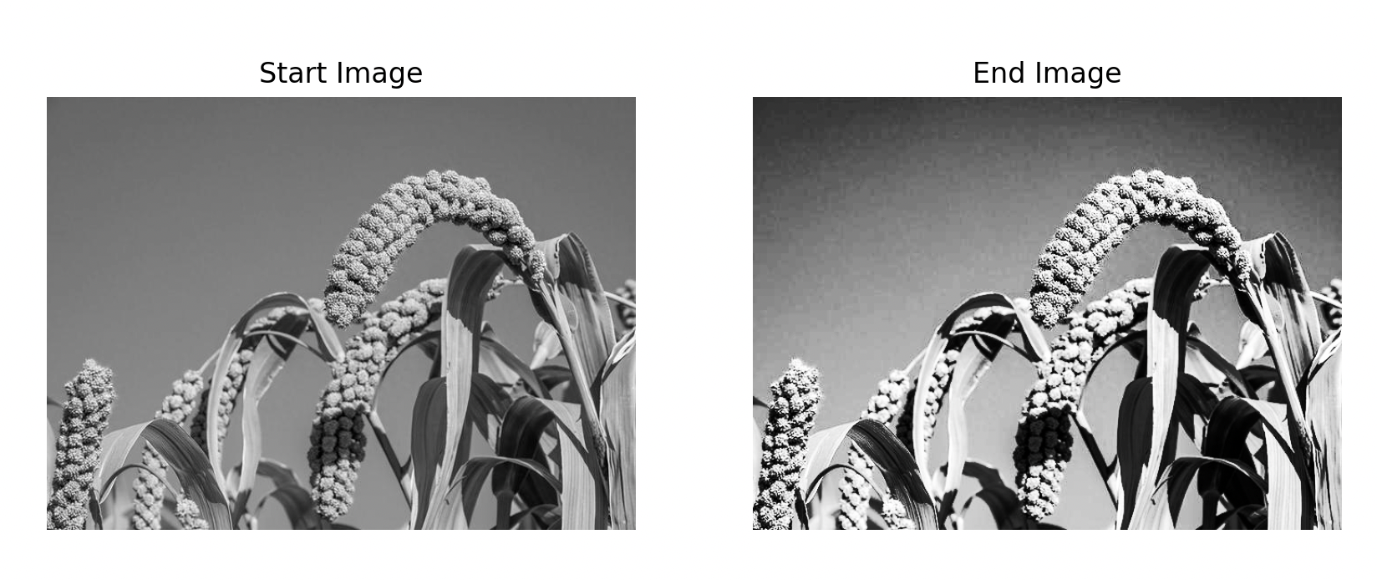

3.Describe the process of image segmentation using the Canny edge detection method. What are the key parameters, and how do they affect the result?

描述使用Canny边缘检测方法进行图像分割的过程。关键参数是什么，它们如何影响结果？

Image Segmentation Using the Canny Edge Detection Method

The Canny Edge Detection Process

The process of Canny edge detection consists of five key steps:

1. Noise Reduction (Gaussian Blurring):

- Images typically contain noise, which can result in false edges. To mitigate this, the first step is to apply a Gaussian filter to smooth the image. The Gaussian filter reduces noise by averaging pixel values over a neighborhood.

- Effect: The more the image is smoothed, the less sensitive the edge detection will be to small variations or noise.

2. Gradient Calculation:

- After smoothing, the algorithm calculates the gradient of the image intensity using a derivative operator like Sobel filters. This results in two gradient images (one for horizontal changes and one for vertical changes).

- The gradient magnitude and direction are computed to determine how quickly the intensity is changing and in which direction.

3. Non-Maximum Suppression:

- To identify the most significant edges, non-maximum suppression is applied. This step keeps only the local maxima of the gradient magnitudes in the direction of the gradient, removing pixels that are not considered to be part of edges.

- Effect: This step thins out the edges, making them sharper and more well-defined.

4. Double Thresholding:

- The gradient values are compared to two thresholds (a lower threshold and a higher threshold). Pixels with gradient magnitudes above the high threshold are considered strong edges, while those below the low threshold are discarded. Pixels between the thresholds are considered weak edges and are only kept if they are connected to strong edges.

- Effect: This step allows the algorithm to differentiate between strong, prominent edges and weak edges, reducing noise and small artifacts.

5. Edge Tracking by Hysteresis:

- In this final step, weak edges are preserved only if they are connected to strong edges. This helps eliminate isolated noise while preserving important edge structures.

- Effect: This step ensures that the edges are continuous and prevents small breaks in the detected edges.

Key Parameters of Canny Edge Detection

The Canny edge detection method involves tuning several important parameters that greatly affect the final output:

1. Gaussian Filter Kernel Size (`ksize`):

- This defines the size of the Gaussian kernel used for smoothing. A larger kernel size results in more blurring, which helps suppress noise but may also remove fine edges.

- Effect: Increasing the kernel size reduces sensitivity to noise but may cause important edges to blur and disappear.

2. Lower Threshold (`lowThreshold`):

- This value is the lower bound for edge detection. Gradient values below this threshold are considered non-edges.

- Effect: Lowering this threshold increases sensitivity to weak edges, but it may also introduce more noise into the result.

3. Higher Threshold (`highThreshold`):

- This value is the upper bound for strong edge detection. Pixels with gradient values above this threshold are considered strong edges.

- Effect: A high value makes the algorithm more selective, preserving only strong edges. A low value makes it more permissive, detecting more edges but possibly introducing noise.

4. Gradient Calculation (Sobel Operator):

- The choice of operator to calculate the gradient can affect the sensitivity to edges in different directions.

Here's an example of using the Canny edge detection method in Python with OpenCV:

Parameters in the Example:

- Gaussian Blur (5, 5): Applies smoothing with a kernel size of 5x5 and a sigma of 1.4.

- Canny thresholds (100, 200): The lower threshold is set to 100 and the higher threshold to 200. Pixels with a gradient above 200 are considered strong edges, and those between 100 and 200 are considered weak edges if connected to strong ones.

When to Use Canny Edge Detection for Segmentation

- Object Boundaries: When you need to segment objects that have well-defined edges.

- Preprocessing Step: Often used before applying more complex segmentation methods like watershed or region-growing algorithms.

- Low-light or noisy environments: In these cases, Canny can help distinguish between noise and actual object boundaries through double thresholding.

中文解释

Canny 边缘检测的流程

1.噪声消除（高斯模糊）：

- 首先通过高斯滤波平滑图像，以减少噪声。高斯滤波会对像素值进行邻域平均，以减少随机噪声的影响。

2.梯度计算：

- 计算图像强度的梯度，通常使用Sobel算子。结果是水平和垂直方向的梯度图。

3.非极大值抑制：

- 只保留局部区域的最大梯度值，去除不显著的边缘信息，使边缘更细致。

4.双阈值处理：

- 通过设置两个阈值（低阈值和高阈值）区分强边缘、弱边缘和非边缘区域。

5.边缘跟踪：

- 保留与强边缘相连的弱边缘，去除孤立的弱边缘。

关键参数

1. 高斯模糊核大小：影响图像的平滑程度。

2. 低阈值：决定弱边缘的敏感度。

3. 高阈值：决定强边缘的选择性。

4.Compare and contrast traditional image processing techniques (such as filtering and morphological operations) with deep learning-based approaches (such as CNNs). In which scenarios is one approach preferred over the other?

将传统的图像处理技术（如滤波和形态学操作）与基于深度学习的方法（如cnn）进行比较和对比。在哪些情况下，一种方法优于另一种方法？

传统图像处理技术

特点：

1、手工设计特征：传统图像处理技术依赖于人为设计的特征提取算法，如边缘检测、纹理分析等。

2、算法固定：一旦特征被设计出来，它们通常是固定的，不需要训练。

3、计算效率较高：由于不需要大量的计算资源来进行训练，传统方法往往具有较高的计算效率。

4、可解释性强：由于特征是由人类专家设计的，因此通常更容易理解和解释。

优点：

1、在特定任务上表现良好：对于一些特定的任务，如简单的边缘检测或阈值分割，传统方法可以提供很好的结果。

2、计算成本较低：相比于深度学习模型，传统方法通常计算量较小，可以在资源受限的环境下运行。

缺点：

1、泛化能力差：当应用场景发生变化时，手工设计的特征可能不再有效。

2、设计复杂：需要专业知识来设计合适的特征，这可能是一项耗时的工作。

基于深度学习的方法（如CNNs）

特点：

1、自动特征学习：深度学习模型可以从原始数据中自动学习特征表示，无需人工设计。

2、端到端训练：整个模型可以作为一个整体进行优化，使得模型可以更好地适应特定的任务。

3、强大的泛化能力：通过大量数据训练，深度学习模型能够在广泛的场景中表现出色。

优点：

1、表现优异：在许多复杂的图像识别和分类任务中，深度学习模型（特别是CNNs）的表现远远超过了传统的图像处理技术。

2、自动化程度高：减少了人为设计特征的需要，使得模型开发过程更加自动化。

3、可扩展性强：通过增加网络层数或宽度，可以很容易地调整模型的复杂度以适应不同的任务需求。

缺点：

1、数据依赖性强：需要大量的标记数据来进行有效的训练。

2、计算成本高：训练过程可能需要大量的计算资源，尤其是在大规模数据集上。

3、可解释性差：深度学习模型通常是“黑盒”模型，其内部工作机制难以解释。

应用场景：

1、传统图像处理技术适用场景

简单任务：如基本的图像分割、边缘检测等。

实时处理：在需要快速响应的应用中，传统方法因其计算效率而受到青睐。

资源受限环境：在计算资源有限的情况下，传统方法因其较低的计算需求而更有优势。

2、基于深度学习的方法适用场景

复杂任务：如目标检测、图像分割、人脸识别等需要高度抽象特征的任务。

大数据集：拥有大量标记数据时，深度学习模型可以从中学习到有用的模式。

研究和前沿应用：在探索新的应用领域或实现最先进的性能时，深度学习提供了强大的工具。