

***Capstone Project Proposal On***

***Automatic Number Plate Recognition System for Vehicle Identification***

***Dept. of CSE***

***Submitted by:***

|  |  |  |
| --- | --- | --- |
| NAME | ID | INTAKE |
| Nafiz Ar Rafi | 17182103359 | 38 |
| Shohana Iasmin | 17182103322 | 38 |
| Maruf Ahmed | 15163103049 | 33 |
| Ashik-E-Rabbi- Md Toha | 17182103143 | 38 |

***Submitted to:***

|  |
| --- |
| M. M. Fazle Rabbi  Assistant professor.  Department of Computer Science and Engineering (CSE) |
| Bangladesh University of Business and Technology (BUBT) |
| Mirpur-2, Dhaka-1216, Bangladesh. |
| Supervised by : Sumi Khatun  Assistant professor, BUBT. |

**Motivation**

We propose an automatic license or number plate recognition (ANPR) system which can extract the license plate number of the vehicles through an image processing algorithms. No additional devices such as GPS or radio frequency identification (RFID) need to be installed for implementing the proposed system. Using database, the system takes pictures from each picture of vehicle and forwards the image to the computer for being processed by the LPR software. Plate recognition software uses different algorithms such as localization, orientation, normalization, segmentation and finally optical character recognition (OCR).

**Introduction**

Vehicle’s license or number plate recognition (ANPR) system has been an important area of research interest in image monitoring and processing systems. With the advent of high-tech cameras, number plate recognition system has numerous applications for traffic management applications, and especially in the parking lot. ANPR system has many applications such as border crossing control, identification of stolen vehicles, automated parking attendant, red light camera, petrol station surveillance, speed enforcement, security. For many of these applications, most of the basic processing algorithms remain the same. The LNPR system works in three steps, the first step is the detection and capturing a vehicle image, the second one is the detection and extraction of number plate in an image. The third step uses image segmentation technique to get the individual character and optical character recognition (OCR) to recognize the individual character with the help of database stored for each and every alphanumeric character.

The purpose of this paper is to develop and implement a smart system for optimum use of information and communication technology (ICT) for managing executive organizations as well as forming a database for facilitating decision-making and adopting better staff and strategic planning methods. License plate number is one of the most appropriate information items for identifying a vehicle and its owner in Iran. Vehicle traffic can be controlled through different techniques. If such traffic involves a variety of vehicle models, then installing special technical equipment for each model would not be economical and cannot provide the expected level of security. License plate identification is a useful and the only practical method used in individual countries to ensure security, prevent theft, and manage vehicle fleet.

**System Model**

ANPR system is proposed for monitoring and managing traffic in the parking lots of private and public organizations via identifying vehicle license plate numbers at the parking gate. This system can also be used to identify stolen vehicles on roads. No additional equipment need to be installed on vehicles for operating this system. Fig. 1 shows that the only requirement of this system is installing special cameras for identifying license numbers at the entrance and exit gates of the parking lots. The images taken by these cameras are subsequently processed in a computer. All vehicle traffic information (including the driver’s image) is stored in the system database for a long time. Thus, detailed traffic information can be retrieved from different parking gates at different times. Moreover, this system can apply intelligent control in the parking lots through automatic opening of the gate only to authorized vehicles upon recognizing their license numbers according to Fig. 1. Other advantages of the proposed system include online access to information such as the total number of vehicles currently present in the parking lot, the number of authorized vehicles, etc. Moreover, too much information of vehicles traffic statistics can be extracted from the system.

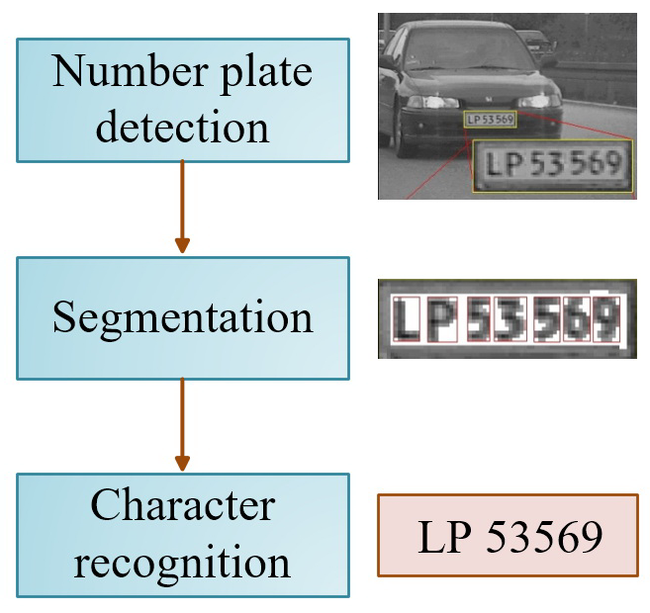

Fig: 1

In this section, we introduce LNPR software. a picture was taken by a camera shown in Fig. 2(a) is sent to LNPR software for image processing and number recognition. To maximize the flexibility of the LNPR system, a modular structure is chosen. In every module image processing algorithm(s) will be implemented. The software uses nine algorithms means nine modules for identifying a license and number plate follows:1- Plate localization: this algorithm is responsible for finding and isolating the plate on the picture. It is shown in Fig. 2(b)2- Plate orientation and sizing: this algorithm compensates for the skew of the plate and adjusts the dimensions to the required size that is illustrated in Fig. 2(c).3- Conversion: Using some conversion image processing techniques, the image can be converted as desired for instance to have a simpler processing of the image, we convert the image from red-green-blue (RGB) layers to gray scale layer demonstrated in Fig. 2(d)4- Normalization: this algorithm adjusts the contrast and brightness of the image that is illustrated in Fig. 2(e).5- Edge detection: it is applied to increase the picture difference between the letters and the plate backing. A median filter may also be used to reduce the visual noise on the image. As can be observed in Fig. 2(f), a useless image part similar to the left side of Fig. 2(e) has been omitted.6- Character segmentation: this algorithm finds the individual characters on the plate and segments them for extra enhancement and also additional lines are deleted as shown in Fig. 2(g).7- Optical character recognition: it is the electronic conversion of images or printed text into machine-encoded text demonstrated in Fig. 2(h). 8- Syntactical and geometrical analysis: it checks characters and positions against country-specific rules.9- The averaging of the recognized value over multiple fields/images to produce a more reliable or confident result. Especially since any single image may contain a reflected light flare, be partially obscured or another temporary effect.

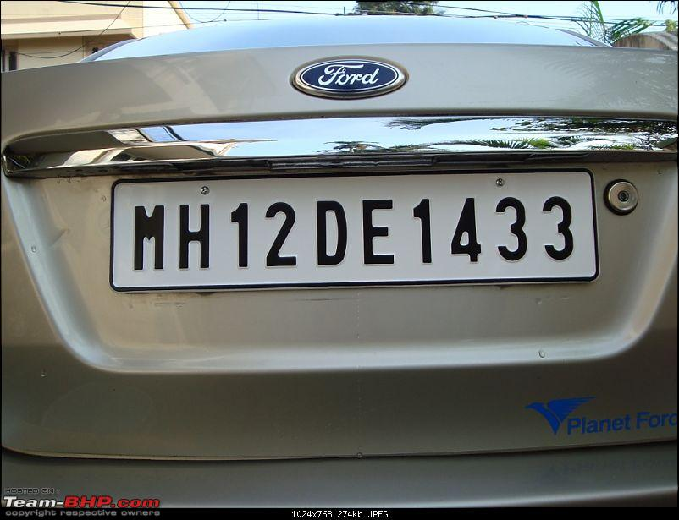

Fig: Taken by camera

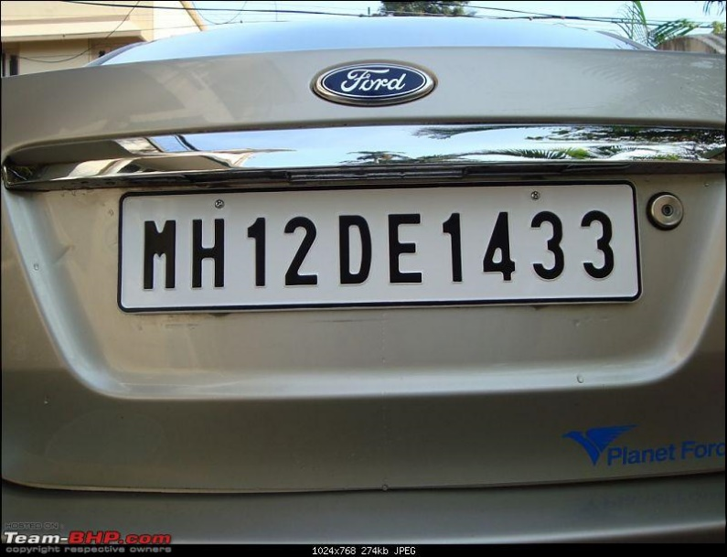

Fig: Plate Localization



Fig: plate orientation and sizing



Fig: RGB to gray conversion

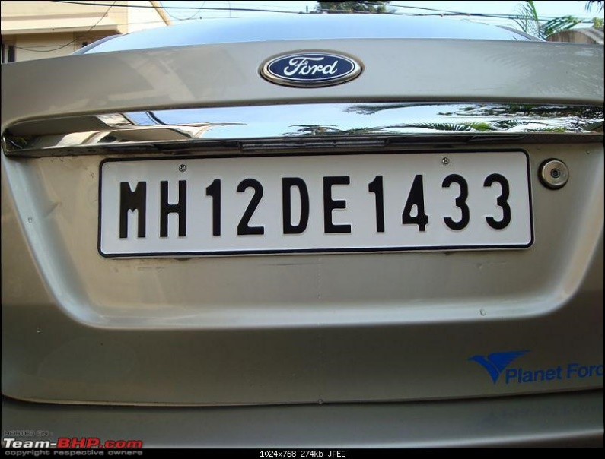

Fig: Plate character segmentation

M H 1 2 D E 1 4 3 3

Fig: Optical Character recognition

**Conclusion**

In summary, this project presented the automatic vehicle identification system using vehicle license and number plate recognition. The LNPR software of the system uses series of image processing algorithms for number plate recognition and finally identifying the vehicle from the database stored on the PC. This software has been written in. Net C# based on the studied and simulated algorithms in Mat Lab. The SQL database has been used to store different achieved records of vehicles. We have evaluated the system performance on real images. Both the simulation and practical results revealed that the LNPR system can robustly detect and recognize the vehicle using license plate in different lightening and weather conditions and can be implemented on the entrance of highly restricted areas. The prototype system can be integrated to the intersection surveillance video system for traffic surveying, stolen vehicles, or for some application specific purposes discussed in the paper.