the final noted in 7th feb 2026

the arm is working good and it can take own decisions when it wanted ; and I am happy with it and now I am going to update a bit to make the movements more faster and I am trying to remove the time limited , so lets see , and the main commends to run this arm is based in two files the main ros and the model is in the ros2-tutorial folder and the web and the controls are in thehead

T-1

ganache

T-2

(.venv) sweet@daniel:~/ros2_examples_ws$ ros2 launch

ur5_description display_robot.launch.py

or

cd ~/ros2_examples_ws
source install/setup.bash
ros2 launch ur5_description display_robot.launch.py

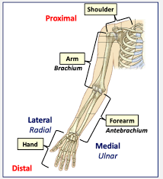
T-3

(.venv) sweet@daniel:~/myhead$ python override_gui.py

T-5

app.py inside the thehead

THE JOINTS _ 6

joint 1 : the base floor to rotate the full control it can do 360 its like the human shoulder bone ,

joint 2 : it have the secondary conrol of the whole body , its like the elbow point of the arm bottom and it sticking to the joint 1 , base, then its the first joint likely in human its the starting of the arm joint sticking to the sshoulder bone

joint 3: it have the next point joint 3 is sticking with the joint 2 and this joint is the elbow

joint 4: this is the wrist 1 its have the upper control s , and controlled by the below 1 ,2 ,3

joint 5: its the wrist 2 jointing with the wrist 1 control the upper movements
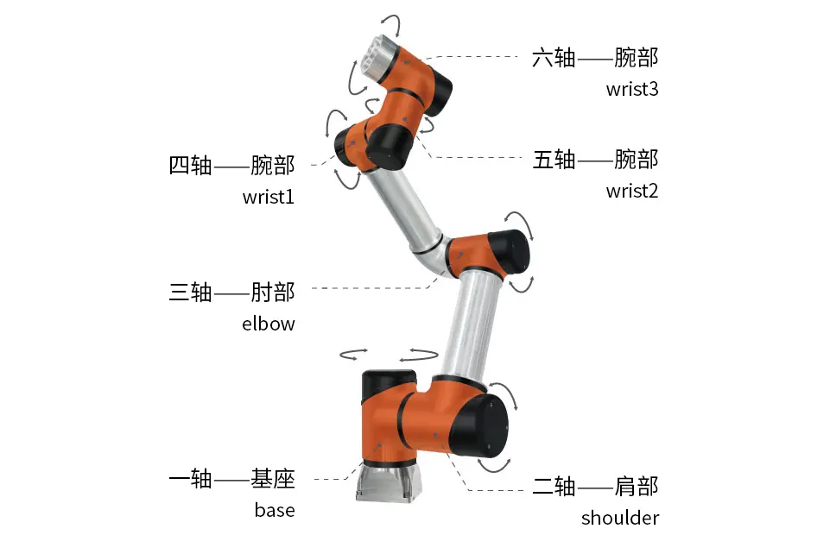
joint 6: the final its the wrist 3 , it may be hand or the suction cups . It only moves 360 circular motion

