CDS-Assignment

1.LINEAR SEARCH:

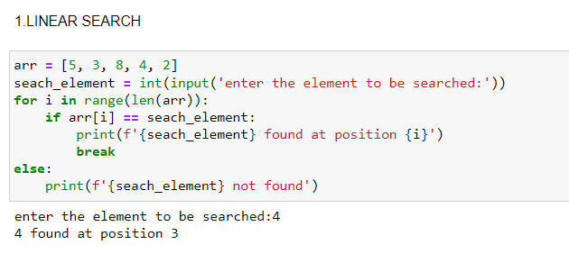

OUTPUT:

enter the element to be searched:4

4 found at position 3

ALGORITHM:

STEP 1: Start

STEP 2: Input an array of size n

STEP 3: Enter the element to be searched

STEP 4: set i to 1

STEP 5: if i > n then go to step 8

If search_element == I then go to step

Set i to i+1

Repeat step 5

STEP 6: print {search_element} found at position {i}

STEP 7: Go to step

STEP 8: Print {search_element} not found

STEP 9: STOP

**FLOW CHART:**

