**N-DIMENSIONS**

Taking n-dimensions as input and calculating the Euclidean distance.

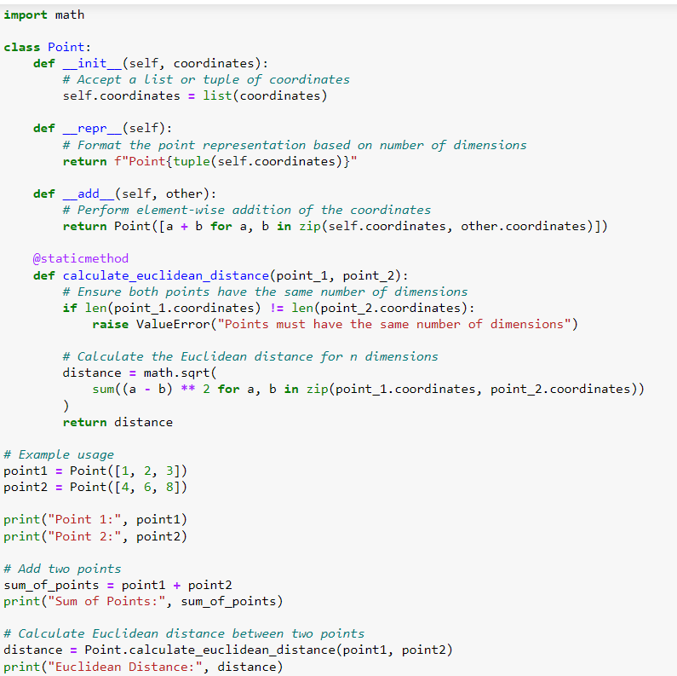

**OUTPUT:**

