**5. RECURSION**

A) GENERATING FIBONACCI SERIES.

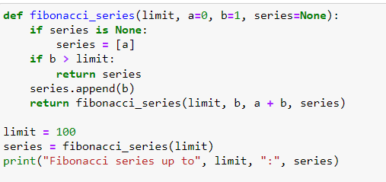

**OUTPUT:**



B) MULTIPLICATION OF NUMBERS WITH ADDITION OPERATOR.

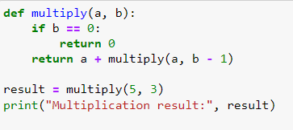

**OUTPUT:**

