2. STACK

A **stack** is a linear data structure that follows the **LIFO** (Last In, First Out) principle, meaning the last element added to the stack is the first to be removed.

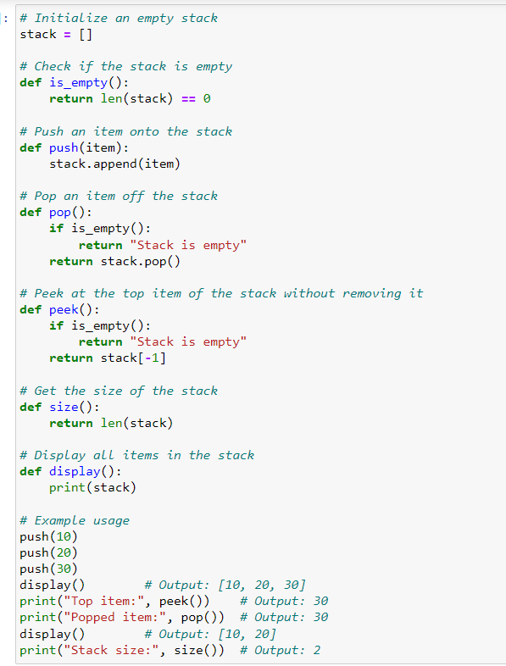

OUTPUT:

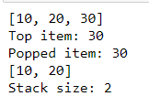

**Stack Operations**

1. **Push Operation**: Add an element to the top of the stack.
2. **Pop Operation**: Remove and return the top element from the stack.
3. **Peek Operation**: Return the top element without removing it.
4. **isEmpty Operation**: Check if the stack is empty.

**Stack Algorithm:**

**1. Push Operation:**

* **Input**: Stack S [], element x
* **Output**: Stack with x added at the top

**2. Pop Operation:**

* **Input**: Stack S []
* **Output**: The top element is removed and returned

**3. Peek Operation:**

* **Input**: Stack S []
* **Output**: Return the top element without removing it

return None

**4. isEmpty Operation:**

* **Input**: Stack S []
* **Output**: True if the stack is empty, else False function