Inner class in java

Inner class means one class which is a member of another class. There are basically four types of inner classes in java.

1) Nested Inner class  
2) Method Local inner classes  
3) Anonymous inner classes  
4) Static nested classes

**Nested Inner class** can access any private instance variable of outer class. Like any other instance variable, we can have access modifier private, protected, public and default modifier.  
Like class, interface can also be nested and can have access specifiers.

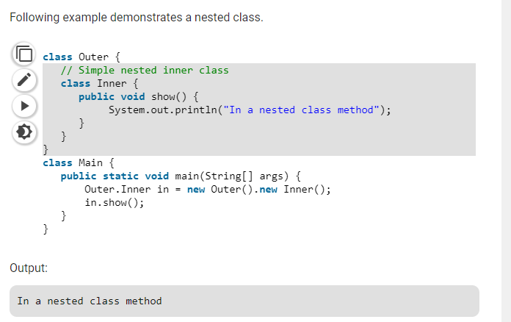

As a side note, we can’t have static method in a nested inner class because an inner class is implicitly associated with an object of its outer class so it cannot define any static method for itself. For example the following program doesn’t compile.

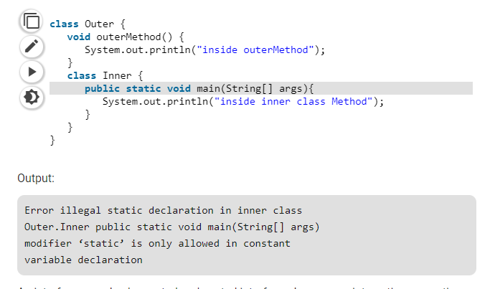

We use inner classes to logically group classes and interfaces in one place so that it can be more readable and maintainable.

Additionally, it can access all the members of outer class including private data members and methods.

1. **class** Java_Outer_class{
2. //code
3. **class** Java_Inner_class{
4. //code
5. }
6. }

### **Advantage of java inner classes**

There are basically three advantages of inner classes in java. They are as follows:

1) Nested classes represent a special type of relationship that is **it can access all the members (data members and methods) of outer class** including private.

2) Nested classes are used **to develop more readable and maintainable code** because it logically group classes and interfaces in one place only.

3) **Code Optimization**: It requires less code to write.

### **Difference between nested class and inner class in Java**

Inner class is a part of nested class. Non-static nested classes are known as inner classes.

### **Types of Nested classes**

There are two types of nested classes non-static and static nested classes.The non-static nested classes are also known as inner classes.

* Non-static nested class (inner class)
  1. Member inner class
  2. Anonymous inner class
  3. Local inner class
* Static nested class

