**Stream map() in Java with examples**

**Stream map(Function mapper)** returns a stream consisting of the results of applying the given function to the elements of this stream.

Stream map(Function mapper) is an **intermediate operation**. These operations are always lazy. Intermediate operations are invoked on a Stream instance and after they finish their processing, they give a Stream instance as output.

**Syntax :**

**<R> Stream<R> map(Function<? super T, ? extends R> mapper)**

where, R is the element type of the new stream.

Stream is an interface and T is the type

of stream elements. mapper is a stateless function

which is applied to each element and the function

returns the new stream.

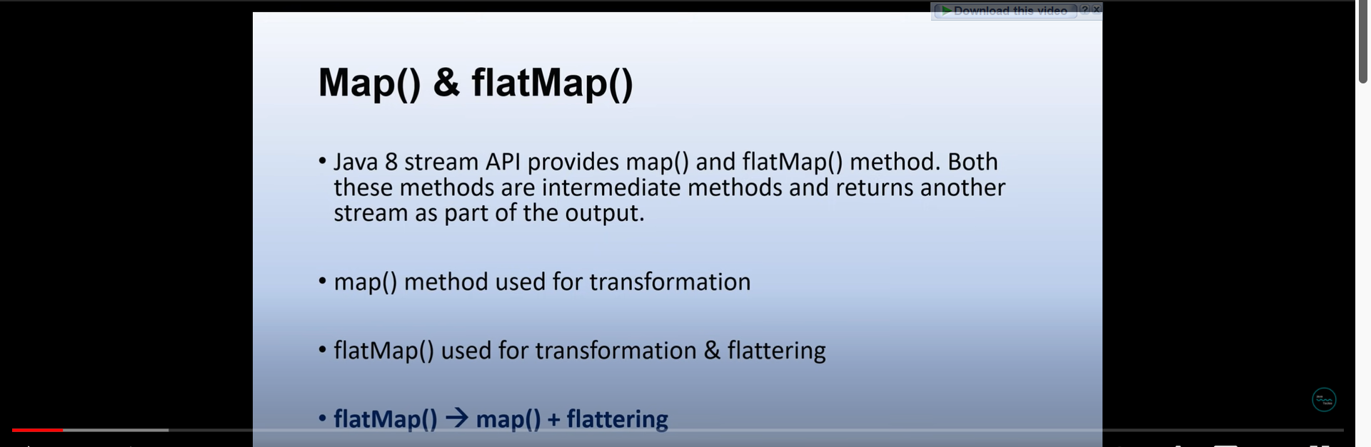

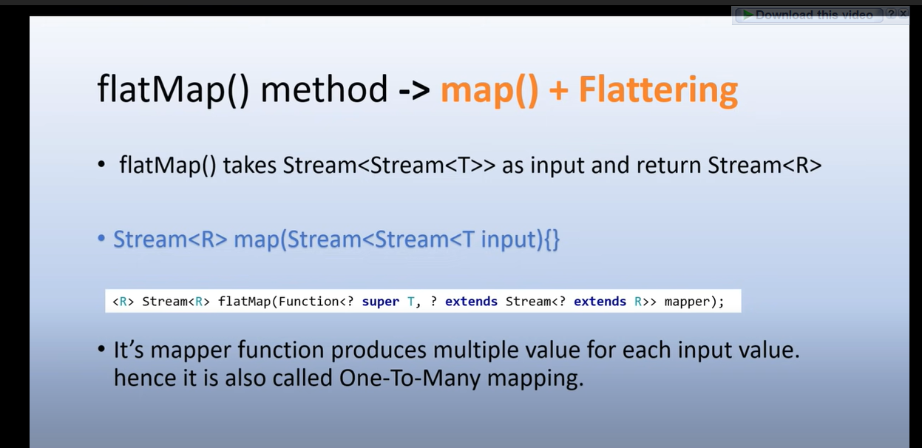

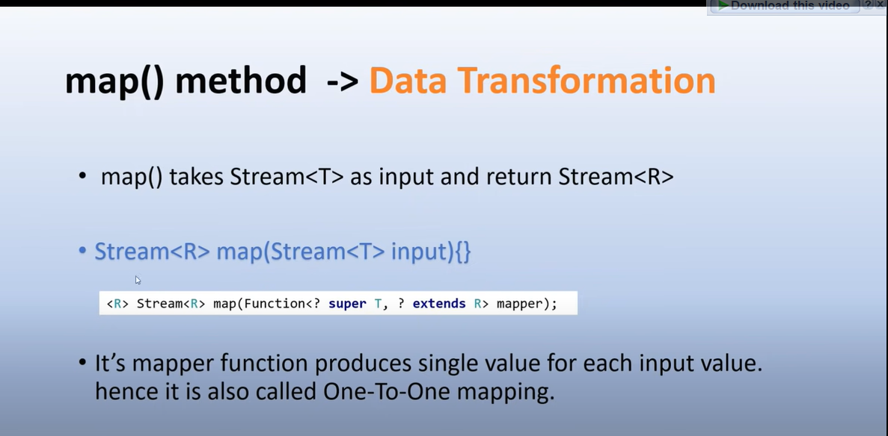

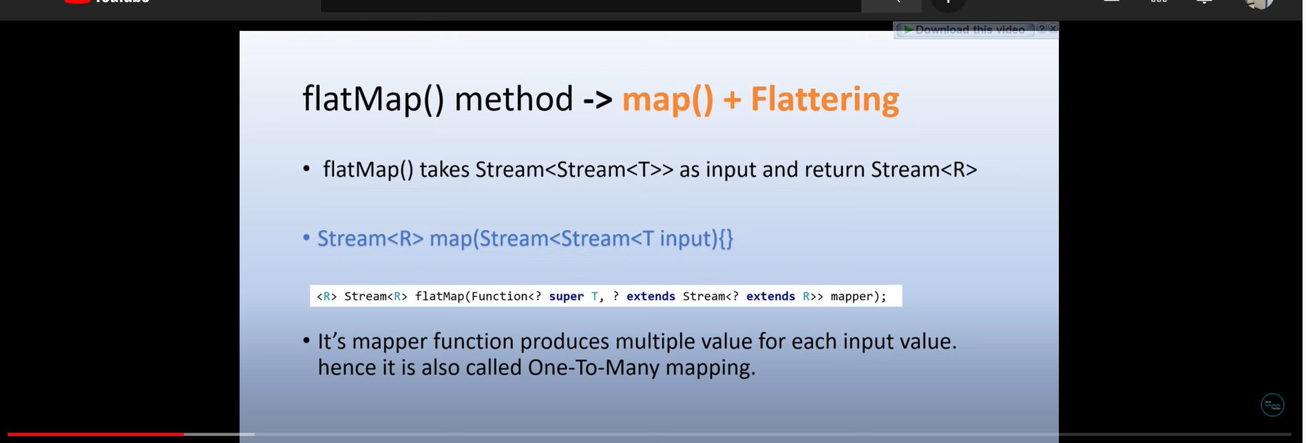

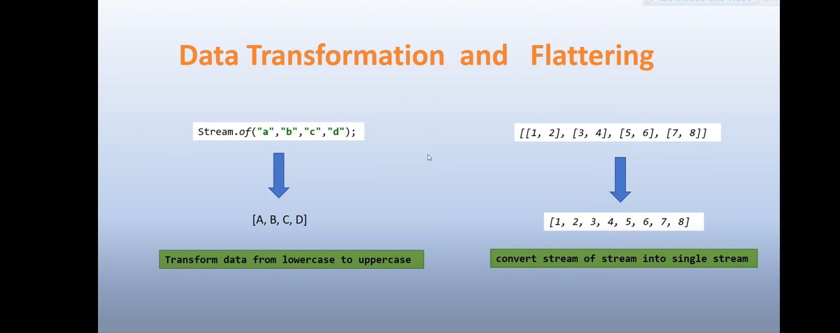

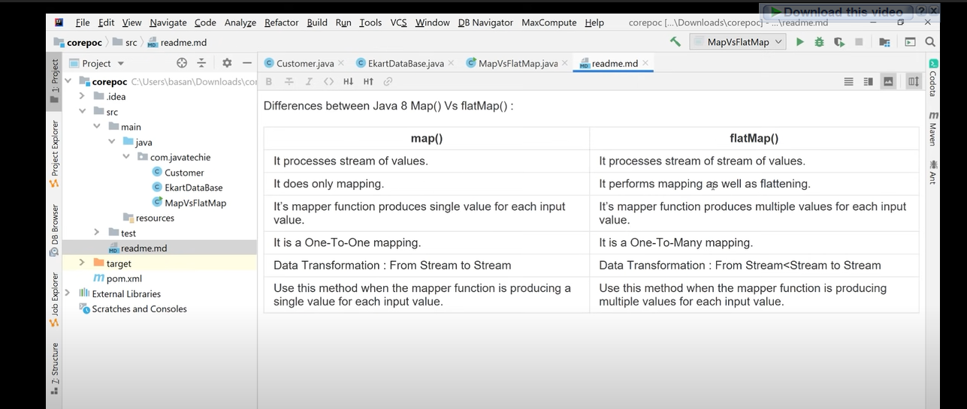

Flattering : making somebody look or sound more attractive or important than he/she really is

**Example 1 :** Stream map() function with operation of number * 3 on each element of stream.