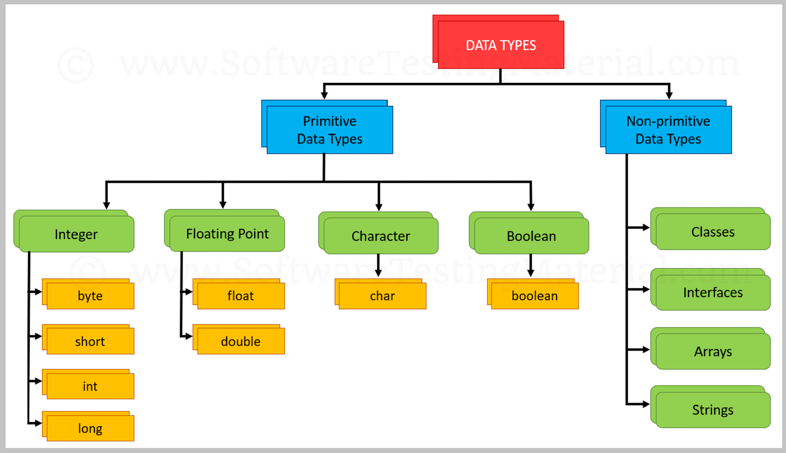

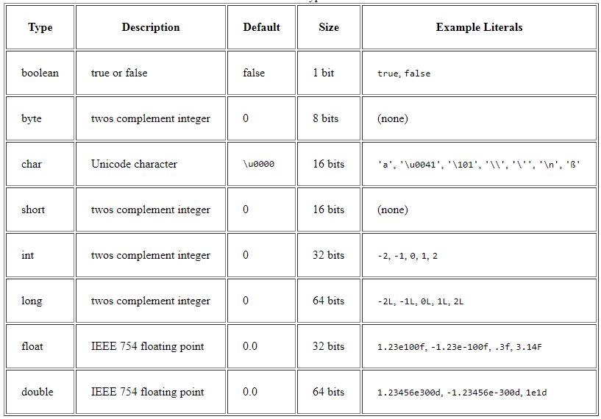

Loops in Java

In programming languages, loops are used to execute a set of instructions/functions repeatedly when some conditions become true. There are three types of loops in Java.

* for loop
* [while loop](https://www.javatpoint.com/java-while-loop)
* [do-while loop](https://www.javatpoint.com/java-do-while-loop)

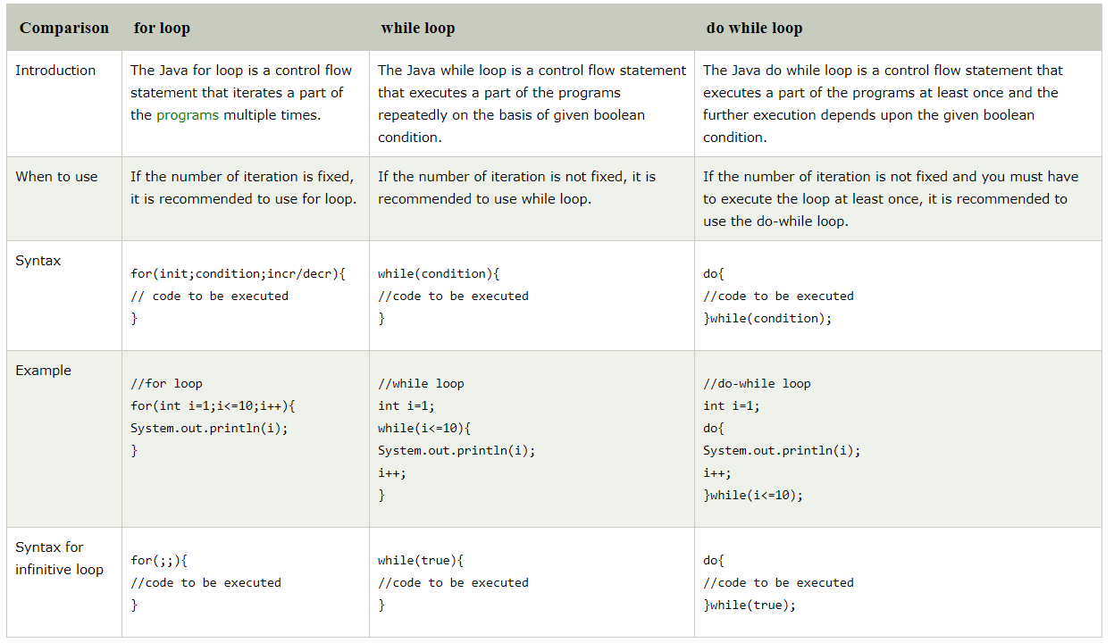

<https://beginnersbook.com/2017/08/java-switch-case/>

# For loop in Java with example

Loops are used to execute a set of statements repeatedly until a particular condition is satisfied. In Java we have three types of basic loops: for, while and do-while. In this tutorial we will learn how to use “**for loop**” in Java.

#### Syntax of for loop:

for(initialization; condition ; increment/decrement)

{

statement(s);

}

## Flow of Execution of the for Loop

As a program executes, the interpreter always keeps track of which statement is about to be executed. We call this the control flow, or the flow of execution of the program.

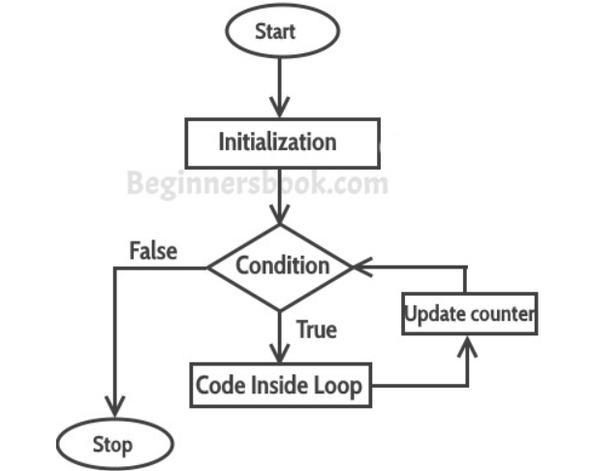

## For loop example to iterate an array:

class ForLoopExample3 {

public static void main(String args[]){

int arr[]={2,11,45,9};

//i starts with 0 as array index starts with 0 too

for(int i=0; i<arr.length; i++){

System.out.println(arr[i]);

}

}

}

# While loop in Java with examples

[**Loops in Java**](https://www.geeksforgeeks.org/loops-in-java/) come into use when we need to repeatedly execute a block of statements.

**Java while loop** is a control flow statement that allows code to be executed repeatedly based on a given Boolean condition. The while loop can be thought of as a repeating if statement.

**Syntax:**

while (test_expression)

{

// statements

update_expression;

}

The various **parts of the While loop** are:

1. **Test Expression:** In this expression we have to test the condition. If the condition evaluates to true then we will execute the body of the loop and go to update expression. Otherwise, we will exit from the while loop.  
   **Example:**

i <= 10

1. **Update Expression**: After executing the loop body, this expression increments/decrements the loop variable by some value.  
   **Example:**

i++;

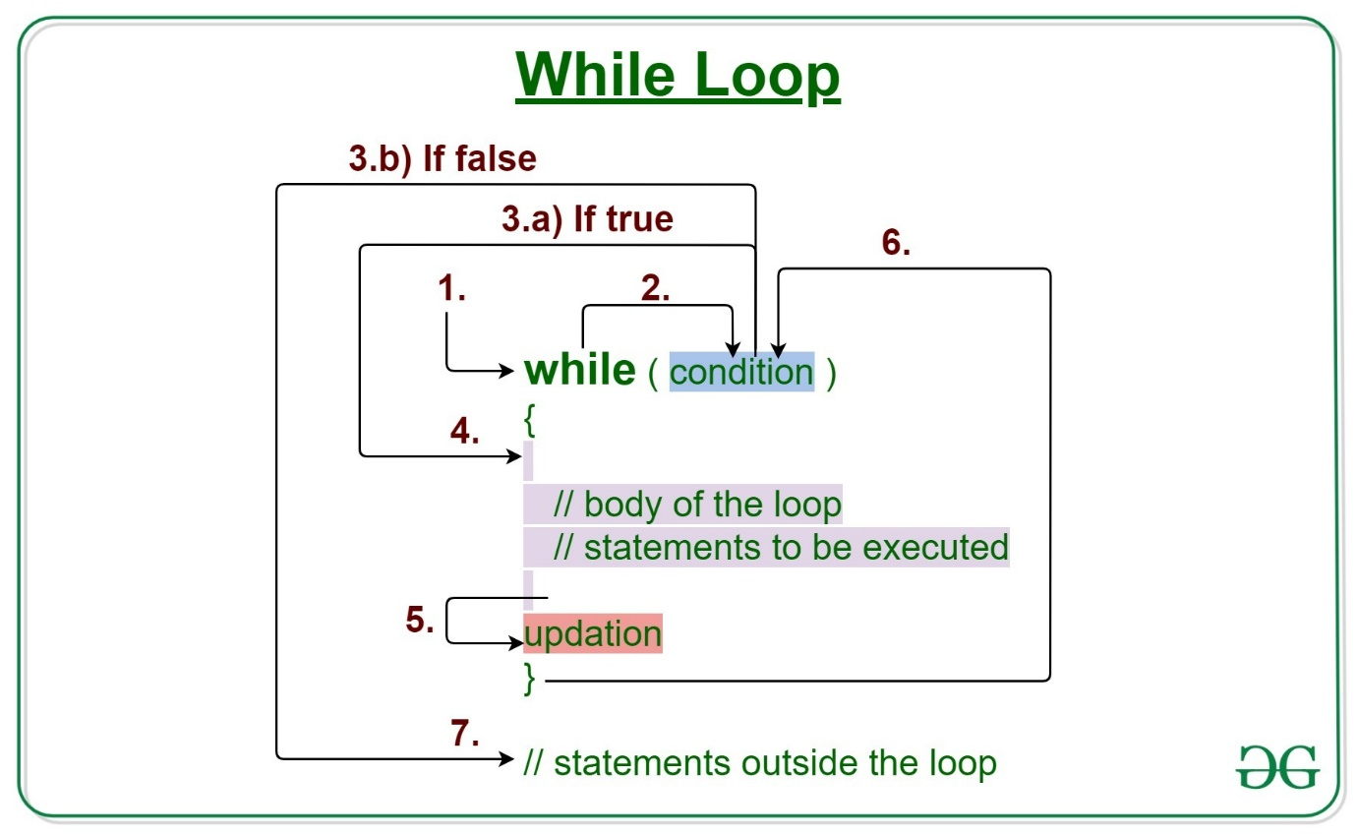

# Java do-while Loop

The Java do-while loop is used to iterate a part of the program several times. If the number of iteration is not fixed and you must have to execute the loop at least once, it is recommended to use do-while loop.

The Java do-while loop is executed at least once because condition is checked after loop body.

1. **do**{
2. //code to be executed
3. }**while**(condition);

