Microservices Tutorial

Microservice Architecture is a Service Oriented Architecture. In the microservice architecture, there are a large number of microservices. By combining all the microservices, it constructs a big service. In the microservice architecture, all the services communicate with each other.

Service-Oriented Architecture (SOA) is a style of software design where services are provided to the other components by application components, through a communication protocol over a network. Its principles are independent of vendors and other technologies.

What are Microservices

Definition: According to Sam Newman, "Microservices are the small services that work together."
According to James Lewis and Martin Fowler, "The microservice architectural style is an approach to develop a single application as a suite of small services. Each microservice runs its process and communicates with lightweight mechanisms. These services are built around business capabilities and independently developed by fully automated deployment machinery."
There is a bare minimum of centralized management of these services, which may be written in different programming language and use different data storage technologies.

Points to remember
- These are the services which are exposed by REST.
- These are small well-chosen deployable units.
- The services must be cloud-enabled.

The microservice defines an approach to the architecture that divides an application into a pool of loosely coupled services that implements business requirements. It is next to Service-Oriented Architecture (SOA). The most important feature of the microservice-based architecture is that it can perform continuous delivery of a large and complex application.
- Microservice helps in breaking the application and build a logically independent smaller applications. For example, we can build a cloud application with the help of Amazon AWS with minimum efforts.

`

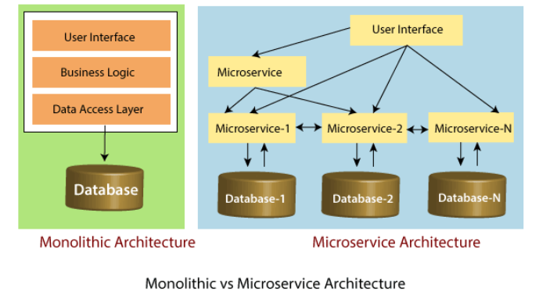

Principles of Microservices
There are the following principles of Microservices:
- Single Responsibility principle
- Modelled around business domain
- Isolate Failure
- Infrastructure automation
- Deploy independently

Single Responsibility Principle
The single responsibility principle states that a class or a module in a program should have only one responsibility. Any microservice cannot serve more than one responsibility, at a time.

Modeled around business domain
Microservice never restrict itself from accepting appropriate technology stack or database. The stack or database is most suitable for solving the business purpose.

Isolated Failure
The large application can remain mostly unaffected by the failure of a single module. It is possible that a service can fail at any time. So, it is important to detect failure quickly, if possible, automatically restore failure.

Infrastructure Automation
The infrastructure automation is the process of scripting environments. With the help of scripting environment, we can apply the same configuration to a single node or thousands of nodes. It is also known as configuration management, scripted infrastructures, and system configuration management.

Deploy independently
Microservices are platform agnostic. It means we can design and deploy them independently without affecting the other services.

Advantages of Microservices
- Microservices are self-contained, independent deployment module.
- The cost of scaling is comparatively less than the monolithic architecture.
- Microservices are independently manageable services. It can enable more and more services as the need arises. It minimizes the impact on existing service.
- It is possible to change or upgrade each service individually rather than upgrading in the entire application.
- Microservices allows us to develop an application which is organic (an application which latterly upgrades by adding more functions or modules) in nature.
- It enables event streaming technology to enable easy integration in comparison to heavyweight interposes communication.
- Microservices follows the single responsibility principle.
- The demanding service can be deployed on multiple servers to enhance performance.
- Less dependency and easy to test.
- Dynamic scaling.
- Faster release cycle.

Disadvantages of Microservices
- Microservices has all the associated complexities of the distributed system.
- There is a higher chance of failure during communication between different services.
- Difficult to manage a large number of services.
- The developer needs to solve the problem, such as network latency and load balancing.
- Complex testing over a distributed environment.

Challenges of Microservices Architecture
Microservice architecture is more complex than the legacy system. The microservice environment becomes more complicated because the team has to manage and support many moving parts. Here are some of the top challenges that an organization face in their microservices journey:
- Bounded Context
- Dynamic Scale up and Scale Down
- Monitoring
- Fault Tolerance
- Cyclic dependencies
- DevOps Culture

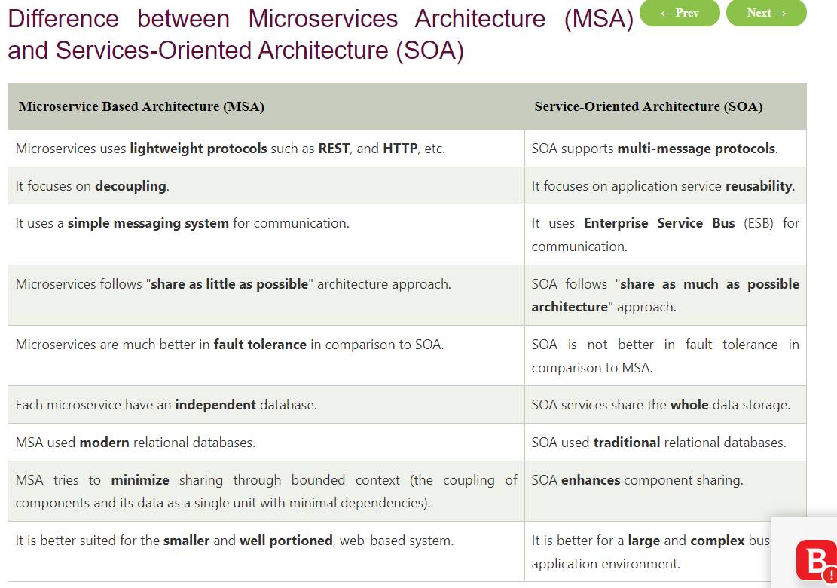

Microservices Monitoring
Monitoring is the control system of the microservices. As the microservices are more complex and harder to understand its performance and troubleshoot the problems. Given the vivid changes to software delivery, it is required to monitor the service. There are five principles of monitoring microservices, as follows:
- Monitor container and what's inside them.
- Alert on service performance.
- Monitor services that are elastic and multi-location.
- Monitor APIs.
- Monitor the organizational structure.

Microservices Monitoring Tool
There are three monitoring tools are as follows:
- Hystrix dashboard
- Eureka admin dashboard
- Spring boot admin dashboard

Microservice Virtualization
Microservices virtualization is the method to simulate the behavior of specific components in various component-based application like cloud-based application, SOA, and API driven architecture. Service virtualization also reduces cost and save time. By combining service virtualization, an organization can develop the application which can be delivered from various locations and dissimilar environments.

Components of Microservices
There are the following components of microservices:
- Spring Cloud Config Server
- Netflix Eureka Naming Server
- Hystrix Server
- Netflix ZuulAPI Gateway Server
- Netflix Ribbon
- Zipkin Distributed Tracing Server

Spring Cloud Config Server
Spring Cloud Config Server provides the HTTP resource-based API for external configuration in the distributed system. We can enable the Spring Cloud Config Server by using the annotation @EnableConfigServer.

No spring.config.import property has been defined
Root cause is Spring Boot 2.4 changed its default functionality. A new spring.config.import property is mandatory.
To fix, add the new spring.config.import property. Here is an example of what worked for me in application.yml.
spring:
config:
import: "optional:configserver:"

Unable to find a @SpringBootConfiguration, you need to use @ContextConfiguration or @SpringBootTest(classes=...) with your test

src/test/java packages and src/main/java packages should match. I had same issue where
- my src/main/java packages were starting with com.comp.example but
- src/test/java packages were starting with com.sample.example
Because of this spring boot application was not able to pickup the configuration of the application, which it picks up from @SpringBootApplication class. So test case should fall under the same packages where @SpringBootApplication in src/main/java is written.

