Collections in Java

https://docs.oracle.com/javase/tutorial/collections/interfaces/set.html

https://beginnersbook.com/java-collections-tutorials/

Iterable Interface
The Iterable interface is the root interface for all the collection classes. The Collection interface extends the Iterable interface and therefore all the subclasses of Collection interface also implement the Iterable interface.
It contains only one abstract method. i.e.,
- Iterator<T> iterator()
It returns the iterator over the elements of type T.

Collection Interface
The Collection interface is the interface which is implemented by all the classes in the collection framework. It declares the methods that every collection will have. In other words, we can say that the Collection interface builds the foundation on which the collection framework depends.
Some of the methods of Collection interface are Boolean add ( Object obj), Boolean addAll ( Collection c), void clear(), etc. which are implemented by all the subclasses of Collection interface.
The Collection in Java is a framework that provides an architecture to store and manipulate the group of objects.
All the operations that you perform on data such as searching, sorting, insertion, manipulation, deletion, etc. can be achieved by Java Collections.
Collection Framework defines several classes and interfaces to represent a group of objects as a single unit. Collections are used to store, retrieve, manipulate, and communicate aggregate data. Typically, they represent data items that form a natural group, such as a poker hand (a collection of cards), a mail folder (a collection of letters), or a telephone directory (a mapping of names to phone numbers).
Java Collections can achieve all the operations that you perform on a data such as searching, sorting, insertion, manipulation, and deletion.

Java Collection means a single unit of objects. Java Collection framework provides many interfaces (Set, List, Queue, Deque) and classes (ArrayList, Vector, LinkedList, PriorityQueue, HashSet, LinkedHashSet, TreeSet).

All collections frameworks contain the following:
- Interfaces: These are abstract data types that represent collections. Interfaces allow collections to be manipulated independently of the details of their representation. In object-oriented languages, interfaces generally form a hierarchy.
- Implementations: These are the concrete implementations of the collection interfaces. In essence, they are reusable data structures.
- Algorithms: These are the methods that perform useful computations, such as searching and sorting, on objects that implement collection interfaces. The algorithms are said to be polymorphic: that is, the same method can be used on many different implementations of the appropriate collection interface. In essence, algorithms are reusable functionality.

Collections in Java
- Java Collection Framework
- Hierarchy of Collection Framework
- Collection interface
- Iterator interface

What is a framework in Java
- It provides readymade architecture.
- It represents a set of classes and interfaces.
- It is optional.

Hierarchy of Collection Framework
Let us see the hierarchy of Collection framework. The java.util package contains all the classes and interfaces for the Collection framework.
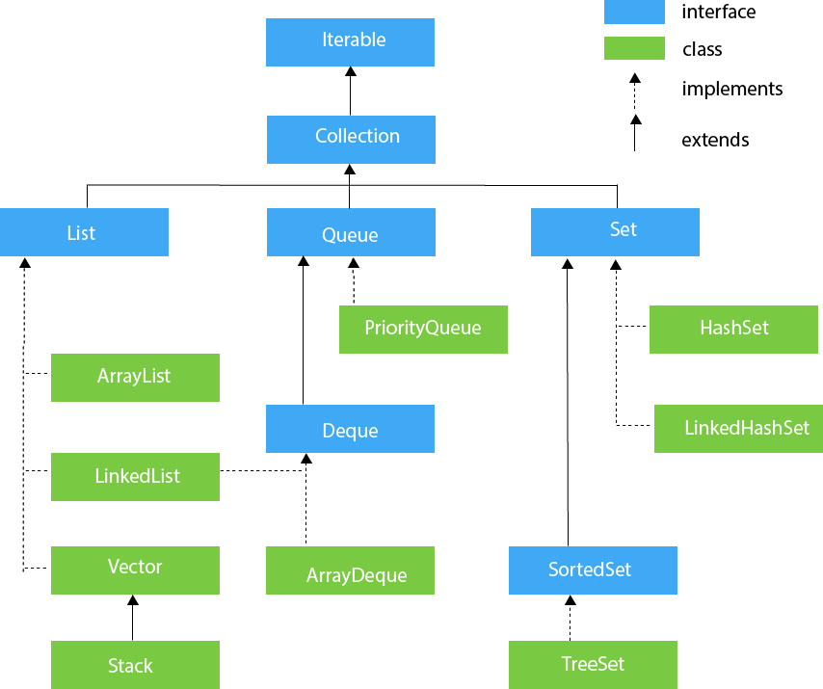

Methods of Collection interface
There are many methods declared in the Collection interface. They are as follows:
No. |  | Method | Description
1 | public boolean add(E e) |  |  | It is used to insert an element in this collection.
2 | public boolean addAll(Collection<? extends E> c) |  |  | It is used to insert the specified collection  elements in the invoking collection.
3 | public boolean remove(Object element) |  |  | It is used to delete an element from the collection.
4 | public boolean removeAll(Collection<?> c) |  |  | It is used to delete all the elements of the  specified collection from the invoking collection.
5 | default boolean removeIf(Predicate<? super E> filter) |  |  | It is used to delete all the elements of the  collection that satisfy the specified predicate.
6 | public boolean retainAll(Collection<?> c) |  |  | It is used to delete all the elements of invoking  collection except the specified collection.
7 | public int size() |  |  | It returns the total number of elements in  the collection.
8 | public void clear() |  |  | It removes the total number of elements from  the collection.
9 | public boolean contains(Object element) |  |  | It is used to search an element.
10 | public boolean containsAll(Collection<?> c) |  |  | It is used to search the specified collection in  the collection.
11 | public Iterator iterator() |  |  | It returns an iterator.
12 | public Object[] toArray() |  |  | It converts collection into array.
13 | public <T> T[] toArray(T[] a) |  |  | It converts collection into array. Here,  the runtime type of the returned array is that  of the specified array.
14 | public boolean isEmpty() |  |  | It checks if collection is empty.
15 | default Stream<E> parallelStream() |  |  | It returns a possibly parallel Stream with the  collection as its source.
16 | default Stream<E> stream() |  |  | It returns a sequential Stream with the collection  as its source.
17 | default Spliterator<E> spliterator() |  |  | It generates a Spliterator over the specified  elements in the collection.
18 | public boolean equals(Object element) |  |  | It matches two collections.
19 | public int hashCode() |  |  | It returns the hash code number of the collection.

Iterator interface
Iterator interface provides the facility of iterating the elements in a forward direction only.

Methods of Iterator interface
There are only three methods in the Iterator interface. They are:
No. | Method | Description
1 | public boolean hasNext() | It returns true if the iterator has more elements otherwise it returns false.
2 | public Object next() | It returns the element and moves the cursor pointer to the next element.
3 | public void remove() | It removes the last elements returned by the iterator. It is less used.

Iterators are used in Collection framework in Java to retrieve elements one by one. There are three iterators.By using Iterator, we can perform both read and remove operations. It is improved version of Enumeration with additional functionality of remove-ability of a element.
Iterator must be used whenever we want to enumerate elements in all Collection framework implemented interfaces like Set, List, Queue, Deque and also in all implemented classes of Map interface. Iterator is the only cursor available for entire collection framework.
Iterator object can be created by calling iterator() method present in Collection interface.
// Here "c" is any Collection object. itr is of
// type Iterator interface and refers to "c"
Iterator itr = c.iterator();

remove() method can throw two exceptions
- UnsupportedOperationException : If the remove operation is not supported by this iterator
- IllegalStateException : If the next method has not yet been called, or the remove method has already been called after the last call to the next method.

Exception
- ArrayStoreException − If the runtime type of the specified array is not a supertype of the runtime type of every element in this list.
- NullPointerException − If the specified array is null.

List Interface in Java

https://www.codejava.net/java-core/collections/java-list-collection-tutorial-and-examples

Ordered,

Null and Duplication Allowed,

Not Sorted,

Maintain insertion order.
The Java.util.List is a child interface of Collection. It is an ordered collection of objects in which duplicate values can be stored. Since List preserves the insertion order, it allows positional access and insertion of elements. List Interface is implemented by the classes of ArrayList, LinkedList, Vector and Stack.

Vector class is a legacy collection and later was retrofitted to implement the List interface. Vector is thread-safe, but ArrayList and LinkedList are not.

public abstract interface List extends Collection
Creating List Objects:
List is an interface, and the instances of List can be created by implementing various classes in the following ways:
List a = new ArrayList();
List b = new LinkedList();
List c = new Vector();
List d = new Stack();
Generic List Object:
After the introduction of Generics in Java 1.5, it is possible to restrict the type of object that can be stored in the List. The type-safe List can be defined in the following way:
// Obj is the type of object to be stored in List
List<Obj> list = new ArrayList<Obj> ();
Operations on List:
List Interface extends Collection, hence it supports all the operations of Collection Interface, along with following additional operations:

Positional Access:
List allows add, remove, get and set operations based on numerical positions of elements in List. List provides following methods for these operations:

1. void add(int index, Object O): This method adds given element at specified index.
2. boolean addAll(int index, Collection c): This method adds all elements from specified
collection to list. First element gets inserted at given index. If there is already an
element at that position, that element and other subsequent elements(if any) are
shifted to the right by increasing their index.
3. Object remove(int index): This method removes an element from the specified index. It
shifts subsequent elements(if any) to left and decreases their indexes by 1.
4. Object get(int index): This method returns element at the specified index.
5. Object set(int index, Object new): This method replaces element at given index with
new element. This function returns the element which was just replaced by new element.

Search:
List provides methods to search element and returns its numeric position. Following two methods are supported by List for this operation:

- int indexOf(Object o): This method returns first occurrence of given element or
-1 if element is not present in list.

- int lastIndexOf(Object o): This method returns the last occurrence of given
element or -1 if element is not present in list.

Iteration:

ListIterator(extends Iterator) is used to iterate over List element. List iterator is bidirectional iterator. For more details about ListIterator refer Iterators in Java.

Range-view:
List Interface provides a method to get the List view of the portion of given List between two indices. Following is the method supported by List for range view operation.

- List subList(int fromIndex, int toIndex):This method returns List view of
specified List between fromIndex(inclusive) and toIndex(exclusive).

ListIterator:

- public interface ListIterator<E> extends Iterator<E>

It is only applicable for List collection implemented classes like arraylist, linkedlist etc. It provides bi-directional iteration.
ListIterator must be used when we want to enumerate elements of List. This cursor has more functionality(methods) than iterator.
ListIterator object can be created by calling listIterator() method present in List interface.
// Here "l" is any List object, ltr is of type
// ListIterator interface and refers to "l"
ListIterator ltr = l.listIterator();
ListIterator interface extends Iterator interface. So all three methods of Iterator interface are available for ListIterator. In addition there are six more methods.

Clearly the three methods that ListIterator inherits from Iterator (hasNext(), next(), and remove()) do exactly the same thing in both interfaces. The hasPrevious() and the previous operations are exact analogues of hasNext() and next(). The former operations refer to the element before the (implicit) cursor, whereas the latter refer to the element after the cursor. The previous operation moves the cursor backward, whereas next moves it forward.

Java ListIterator Methods
- void add(Object o) : Inserts the specified element into the list (optional operation).
- boolean hasNext() : Returns true if this list iterator has more elements when traversing the list in the forward direction.
- boolean hasPrevious() : Returns true if this list iterator has more elements when traversing the list in the reverse direction.
- Object next() : Returns the next element in the list and advances the cursor position.
- int nextIndex() : Returns the index of the element that would be returned by a subsequent call to next().
- Object previous() : Returns the previous element in the list and moves the cursor position backwards.
- int previousIndex() : Returns the index of the element that would be returned by a subsequent call to previous().
- void remove() : Removes from the list the last element that was returned by next() or previous() (optional operation).
- void set(Object o) : Replaces the last element returned by next() or previous() with the specified element (optional operation).

ListIterator has no current element; its cursor position always lies between the element that would be returned by a call to previous() and the element that would be returned by a call to next()
set() method can throw four exceptions
- UnsupportedOperationException – if the set operation is not supported by this list iterator.
- ClassCastException : If the class of the specified element prevents it from being added to this list
- IllegalArgumentException : If some aspect of the specified element prevents it from being added to this list.

Limitations of ListIterator : It is the most powerful iterator but it is only applicable for List implemented classes, so it is not a universal iterator.

Important Common Points
1 : Please note that initially any iterator reference will point to the index just before the index of first element in a collection.
2 : We don’t create objects of Enumeration, Iterator, ListIterator because they are interfaces. We use methods like elements(), iterator(), listIterator() to create objects. These methods have anonymous Inner classes that extends respective interfaces and return this class object. This can be verified by below code. For more on inner class refer.

// Java program to demonstrate iterators references
import java.util.Enumeration;
import java.util.Iterator;
import java.util.ListIterator;
import java.util.Vector;

public class Test
{
public static void main(String[] args)
{
Vector v = new Vector();

// Create three iterators
Enumeration e = v.elements();
Iterator itr = v.iterator();
ListIterator ltr = v.listIterator();

// Print class names of iterators
System.out.println(e.getClass().getName());
System.out.println(itr.getClass().getName());
System.out.println(ltr.getClass().getName());
}
}
Output:
java.util.Vector$1
java.util.Vector$Itr
java.util.Vector$ListItr
The $ symbol in reference class name is a proof that concept of inner classes is used and these class objects are created.

List Interface declaration
- public interface List<E> extends Collection<E>

Methods of Java List Interface
Method |  |  |  | Description
E get(int index) |  |  |  | It is used to fetch the element from the particular  position of the list.
int lastIndexOf(Object o) |  |  |  | It is used to return the index in this list of the last  occurrence of the specified element, or -1 if the  list does not contain this element.
int indexOf(Object o) |  |  |  | It is used to return the index in this list of the first  occurrence of the specified element, or -1 if the  List does not contain this element.
void replaceAll(UnaryOperator operator) |  |  |  | It is used to replace all the elements from the  list with the specified element.
void retainAll(Collection<?> c) |  |  |  | It is used to retain all the elements in the list that  are present in the specified collection.
E set(int index, E element) |  |  |  | It is used to replace the specified element in the list,  present at the specified position.
void sort(Comparator<? super E> c) |  |  |  | It is used to sort the elements of the list on the basis  of specified comparator.
List<E> subList(int fromIndex, int toIndex) |  |  |  | It is used to fetch all the elements lies within the  given range.

Iterator vs ListIterator
1) Iterator is used for traversing List and Set both.
We can use ListIterator to traverse List only, we cannot traverse Set using ListIterator.
2) We can traverse in only forward direction using Iterator.
Using ListIterator, we can traverse a List in both the directions (forward and Backward).
3) We cannot obtain indexes while using Iterator
We can obtain indexes at any point of time while traversing a list using ListIterator. The methods nextIndex() and previousIndex() are used for this purpose.
4) We cannot add element to collection while traversing it using Iterator, it throws ConcurrentModificationException when you try to do it.
We can add element at any point of time while traversing a list using ListIterator.
5) We cannot replace the existing element value when using Iterator.
By using set(E e) method of ListIterator we can replace the last element returned by next() or previous() methods.

Concurrent Modification
The Concurrent modification in Java is to modify an object concurrently while another task is running over it. In simple terms, concurrent modification is the process of modifying objects while another thread is running over them. It will change the structure of the data collection, either by removing, adding, or updating the value of the elements in the collection.
Not all iterators support this behavior; implementation of some iterator may throw ConcurrentModificationException.

Fail Fast and Fail Safe Iterator in Java
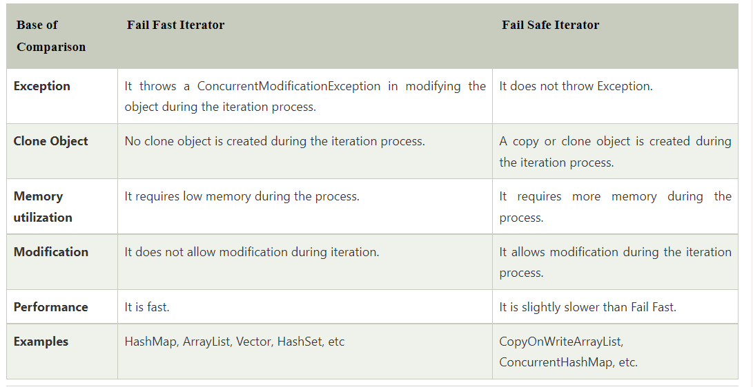

ArrayList implement List

- Java ArrayList class is non synchronized.
- Java ArrayList allows random access because array works at the index basis.
- In Java ArrayList class, manipulation is slow because a lot of shifting needs to occur if any element is removed from the array list.
void ensureCapacity(int requiredCapacity) |  | It is used to enhance the capacity of an ArrayList instance.
Object clone() |  | It is used to return a shallow copy of an ArrayList.
void trimToSize() | It is used to trim the capacity of this ArrayList instance to be the list's  current size.

LinkedList implements List:

- Java LinkedList class is non synchronized.
- In Java LinkedList class, manipulation is fast because no shifting needs to occur.
- Java LinkedList class can be used as a list, stack or queue.

Doubly Linked List
In the case of a doubly linked list, we can add or remove elements from both sides.
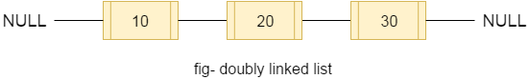

LinkedList class declaration
Let's see the declaration for java.util.LinkedList class.
- public class LinkedList<E> extends AbstractSequentialList<E> implements List<E>, Deque<E>, Cloneable, Serializable

Constructors of Java LinkedList
Constructor | Description
LinkedList() | It is used to construct an empty list.
LinkedList(Collection<? extends E> c) | It is used to construct a list containing the elements of the specified  collection, in the order, they are returned by the collection's iterator.

Vector and Stack Class in List

Vector implements List
Stack extends Vector

- It preserves the insertion order.
- It allow heterogeneous object
- For retrieval purpose Vector is the best choice
- It is synchronized. Every method in the vector is synchronized. So it is thread safe.
Vector extends AbstractList implements List, RandomAccess
Vector implements RandomAcess interface that’s why its retrieval methods are very fast.

Stack
Stack class is the child class of Vector.
- It follows LIFO (Last in first out) mechanism.
- It is the stack implementation in java
- Stack v = Stack();
- It creates an empty Stack.
- Additional methods defined by Stack
- 1. Object push(Object item)
Pushes the element into Stack and returns the same element
- 2. Object pop()
Removes the element from Stack and returns the element
- 3. Object peek()
Returns the top element from Stack.
- 4. Object empty()
Returns true when the Stack is empty.
- 5. int search(Object o)
- Returns the offset value from the stack if the element is found, otherwise it returns -1.

Difference between ArrayList and LinkedList.
Comparision between ArrayList and LinkedList:-

- Insertions are easy and fast in LinkedList as compared to ArrayList because there is no risk of resizing array and copying content to new array if array gets full which makes adding into ArrayList of O(n) in worst case, while adding is O(1) operation in LinkedList in Java. ArrayList also needs to be update its index if you insert something anywhere except at the end of array.
- Removal also better in LinkedList than ArrayList due to same reasons as insertion.
- LinkedList has more memory overhead than ArrayList because in ArrayList each index only holds actual object (data) but in case of LinkedList each node holds both data and address of next and previous node.
- Both LinkedList and ArrayList require O(n) time to find if an element is present or not. However we can do Binary Search on ArrayList if it is sorted and therefore can search in O(Log n) time.

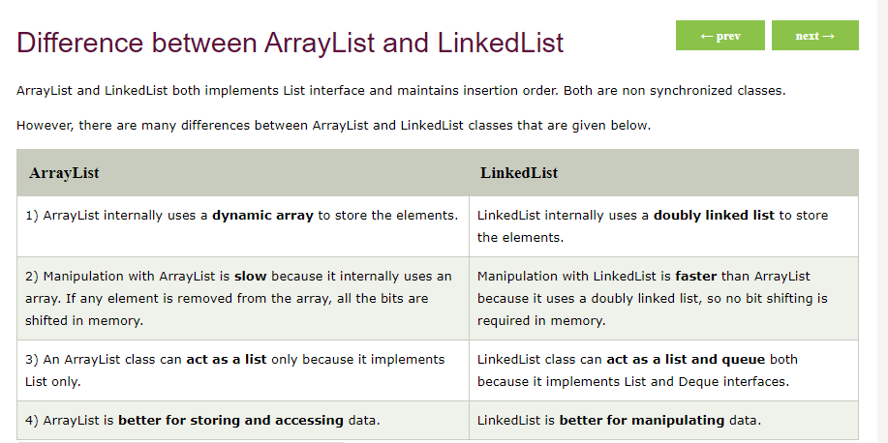

Difference between ArrayList and Vector
ArrayList and Vector both implements List interface and maintains insertion order.
However, there are many differences between ArrayList and Vector classes that are given below.
ArrayList | Vector
1) ArrayList is not synchronized. | Vector is synchronized.
2) ArrayList increments 50% of current array size if the number of elements exceeds from its capacity. | Vector increments 100% means doubles the array size if the total number of elements exceeds than its capacity.
3) ArrayList is not a legacy class. It is introduced in JDK 1.2. | Vector is a legacy class.
4) ArrayList is fast because it is non-synchronized. | Vector is slow because it is synchronized, i.e., in a  multithreading environment, it holds the other threads in  runnable or non-runnable state until current thread  releases the lock of the object.
5) ArrayList uses the Iterator interface to traverse the elements. | A Vector can use the Iterator interface or Enumeration interface to traverse the elements.

When Collections framework were added in J2SE 1.2, the original classes were reengineered to support the collection interface. These classes are also known as Legacy classes.

Queue Interface in Java Collections(java.util.Queue )

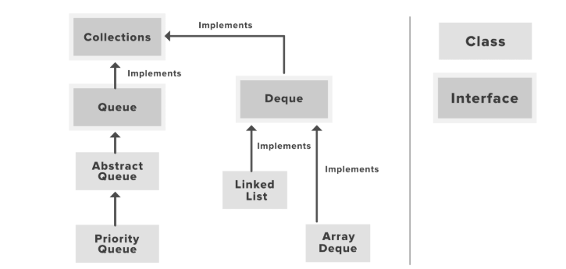

FIFO(fisrt-in-first-out).

Does allow duplicate elements.

Not Sorted element.

do not allow insertion of null elements
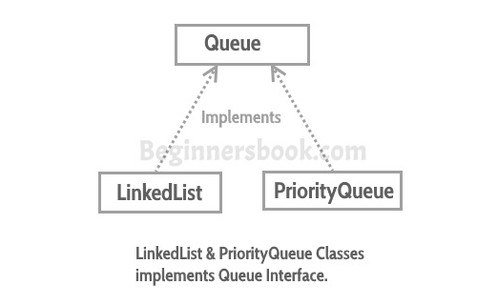
In the Java Collections Framework, Queueis the main interface, and there are four sub interfaces: Deque, BlockingDeque, BlockingQueue, and TransferQueue.
Except the Deque interface which is in the java.util package, all others are organized in the java.util.concurrent package, which is designed for multi-threading or concurrent programming.

Queue is an interface so we cannot instantiate it, rather we create instance of LinkedList or PriorityQueue and assign it to the Queue like this:

Queue q1 = new LinkedList();
Queue q2 = new PriorityQueue();

- The Queue is used to insert elements at the end of the queue and removes from the beginning of the queue. It follows FIFO concept.
- The Java Queue supports all methods of Collection interface including insertion, deletion etc.
- LinkedList, ArrayBlockingQueue and PriorityQueue are the most frequently used implementations.
- If any null operation is performed on BlockingQueues, NullPointerException is thrown.

Methods of Queue interface
boolean add(E e): This method adds the specified element at the end of Queue. Returns true if the the element is added successfully or false if the element is not added that basically happens when the Queue is at its max capacity and cannot take any more elements.
E element(): This method returns the head (the first element) of the Queue.
boolean offer(object): This is same as add() method.
E remove(): This method removes the head(first element) of the Queue and returns its value.
E poll(): This method is almost same as remove() method. The only difference between poll() and remove() is that poll() method returns null if the Queue is empty.
E peek(): This method is almost same as element() method. The only difference between peek() and element() is that peek() method returns null if the Queue is empty.

Java PriorityQueue class:
Java PriorityQueue class is a queue data structure implementation in which objects are processed based on their priority. It is different from standard queues where FIFO (First-In-First-Out) algorithm is followed.
In a priority queue, added objects are according to their priority. By default, the priority is determined by objects’ natural ordering. Default priority can be overridden by a Comparator provided at queue construction time.
DEQUE

Deque: abstracts a queue that has two heads. A deque allows adding or removing elements at both ends.

Methods of Deque:
- addFirst(element): Adds an element to the head.
- addLast(element): Adds an element to the tail.
- offer(element): Adds an element to the tail and returns a boolean to explain if the insertion was successful.
- offerFirst(element): Adds an element to the head and returns a boolean to explain if the insertion was successful.
- offerLast(element): Adds an element to the tail and returns a boolean to explain if the insertion was successful.

- descendingIterator(): Returns an iterator that has the reverse order for this deque.
- push(element): Adds an element to the head.
- pop(element): Removes an element from the head and returns it.
- removeFirst(): Removes the element at the head.
- removeLast(): Removes the element at the tail.
- poll(): Retrieves and removes the head of the queue represented by this deque (in other words, the first element of this deque), or returns null if this deque is empty.
- pollFirst(): Retrieves and removes the first element of this deque, or returns null if this deque is empty.
- pollLast(): Retrieves and removes the last element of this deque, or returns null if this deque is empty.
- peek(): Retrieves, but does not remove, the head of the queue represented by this deque (in other words, the first element of this deque), or returns null if this deque is empty.
- peekFirst(): Retrieves, but does not remove, the first element of this deque, or returns null if this deque is empty.
- peekLast(): Retrieves, but does not remove, the last element of this deque, or returns null if this deque is empty.

PriorityQueue Features
Let’s note down few important points on the PriorityQueue.
- PriorityQueue is an unbounded queue and grows dynamically. The default initial capacity is '11' which can be overridden using initialCapacity parameter in appropriate constructor.
- It does not allow NULL objects.
- Objects added to PriorityQueue MUST be comparable.
- The objects of the priority queue are ordered by default in natural order.
- A Comparator can be used for custom ordering of objects in the queue.
- The head of the priority queue is the least element based on the natural ordering or comparator based ordering. When we poll the queue, it returns the head object from the queue.
- If multiple objects are present of same priority the it can poll any one of them randomly.
- PriorityQueue is not thread safe. Use PriorityBlockingQueue in concurrent environment.
- It provides O(log(n)) time for add and poll methods.

3. Java PriorityQueue Constructors
PriorityQueue class provides 6 different ways to construct a priority queue in Java.
- PriorityQueue() : constructs empty queue with the default initial capacity (11) that orders its elements according to their natural ordering.
- PriorityQueue(Collection c) : constructs empty queue containing the elements in the specified collection.
- PriorityQueue(int initialCapacity) : constructs empty queue with the specified initial capacity that orders its elements according to their natural ordering.
- PriorityQueue(int initialCapacity, Comparator comparator) : constructs empty queue with the specified initial capacity that orders its elements according to the specified comparator.
- PriorityQueue(PriorityQueue c) : constructs empty queue containing the elements in the specified priority queue.
- PriorityQueue(SortedSet c) : constructs empty queue containing the elements in the specified sorted set.

4. Java PriorityQueue Methods
PriorityQueue class has below given important methods, you should know.
- boolean add(object) : Inserts the specified element into this priority queue.
- boolean offer(object) : Inserts the specified element into this priority queue.
- boolean remove(object) : Removes a single instance of the specified element from this queue, if it is present.
- Object poll() : Retrieves and removes the head of this queue, or returns null if this queue is empty.
- Object element() : Retrieves, but does not remove, the head of this queue, or throws NoSuchElementException if this queue is empty.
- Object peek() : Retrieves, but does not remove, the head of this queue, or returns null if this queue is empty.
- void clear() : Removes all of the elements from this priority queue.
- Comparator comparator() : Returns the comparator used to order the elements in this queue, or null if this queue is sorted according to the natural ordering of its elements.
- boolean contains(Object o) : Returns true if this queue contains the specified element.
- Iterator iterator() : Returns an iterator over the elements in this queue.
- int size() : Returns the number of elements in this queue.
- Object[] toArray() : Returns an array containing all of the elements in this queue.

- PriorityQueue doesn’t permit null.
- We can’t create PriorityQueue of Objects that are non-comparable
- PriorityQueue are unbound queues.
- The head of this queue is the least element with respect to the specified ordering. If multiple elements are tied for least value, the head is one of those elements — ties are broken arbitrarily.
- The queue retrieval operations poll, remove, peek, and element access the element at the head of the queue.
- It inherits methods from AbstractQueue, AbstractCollection, Collection and Object class.

Set in Java

No Duplication.

unordered collection

Set implementations: HashSet, LinkedHashSet, TreeSet etc.

Set can have only a single null value at most.

List interface has one legacy class called Vector whereas Set interface does not have any legacy class.

When to use Set and When to use List?
The usage is purely depends on the requirement:
If the requirement is to have only unique values then Set is your best bet as any implementation of Set maintains unique values only.

The Java platform contains three general-purpose Set implementations: HashSet, TreeSet, and LinkedHashSet.

HashSet, which stores its elements in a hash table, is the best-performing implementation; however it makes no guarantees concerning the order of iteration. TreeSet, which stores its elements in a red-black tree, orders its elements based on their values; it is substantially slower than HashSet. LinkedHashSet, which is implemented as a hash table with a linked list running through it, orders its elements based on the order in which they were inserted into the set (insertion-order). LinkedHashSet spares its clients from the unspecified, generally chaotic ordering provided by HashSet at a cost that is only slightly higher.
- Set has various methods to add, remove clear, size, etc to enhance the usage of this interface.

public interface Set<E> extends Collection<E>

Set also adds a stronger contract on the behavior of the equals and hashCode operations, allowing Set instances to be compared meaningfully even if their implementation types differ. Two Set instances are equal if they contain the same elements.
A collection that contains no duplicate elements. More formally, sets contain no pair of elements e1 and e2 such that e1.equals(e2), and at most one null element. As implied by its name, this interface models the mathematical set abstraction.

The Set interface places additional stipulations, beyond those inherited from the Collection interface, on the contracts of all constructors and on the contracts of the add, equals and hashCode methods. Declarations for other inherited methods are also included here for convenience. (The specifications accompanying these declarations have been tailored to the Set interface, but they do not contain any additional stipulations.)

Some set implementations have restrictions on the elements that they may contain. For example, some implementations prohibit null elements, and some have restrictions on the types of their elements. Attempting to add an ineligible element throws an unchecked exception, typically NullPointerException or ClassCastException. Attempting to query the presence of an ineligible element may throw an exception, or it may simply return false; some implementations will exhibit the former behavior and some will exhibit the latter. More generally, attempting an operation on an ineligible element whose completion would not result in the insertion of an ineligible element into the set may throw an exception or it may succeed, at the option of the implementation. Such exceptions are marked as "optional" in the specification for this interface.

public interface SortedSet<E> extends Set<E>

A Set that further provides a total ordering on its elements. The elements are ordered using their natural ordering, or by a Comparator typically provided at sorted set creation time. The set's iterator will traverse the set in ascending element order. Several additional operations are provided to take advantage of the ordering. (This interface is the set analogue of SortedMap.)
All elements inserted into a sorted set must implement the Comparable interface (or be accepted by the specified comparator). Furthermore, all such elements must be mutually comparable: e1.compareTo(e2) (or comparator.compare(e1, e2)) must not throw a ClassCastException for any elements e1 and e2 in the sorted set. Attempts to violate this restriction will cause the offending method or constructor invocation to throw a ClassCastException.

Note that the ordering maintained by a sorted set (whether or not an explicit comparator is provided) must be consistent with equals if the sorted set is to correctly implement the Set interface. (See the Comparable interface or Comparator interface for a precise definition of consistent with equals.) This is so because the Set interface is defined in terms of the equals operation, but a sorted set performs all element comparisons using its compareTo (or compare) method, so two elements that are deemed equal by this method are, from the standpoint of the sorted set, equal. The behavior of a sorted set is well-defined even if its ordering is inconsistent with equals; it just fails to obey the general contract of the Set interface.

All general-purpose sorted set implementation classes should provide four "standard" constructors:
1) A void (no arguments) constructor, which creates an empty sorted set sorted according to the natural ordering of its elements.
2) A constructor with a single argument of type Comparator, which creates an empty sorted set sorted according to the specified comparator.
3) A constructor with a single argument of type Collection, which creates a new sorted set with the same elements as its argument, sorted according to the natural ordering of the elements.
4) A constructor with a single argument of type SortedSet, which creates a new sorted set with the same elements and the same ordering as the input sorted set. There is no way to enforce this recommendation, as interfaces cannot contain constructors.

HashSet Class in Java
This class implements the Set interface, backed by a hash table (actually a HashMap instance). It makes no guarantees as to the iteration order of the set; in particular, it does not guarantee that the order will remain constant over time. This class permits the null element. This class is not synchronized. However it can be synchronized explicitly like this: Set s = Collections.synchronizedSet(new HashSet(...));

Points to Note about HashSet:
- HashSet doesn’t maintain any order, the elements would be returned in any random order.
- HashSet doesn’t allow duplicates. If you try to add a duplicate element in HashSet, the old value would be overwritten.
- HashSet allows null values however if you insert more than one nulls it would still return only one null value.
- HashSet is non-synchronized.
- The iterator returned by this class is fail-fast which means iterator would throw ConcurrentModificationException if HashSet has been modified after creation of iterator, by any means except iterator’s own remove method.

HashSet Methods:
- boolean add(Element e): It adds the element e to the list.
- void clear(): It removes all the elements from the list.
- Object clone(): This method returns a shallow copy of the HashSet.
- boolean contains(Object o): It checks whether the specified Object o is present in the list or not. If the object has been found it returns true else false.
- boolean isEmpty(): Returns true if there is no element present in the Set.
- int size(): It gives the number of elements of a Set.
- boolean(Object o): It removes the specified Object o from the Set.

LinkedHashSet Class in Java
- HashSet doesn’t maintain any kind of order of its elements.
- TreeSet sorts the elements in ascending order.
- LinkedHashSet maintains the insertion order. Elements gets sorted in the same sequence in which they have been added to the Set.

Java SortedSet<E> interface
A set is used to provide a particular ordering on its element. The elements are ordered either by using a natural ordering or by using a Comparator. All the elements which are inserted into a sorted set must implement the Comparable interface.
The set's iterator will traverse the set in an ascending order. Several other operations are provided in order to make best use of ordering. All the elements must be mutually comparable.
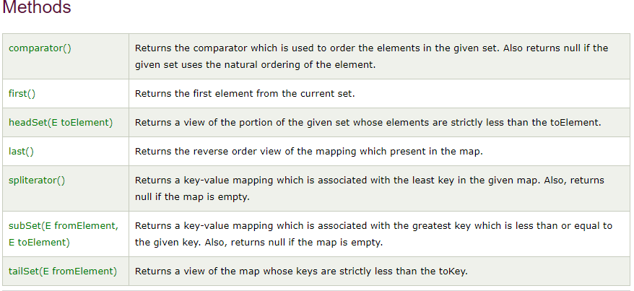
TreeSet Class in Java
TreeSet is similar to HashSet except that it sorts the elements in the ascending order while HashSet doesn’t maintain any order. TreeSet allows null element but like HashSet it doesn’t allow duplication. Like most of the other collection classes this class is also not synchronized, however it can be synchronized explicitly like this: SortedSet s = Collections.synchronizedSortedSet(new TreeSet(...));
Q: When I use an object as a key in a Hashtable , what in the Object class must I override and why?
A: When you create your own key object for use in a Hashtable, you must override the Object.equals() and Object.hashCode() methods since Hashtable uses a combination of the key's hashCode() and equals() methods to store and retrieve its entries quickly. It's also a general rule that when you override equals(), you always override hashCode().
Differences Between HashSet, LinkedHashSet and TreeSet:
FEATURES | HASHSET | LINKEDHASHSET | TREESET
Internal Working | HashSet internally uses HashMap for storing objects | LinkedHashSet uses LinkedHashMap internally to store objects | TreeSet uses TreeMap internally to store objects
When To Use | If you don’t want to maintain insertion order but want store unique objects | If you want to maintain insertion order of elements then you can use LinkedHashSet | If you want to sort the elements according to some Comparator then use TreeSet
Order | HashSet does not maintain insertion order | LinkedHashSet maintains insertion order of objects | While TreeSet orders of the elements according to supplied Comparator. Default, It’s objects will be placed in their natural ascending order.
Complexity of Operations | HashSet gives O(1) complicity for insertion, removing and retrieving objects | LinkedHashSet gives insertion, removing and retrieving operations performance in order O(1). | While TreeSet gives performance of order O(log(n)) for insertion, removing and retrieving operations.
Performance | HashSet performance is better according to LinkedHashSet and TreeSet. | The performance of LinkedHashSet is slow to TreeSet. The performance LinkedHashSet is almost similar to HashSet but slower because, LinkedHashSet maintains LinkedList internally to maintain the insertion order of elements | TreeSet performance is better to LinkedHashSet excluding insertion and removal operations because, it has to sort the elements after each insertion and removal operations.
Compare | HashSet uses equals() and hashCode() methods to compare the objects | LinkedHashSet uses equals() and hashCode() methods to compare it’s objects | TreeSet uses compare() and compareTo() methods to compare the objects
Null Elements | HashSet allows only one null objects | LinkedHashSet allows only one null objects. | TreeSet not allow a any null objects. If you insert null objects into TreeSet, it throws NullPointerException
Syntax | HashSet obj = new HashSet(); | LinkedHashSet obj = new LinkedHashSet(); | TreeSet obj = new TreeSet();

The Map Interface

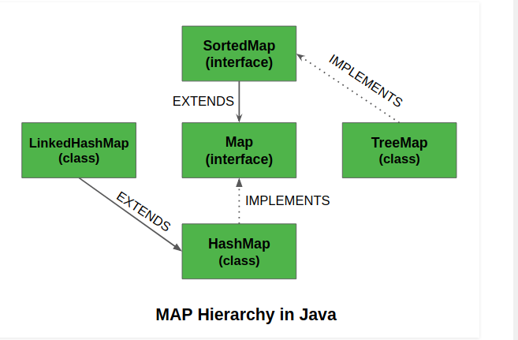
Object that maps keys to values.
A map cannot contain duplicate keys
Each key can map to at most one value.
The Java platform contains three general-purpose Map implementations: HashMap, TreeMap, and LinkedHashMap.

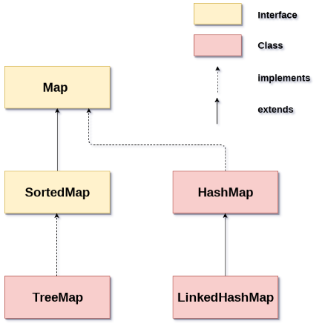
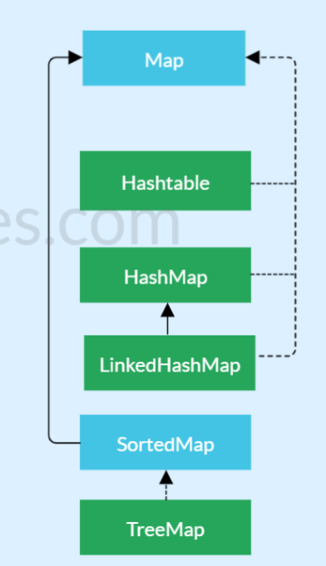
A Map is an object that maps keys to values. A map cannot contain duplicate keys: Each key can map to at most one value. It models the mathematical function abstraction. The Map interface includes methods for basic operations (such as put, get, remove, containsKey, containsValue, size, and empty), bulk operations (such as putAll and clear), and collection views (such as keySet, entrySet, and values).
The Java platform contains three general-purpose Map implementations: HashMap, TreeMap, and LinkedHashMap. Their behavior and performance are precisely analogous to HashSet, TreeSet, and LinkedHashSet, as described in The Set Interface section.

Few characteristics of the Map Interface are:
- A Map cannot contain duplicate keys and each key can map to at most one value. Some implementations allow null key and null value like the HashMap and LinkedHashMap, but some do not like the TreeMap.
- The order of a map depends on specific implementations, e.g TreeMap and LinkedHashMap have predictable order, while HashMap does not.
- There are two interfaces for implementing Map in java: Map and SortedMap, and three classes: HashMap, TreeMap and LinkedHashMap.

Some of the important points about Map in java are;
- Map provides three collection views – set of keys, set of key-value mappings and collection of values.
- Map doesn’t guarantee order of mappings, however it depends on the implementation. For example, HashMap doesn’t guarantee the order of mappings but TreeMap does.
- Map utilise hashCode and equals methods on Key for get and put operations. So mutable classes are not a good fit for Map keys. If the values of hashCode or equals change after put, you won’t get the correct value in get operation.
- Popular implementation classes of Map in Java are HashMap, Hashtable, TreeMap, ConcurrentHashMap and LinkedHashMap.
- AbstractMap class provides skeletal implementation of the Map interface, most of the Map concrete classes extend AbstractMap class and implement required methods.
Why and When to use Maps?
Maps are perfect to use for key-value association mapping such as dictionaries. The maps are used to perform lookups by keys or when someone wants to retrieve and update elements by keys. Some examples are:
- A map of error codes and their descriptions.
- A map of zip codes and cities.
- A map of managers and employees. Each manager (key) is associated with a list of employees (value) he manages.
- A map of classes and students. Each class (key) is associated with a list of students (value).
Methods in Map Interface:

- public Object put(Object key, Object value): This method is used to insert an entry in this map.
- public void putAll(Map map): This method is used to insert the specified map in this map.
- public Object remove(Object key): This method is used to delete an entry for the specified key.
- public Object get(Object key):This method is used to return the value for the specified key.
- public boolean containsKey(Object key): This method is used to search the specified key from this map.
- public Set keySet(): This method is used to return the Set view containing all the keys.
- public Set entrySet(): This method is used to return the Set view containing all the keys and values.

2. Implementations of Map
In the inheritance tree of the Map interface, there are several implementations but only 3 major, common, and general purpose implementations - they are HashMap and LinkedHashMap and TreeMap. Let’s see the characteristics and behaviors of each implementation:
- HashMap: this implementation uses a hash table as the underlying data structure. It implements all of the Map operations and allows null values and one null key. This class is roughly equivalent to Hashtable - a legacy data structure before Java Collections Framework, but it is not synchronized and permits nulls. HashMap does not guarantee the order of its key-value elements. Therefore, consider to use a HashMap when order does not matter and nulls are acceptable. s
- LinkedHashMap: this implementation uses a hash table and a linked list as the underlying data structures, thus the order of a LinkedHashMap is predictable, with insertion-order as the default order. This implementation also allows nulls like HashMap. So consider using a LinkedHashMap when you want a Map with its key-value pairs are sorted by their insertion order.
- TreeMap: this implementation uses a red-black tree as the underlying data structure. A TreeMap is sorted according to the natural ordering of its keys, or by a Comparator provided at creation time. This implementation does not allow nulls. So consider using a TreeMap when you want a Map sorts its key-value pairs by the natural order of the keys (e.g. alphabetic order or numeric order), or by a custom order you specify.

Java Hashtable class

https://www.infoworld.com/article/2077346/hashtables.html#:~:text=When%20you%20pass%20a%20key,to%20place%20the%20key%2Fvalue.&text=In%20Java%2C%20the%20Hashtable%20responds,implementations%20may%20handle%20collisions%20differently).
Java Hashtable class implements a hashtable, which maps keys to values. It inherits Dictionary class and implements the Map interface.
a hash table (hash map) is a data structure that implements an associative array abstract data type, a structure that can map keys to values. A hash table uses a hash function to compute an index, also called a hash code, into an array of buckets or slots, from which the desired value can be found.

Points to remember
- A Hashtable is an array of a list. Each list is known as a bucket. The position of the bucket is identified by calling the hashcode() method. A Hashtable contains values based on the key.
- Java Hashtable class contains unique elements.
- Java Hashtable class doesn't allow null key or value.
- Java Hashtable class is synchronized.
- The initial default capacity of Hashtable class is 11 whereas loadFactor is 0.75.

Hashtable class declaration
Let's see the declaration for java.util.Hashtable class.
- public class Hashtable<K,V> extends Dictionary<K,V> implements Map<K,V>, Cloneable, Serializable

Hashtable class Parameters
Let's see the Parameters for java.util.Hashtable class.
- K: It is the type of keys maintained by this map.
- V: It is the type of mapped values.

Difference between HashMap and Hashtable
HashMap and Hashtable both are used to store data in key and value form. Both are using hashing technique to store unique keys.
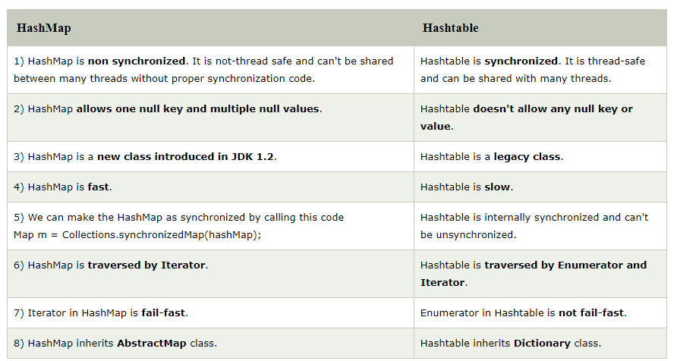
Incase, you have called iterator on a collection object, and another thread tries to modify the collection object, then concurrent modification exception will be thrown. This is called fail-fast.

HashMap in Java
HashMap is a part of Java’s collection since Java 1.2. It provides the basic implementation of the Map interface of Java. It stores the data in (Key, Value) pairs. To access a value one must know its key. HashMap is known as HashMap because it uses a technique called Hashing.
Hashing is a technique of converting a large String to small String that represents the same String. A shorter value helps in indexing and faster searches.
HashSet also uses HashMap internally. It internally uses a link list to store key-value pairs already explained in HashSet in detail and further articles.

Few important features of HashMap are:
- HashMap is a part of java.util package.
- HashMap extends an abstract class AbstractMap which also provides an incomplete implementation of Map interface.
- It also implements Cloneable and Serializable interface. K and V in the above definition represent Key and Value respectively.
- HashMap doesn’t allow duplicate keys but allows duplicate values. That means A single key can’t contain more than 1 value but more than 1 key can contain a single value.
- HashMap allows null key also but only once and multiple null values.
- This class makes no guarantees as to the order of the map; in particular, it does not guarantee that the order will remain constant over time. It is roughly similar to HashTable but is unsynchronized.

LinkedHashMap

LinkedHashMap<Integer, String> lhm = new LinkedHashMap<Integer, String>()

LinkedHashMap is just like HashMap with an additional feature of maintaining an order of elements inserted into it. HashMap provided the advantage of quick insertion, search and deletion but it never maintained the track and order of insertion which the LinkedHashMap provides where the elements can be accessed in their insertion order. Few important features of LinkedHashMap are as follows:
- A LinkedHashMap contains values based on the key. It implements the Map interface and extends HashMap class.
- It contains only unique elements (See this for details)..
- It may have one null key and multiple null values (See this for details).
- It is same as HashMap with additional feature that it maintains insertion order. For example, when we ran the code with HashMap, we got different order of elements

Methods in LinkedHashMap:
- void clear(): This method is used to remove all the mappings from the map.
- boolean containsKey(Object key): This method is used to returns true if a specified element is mapped by one or more keys.
- Object get(Object key): The method is used to retrieve or fetch the value mapped by the specified key.
- protected boolean removeEldestEntry(Map.Entry eldest): The method is used to return true when the map removes its eldest entry from the map.
- entrySet?(): This method returns a Set view of the mappings contained in this map.
- forEach?(BiConsumer<K,V> action): This method Performs the given action for each entry in this map until all entries have been processed or the action throws an exception.
- getOrDefault?(Object key, V defaultValue): This method returns the value to which the specified key is mapped, or defaultValue if this map contains no mapping for the key.
- keySet?(): This method returns a Set view of the keys contained in this map.
- removeEldestEntry?(Map.Entry<K,V> eldest): This method returns true if this map should remove its eldest entry.
- replaceAll?(BiFunction<K,V> function): This method replaces each entry’s value with the result of invoking the given function on that entry until all entries have been processed or the function throws an exception.
- values?(): This method returns a Collection view of the values contained in this map.

Java SortedMap and TreeMap Tutorial and Examples

TreeMap doesn’t only implement the Map interface, it also implements the SortedMap and NavigableMap interfaces. Therefore, besides the behaviors inherited from the Map, TreeMap also inherits the behaviors defined by SortedMap and NavigableMap. The following picture depicts the API hierarchy of TreeMap:
The main characteristic of a SortedMap is that, it orders the keys by their natural ordering, or by a specified comparator. So consider using a TreeMap when you want a map that satisfies the following criteria:
- null key or null value are not permitted.
- The keys are sorted either by natural ordering or by a specified comparator.
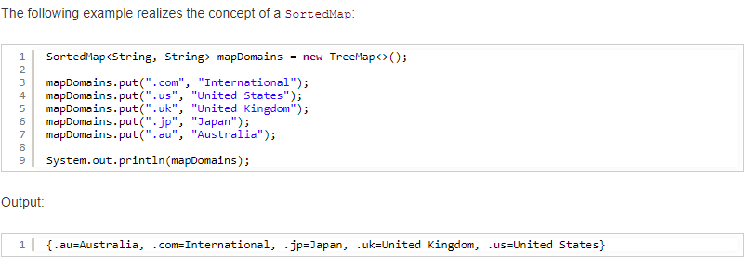
Here, this map contains mappings of domain=country, and as we see in the output, the domains (keys) are sorted by alphabetic order (natural ordering of Strings).

Besides the operations inherited from the Map interface, the SortedMap also defines the following operations:
- Range view: returns a sub sorted map whose keys fall within a range of keys in the original map.
- Endpoints: returns the first or last key in the sorted map.
- Comparator access: returns the comparator (implements the Comparator interface), if any, used to sort the map.

* Range View Operations:
+ subMap(K fromKey, K toKey): returns a sorted map whose keys range from fromKey, inclusive, to toKey, exclusive.
+ headMap(K toKey): returns a sorted map whose keys are strictly less than toKey.
+ tailMap(K fromKey): returns a sorted map whose keys are greater than or equal to fromKey.

* Endpoint operations:
+ firstKey(): returns the first (lowest) key currently in the map.
+ lastKey(): returns the last (highest) key currently in the map.

* Comparator access:
+ comparator(): returns the comparator used to order the keys in the map, or returns null if this map uses the natural ordering of its keys.

Difference between HashMap and ConcurrentHashMap.

HashMap is the Class which is under Traditional Collection and ConcurrentHashMap is a Class which is under Concurrent Collections, apart from this there are various differences between them which are:

- HashMap is non-Synchronized in nature i.e. HashMap is not Thread-safe whereas ConcurrentHashMap is Thread-safe in nature.
- HashMap performance is relatively high because it is non-synchronized in nature and any number of threads can perform simultaneously. But ConcurrentHashMap performance is low sometimes because sometimes Threads are required to wait on ConcurrentHashMap.
- While one thread is Iterating the HashMap object, if other thread try to add/modify the contents of Object then we will get Run-time exception saying ConcurrentModificationException.Whereas In ConcurrentHashMap we wont get any exception while performing any modification at the time of Iteration.

Difference between Comparable and Comparator
Comparable and Comparator both are interfaces and can be used to sort collection elements.
However, there are many differences between Comparable and Comparator interfaces that are given below.

