covariant type in java ?
Covariant return type refers to return type of an overriding method. ... Covariant return type works only for non-primitive return types. From Java 5 onwards, we can override a method by changing its return type only by abiding the condition that return type is a subclass of that of overridden method return type

immutal class?
Class and data member must be final, A parameterized constructor, Getter method for all the variables in it, No setter.

Volatile Keyword in Java
Volatile keyword is used to modify the value of a variable by different threads. It is also used to make classes thread safe. It means that multiple threads can use a method and instance of the classes at the same time without any problem. The volatile keyword can be used either with primitive type or objects.
The volatile keyword does not cache the value of the variable and always read the variable from the main memory. The volatile keyword cannot be used with classes or methods. However, it is used with variables. It also guarantees visibility and ordering. It prevents the compiler from the reordering of code.

How to create Mutual class?

Serializable vs deSerializable ?

That Serializable is a marker interface means that it contains no methods. Therefore, a class implementing Serializable does not have to implement any specific methods. Implementing Serializable thus just tells the Java serialization classes that this class is intended for object serialization.
Serialization is a mechanism of converting the state of an object into a byte stream. Deserialization is the reverse process where the byte stream is used to recreate the actual Java object in memory. This mechanism is used to persist the object.

flexiblity,security,abstraction,reuseability ==> Piller of Opps.

composition( Has-A relationship) vs aggregation(IS-a) ?

Aggregation implies a relationship where the child can exist independently of the parent. Example: Class (parent) and Student (child). Delete the Class and the Students still exist.
Composition implies a relationship where the child cannot exist independent of the parent. Example: House (parent) and Room (child). Rooms don't exist separate to a House.

method hiding ?

When super class and sub class contains same method including parameters and if they are static.
The method in the super class will be hidden by the one that is in the sub class. This mechanism is known as method hiding.

automatically --exact method signnature?

this()-> contructor chaining .

instance vs static block difference?

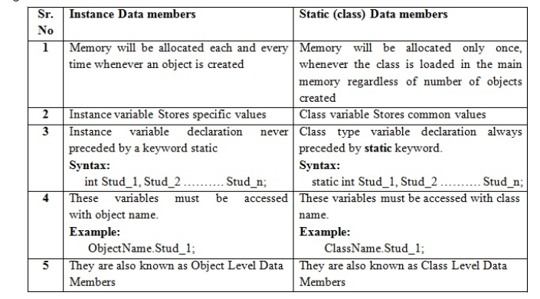

iterator?

hashmap vs hashtable?

1) HashMap is non synchronized. It is not-thread safe and can't be shared between many threads without proper synchronization code.
2) HashMap allows one null key and multiple null values.
4) HashMap is fast.
5) We can make the HashMap as synchronized by calling this code
Map m = Collections.synchronizedMap(hashMap);
6) HashMap is traversed by Iterator.
1) Hashtable is synchronized. It is thread-safe and can be shared with many threads.
2) Hashtable doesn't allow any null key or value.

What Is Cloning?
Cloning is a process of creating an exact copy of an existing object in the memory. In java, clone() method of java.lang.Object class is used for cloning process. This method creates an exact copy of an object on which it is called through field-by-field assignment and returns the reference of that object. Not all the objects in java are eligible for cloning process. The objects which implement Cloneable interface are only eligible for cloning process. Cloneable interface is a marker interface which is used to provide the marker to cloning process.
Shallow cloning vs Deep cloning :
Shallow cloning
The process of creating bitwise copy of an object is called Shallow Cloning .
2. If the main object contain any primitive variables then exactly duplicate copies
will be created in cloned object.
3. If the main object contain any reference variable then the corresponding object
won't be created just reference variable will be created by pointing to old
contained object.
4. By using main object reference if we perform any change to the contained object
then those changes will be reflected automatically to the cloned object , by
default Object class clone( ) meant for Shallow Cloning.
5.Shallow cloning is the best choice , if the Object contains only primitive values.

Deep cloning
1.The process of creating exactly independent duplicate object(including contained
objects also) is called deep cloning.
2. In Deep cloning , if main object contain any reference variable then the
corresponding Object copy will also be created in cloned object.
3. Object class clone( ) method meant for Shallow Cloning , if we want Deep
cloning then the programmer is responsible to implement by overriding clone( )
method.
In Deep cloning by using main Object reference if we perform any change to the
contained Object those changes won't be reflected to the cloned object.

Lazy Copy:
A lazy copy can be defined as a combination of both shallow copy and deep copy. The mechanism follows a simple approach – at the initial state, shallow copy approach is used. A counter is also used to keep a track on how many objects share the data. When the program wants to modify the original object, it checks whether the object is shared or not. If the object is shared, then the deep copy mechanism is initiated.

constructor?

default size of the array ? 10 object

Spring boot version ? 2.2.1

number of ways to generate the object of class?
================================================================
Using the new keyword
Java Class.newInstance() method
Using newInstance() method of Class class
Using clone() method
Using deserialization
======================================================
Why java won't provide support for multiple inheritance? :
java, every class is a child of Object class. When it inherits from more than one super class, sub class gets the ambiguity to acquire the property of Object class

method signature-> method name+method parameter

Why ambiguity problem won't be there in interfaces? Because there is no body of method

why Cyclic inheritance is not allowed in java? -> ambiguity

Automatic promotion in overloading.?
While resolving overloaded methods if the exact match method is not available, you will not immediately get any compile time error. First, the compiler promotes lower type argument to the higher type argument and checks whether the match method is available or not. If the match method is available, it will be considered.
If the match method is not available, compiler promotes argument once again to the higher type. This process will be continued until all possible promotions are not checked. Still, if the match method is not available, we will get compile time error. This process is called automatic type promotion in method overloading.

why abstract class have constructor ? : yes so that we can create object of abstract class.

Can we create object of the Abstract Class? yes

Static variable,class,method vs InstanceBlock,variable,class,method
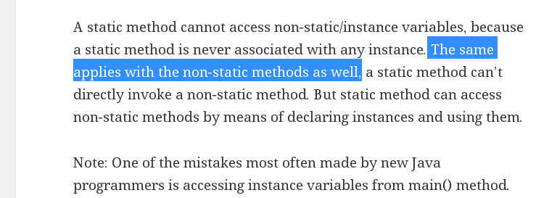
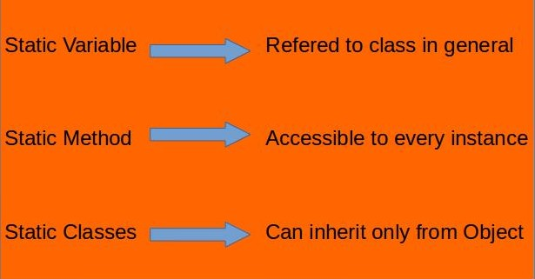
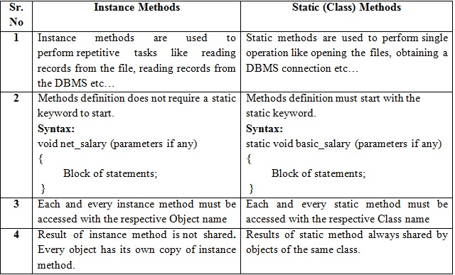

Singleton Class in Java
In object-oriented programming, a singleton class is a class that can have only one object (an instance of the class) at a time.
After first time, if we try to instantiate the Singleton class, the new variable also points to the first instance created. So whatever modifications we do to any variable inside the class through any instance, it affects the variable of the single instance created and is visible if we access that variable through any variable of that class type defined.
To design a singleton class:
- Make constructor as private.
- Write a static method that has return type object of this singleton class. Here, the concept of Lazy initialization is used to write this static method.

HTTP Methods

The GET Method
GET is used to request data from a specified resource.
GET is one of the most common HTTP methods.
Note that the query string (name/value pairs) is sent in the URL of a GET request:
/test/demo_form.php?name1=value1&name2=value2
- GET requests can be cached
- GET requests remain in the browser history
- GET requests can be bookmarked
- GET requests should never be used when dealing with sensitive data
- GET requests have length restrictions
- GET requests are only used to request data (not modify)

The POST Method
POST is used to send data to a server to create/update a resource.
The data sent to the server with POST is stored in the request body of the HTTP request:
POST /test/demo_form.php HTTP/1.1
Host: w3schools.com
name1=value1&name2=value2
POST is one of the most common HTTP methods.
Some other notes on POST requests:
- POST requests are never cached
- POST requests do not remain in the browser history
- POST requests cannot be bookmarked
- POST requests have no restrictions on data length

The PUT Method
PUT is used to send data to a server to create/update a resource.
The difference between POST and PUT is that PUT requests are idempotent. That is, calling the same PUT request multiple times will always produce the same result. In contrast, calling a POST request repeatedly have side effects of creating the same resource multiple times.
Difference between PUT and Patch
Also, another difference is that when you want to update a resource with PUT request, you have to send the full payload as the request whereas with PATCH, you only send the parameters which you want to update.

difference between sleep and yield in java
Yield method temporarily pauses the currently executing thread to give a chance to the remaining waiting threads of the same priority to execute.
If there is no waiting thread or all the waiting threads of low priority then the current thread will continue its execution
WhereAs
Sleep method causes the currently executing thread to sleep for the number of milliseconds or the nanoseconds specified in the argument.

java 8 interface vs abstract class?
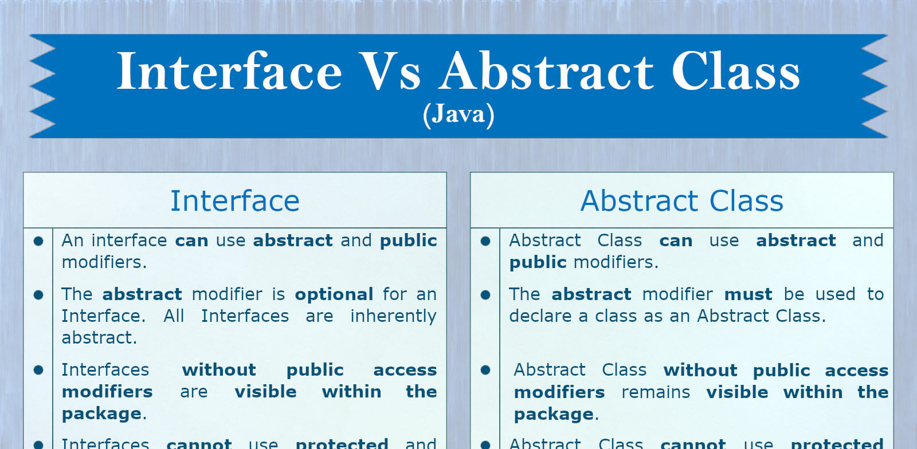

Try with Resources
In Java, the try-with-resources statement is a try statement that declares one or more resources. The resource is as an object that must be closed after finishing the program. The try-with-resources statement ensures that each resource is closed at the end of the statement execution.
You can pass any object that implements java.lang.AutoCloseable, which includes all objects which implement java.io.Closeable.
The following example writes a string into a file. It uses an instance of FileOutputStream to write data into the file. FileOutputStream is a resource that must be closed after the program is finished with it. So, in this example, closing of resource is done by itself try.

Note - In a try-with-resources statement, catch or finally block executes after closing of the declared resources.

Java Marker Interface: It is an empty interface (no field or methods)

Marker interface is used as a tag to inform a message to the Java compiler so that it can add special behaviour to the class implementing it. Java marker interface has no members in it.

Java Marker Interface Examples
- java.lang.Cloneable
- java.io.Serializable
- java.util.EventListener

We cannot create marker interfaces, as you cannot instruct JVM to add special behavior to all classes implementing (directly) that special interface.

Internal Working of HashMap in Java : it use hashset.

@componet :

Hashmap

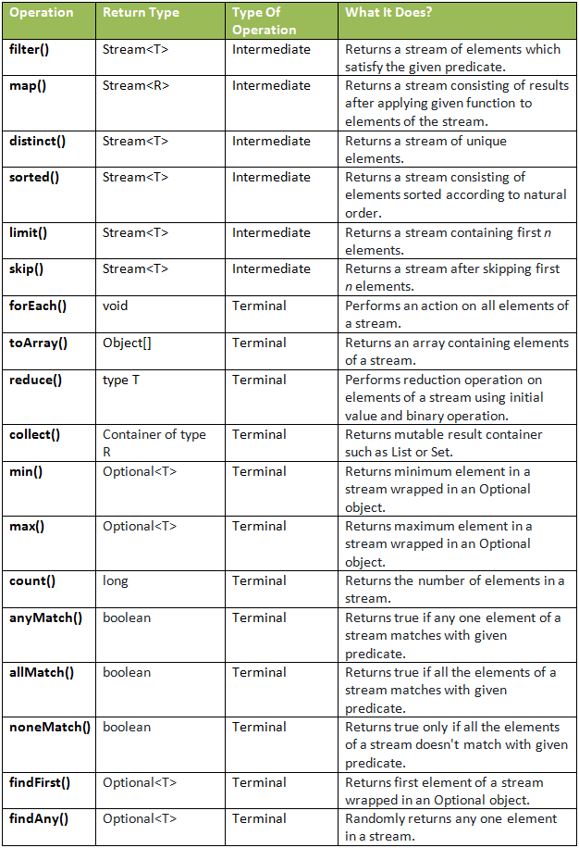

RESTful Web Services - Statelessness

As per the REST architecture, a RESTful Web Service should not keep a client state on the server. This restriction is called Statelessness. It is the responsibility of the client to pass its context to the server and then the server can store this context to process the client's further request. For example, session maintained by server is identified by session identifier passed by the client.

Top 5 Types of Memory in Java

1. Method Area
All executing threads share this part of the JVM memory area. Class elements like constant pool, class fields, constructor codes, method codes, etc. Method area can be considered as a part of the heap area but stores per-class data only. We can say that the method area is responsible for holding class level information.

2. Heap Memory
Heap Memory in java is used by java runtime to allocate memory to objects and class during a java program’s execution. Whenever an object is created in java, it gets stored into heap memory. A garbage collection process runs on heap memory to free up unnecessary space that is garbage collection removes those objects from the heap area that does not have any references. Heap memory in java is divided into the following parts:
- Young Generation: This is the part where all newly created objects are placed. When this part of the java heap gets filled up, a minor garbage collection occurs to free up space.
- Old Generation: All objects left in memory after minor garbage collection are moved into the old generation. Therefore this is the part of heap memory where long-living objects are present.
- Permanent Generation: This part of JVM contains native and static methods that provide metadata for running java applications.
Here are some important points regarding java heap memory:
- If Heap space gets full, OutOfMemory error is thrown by java.
- Access to Heap memory is slow as compared to stack memory.
- Heap memory is much more in size as compared to stack memory.
- Heap memory is not thread-safe as all objects share it.
- Automatic deallocation is not present in heap memory as it needs a garbage collector to free up space.

3. Stack Memory
As the name signifies, stack memory is based on LIFO (last in, first out) principle. Stack memory is used for static memory allocation, and each executing thread in a java program has its own stack memory. Whenever a Java method is called, a new block is created in java stack memory to hold local or intermediate variables and references to other objects in the method. As soon as the execution of the method gets completed, the block of memory in the stack becomes empty and is used by the next method. The size of Stack memory is less as compared to heap memory. Here are some of the important features of stack memory.
- Stack Memory grows and shrinks itself as new methods are added and removed to stack memory, respectively.
- Stack memory gets automatically allocated and deallocated after the method completes its execution.
- Access to stack memory is fast as compared to heap memory.
- Whenever stack memory gets full, an exception called stack overflow exception is thrown by java.
- Stack memory is thread-safe as each thread has its own stack memory.

4. PC Registers
The main function of pc registers is to store the address of currently executing the instruction. It also stores the address of threads responsible for executing current instruction. The size of memory allocated to pc registers is very small. Java applications executing in JVM does not have any effect on pc register memory or its contents.

5. Native Area
This area is implemented using languages other than java. With the creation of new threads, memory is allocated in this area for each created thread. The size of the native area can be fixed or dynamic.

Difference between volatile and transient keywords in Java

transient is a variables modifier used in serialization. At the time of serialization, if we don't want to save value of a particular variable in a file, then we use transient keyword. When JVM comes across transient keyword, it ignores original value of the variable and save default value of that variable data type.

The Volatile keyword is used to mark the JVM and thread to read its value from primary memory and not utilize cached value present in the thread stack. It is used in concurrent programming in java.

The volatile keyword flushes the changes directly to the main memory instead of the CPU cache.

Can we use the static variables inside static methods?
No, we can not write or declare static variable in any method including static.
Static variable belong to class directly .

Can we use the final keyword with the constructor?

No, a constructor can't be made final. A final method cannot be overridden by any subclasses. ... In other words, constructors cannot be inherited in Java therefore, there is no need to write final before constructors. Therefore, java does not allow final keyword before a constructor.

What are the different bean scopes in Spring?

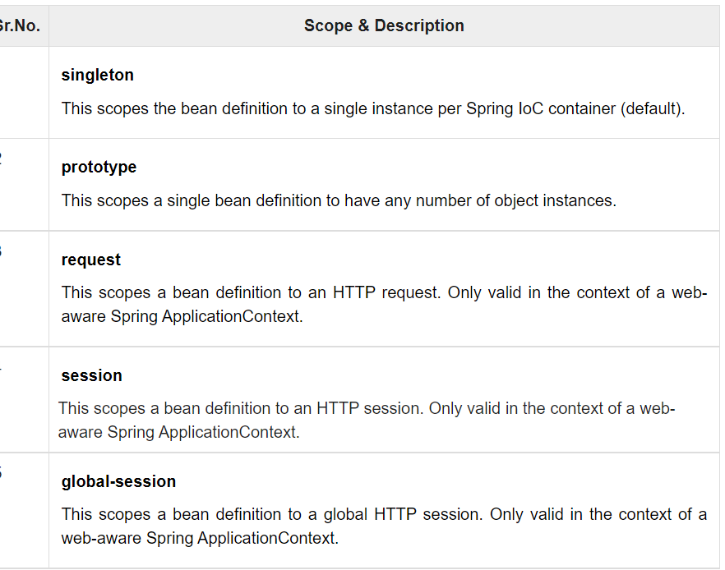

Code to sort an array without using any predefined class and methods?

What is Bean Factory ?
A BeanFactory is factory Pattern which is based on IOC design principles.it is used to make a clear separation between application configuration and dependency from actual code.
A BeanFactory is like a factory class that contains a collection of beans. The BeanFactory holds Bean Definitions of multiple beans within itself and then instantiates the bean whenever asked for by clients.
BeanFactory is able to create associations between collaborating objects as they are instantiated. This removes the burden of configuration from bean itself and the beans client.
BeanFactory also takes part in the life cycle of a bean, making calls to custom initialization and destruction methods.
BeanFactory factory = new XmlBeanFactory(new FileInputStream("beans.xml"));

What is Application Context?
A bean factory is fine to simple applications, but to take advantage of the full power of the Spring framework, you may want to move up to Springs more advanced container, the application context. On the surface, an application context is same as a bean factory.Both load bean definitions, wire beans together, and dispense beans upon request. But it also provides:
1 A means for resolving text messages, including support for internationalization.
2 A generic way to load file resources.
3 Events to beans that are registered as listeners.

What are the Name of different types of Autowire types?
There are five different types of Autowire, they are:
1 no
2 byName
3 byType
4 constructor
5 autodetect

What are the difference between BeanFactory and ApplicationContext in spring?
There are some differences between BeanFactoy and ApplicationContext in Spring as follows:
ApplicationContext | BeanFactory
1 Here we can have more than one config files possible. | 1 In this only one config file or .xml file.
2 Application contexts can publish events to beans that are registered as listeners | 2 Doesn�t support.
3 Support internationalization (I18N) messages. | 3 It�s not.
4 Support application life-cycle events, and validation. | 4 Doesn�t support.
5 Support many enterprise services such JNDI access, EJB integration, remoting | 5 Doesn�t support.
6 Application contexts provide a generic way to load file resources, such as images. | 6 It's not.
7 Application contexts provide a means for resolving text messages. | 7 It's not.
8 ResourceLoader support: Spring�s Resource interface us a flexible generic abstraction for handling low-level resources. An application context itself is a ResourceLoader, Hence provides an application with access to deployment-specific Resource instances. | 8 It's not.

Spring Dependency Injection

. Constructor-Based Injection:

2. Setter Injection:

Difference between constructor and setter injection
There are many key differences between constructor injection and setter injection.
- Partial dependency: can be injected using setter injection but it is not possible by constructor. Suppose there are 3 properties in a class, having 3 arg constructor and setters methods. In such case, if you want to pass information for only one property, it is possible by setter method only.
- Overriding: Setter injection overrides the constructor injection. If we use both constructor and setter injection, IOC container will use the setter injection.
- Changes: We can easily change the value by setter injection. It doesn't create a new bean instance always like constructor. So setter injection is flexible than constructor injection.

Are Spring singleton beans thread-safe?

No,Singletons are about creation. This design pattern ensures that only one instance of a class is created.

Thread safety is about execution. To quote Wikipedia:
A piece of code is thread-safe if it only manipulates shared data structures in a manner that guarantees safe execution by multiple threads at the same time.
So eventually thread safety depends on the code and the code only. And this is the reason why Spring beans are not thread safe per se.

ContextLoaderListener vs DispatcherServlet
In XML based Spring MVC configuration, you must have seen two declarations in web.xml file i.e. ContextLoaderListener and DispatcherServlet. Let’s try to understand their purpose in framework and their differences.

ContextLoaderListener creates root application context. DispatcherServlet entries create one child application context per servlet entry. Child contexts can access beans defined in root context.

What is Swagger spring boot?
Advertisements. Swagger2 is an open source project used to generate the REST API documents for RESTful web services. It provides a user interface to access our RESTful web services via the web browser.

