@SpringBootApplication
@SpringBootApplication encapsulates @Configuration, @EnableAutoConfiguration, and @ComponentScan annotations with their default attributes.
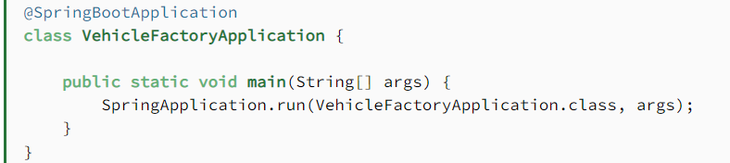

@EnableAutoConfiguration
@EnableAutoConfiguration, as its name says, enables auto-configuration. It means that Spring Boot looks for auto-configuration beans on its classpath and automatically applies them.
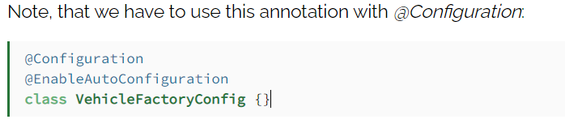

Auto-Configuration Conditions
Usually, when we write our custom auto-configurations, we want Spring to use them conditionally. We can achieve this with the annotations in this section.
We can place the annotations in this section on @Configuration classes or @Bean methods.
In the next sections, we'll only introduce the basic concept behind each condition. For further information, please visit this article.

