Lambda Expressions in Java 8

Lambda expressions basically express instances of functional interfaces (An interface with single abstract method is called functional interface. An example is java.lang.Runnable). lambda expressions implement the only abstract function and therefore implement functional interfaces

lambda expressions are added in Java 8 and provide below functionalities.
- Enable to treat functionality as a method argument, or code as data.
- A function that can be created without belonging to any class.
- A lambda expression can be passed around as if it was an object and
executed on demand.

lambda operator -> body
where lambda operator can be:
- Zero parameter:
() -> System.out.println("Zero parameter lambda");
- One parameter:–
(p) -> System.out.println("One parameter: " + p);
It is not mandatory to use parentheses, if the type of that variable can be inferred from the context
- Multiple parameters :
(p1, p2) -> System.out.println("Multiple parameters: " + p1 + ", " + p2);

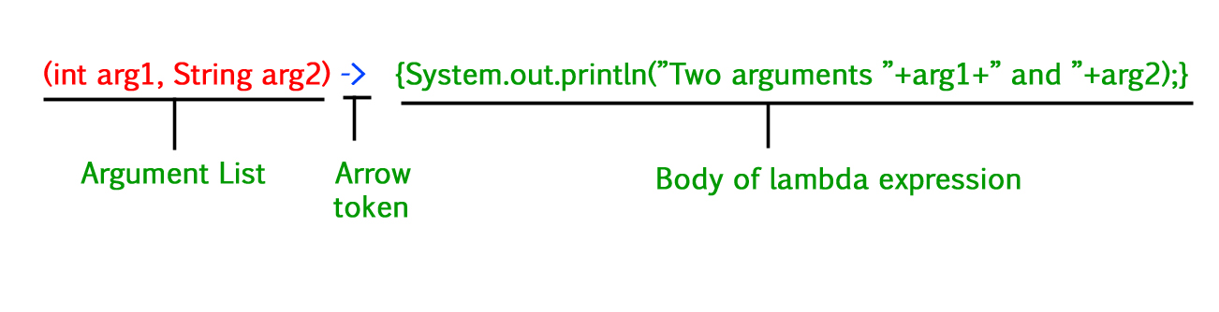

Stream API in java
https://howtodoinjava.com/java8/java-streams-by-examples/
Table of Contents

1. Stream vs Collection
2. Different ways to create streams
3. Converting streams to collections
4. Core stream operations
4.1. Intermediate operations
4.2. Terminal operations
5. Short-circuit operations
6. Parallelism

A Stream in Java can be defined as a sequence of elements from a source. The source of elements here refers to a Collection or Array that provides data to the Stream.
Java streams are designed in such a way that most of the stream operations (called intermediate operations) return a Stream. This helps to create a chain of stream operations. This is called stream pipe-lining.
Based on the above points, a stream is :
- Not a data structure
- Designed for lambdas
- Do not support indexed access
- Can easily be aggregated as arrays or lists
- Lazy access supported
- Parallelizable

7. Stream Operations

7.1 Creating Streams
- concat()
- empty()
- generate()
- iterate()
- of()

7.2 Intermediate Operations
- filter()
- map()
- flatMap()
- distinct()
- sorted()
- peek()
- limit()
- skip()

7.3. Terminal Operations
- forEach()
- forEachOrdered()
- toArray()
- reduce()
- collect()
- min()
- max()
- count()
- anyMatch()
- allMatch()
- noneMatch()
- findFirst()
- findAny()

Java Optional Class : Every Java Programmer is familiar with NullPointerException. It can crash your code. And it is very hard to avoid it without using too many null checks.
Java 8 has introduced a new class Optional in java.util package. It can help in writing a neat code without using too many null checks. By using Optional, we can specify alternate values to return or alternate code to run. This makes the code more readable because the facts which were hidden are now visible to the developer.
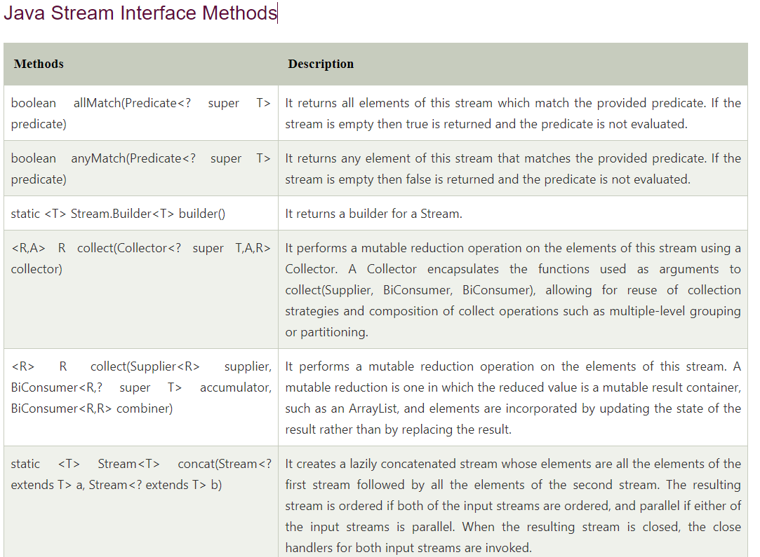

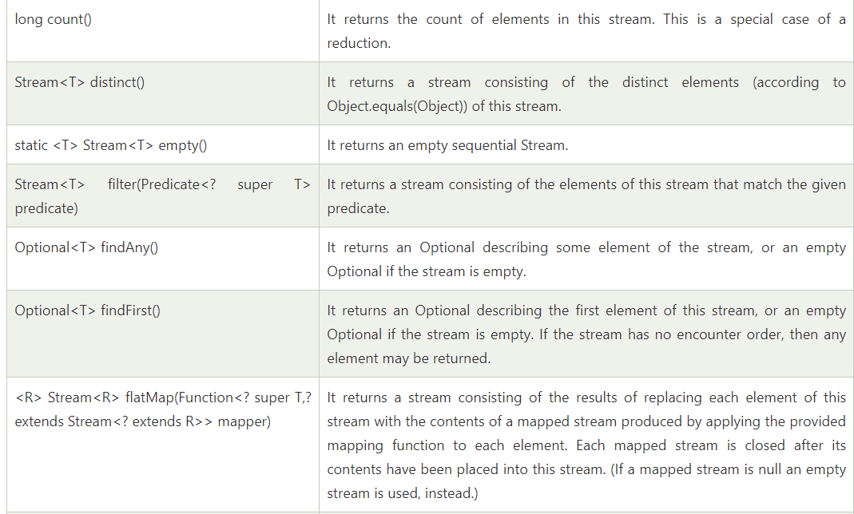

2. Creating Streams
The given below ways are the most popular different ways to build streams from collections.

2.1. Stream.of()
In the given example, we are creating a stream of a fixed number of integers.
public class StreamBuilders
{
public static void main(String[] args)
{
Stream<Integer> stream = Stream.of(1,2,3,4,5,6,7,8,9);
stream.forEach(p -> System.out.println(p));
}
}

2.2. Stream.of(array)
In the given example, we are creating a stream from the array. The elements in the stream are taken from the array.
public class StreamBuilders
{
public static void main(String[] args)
{
Stream<Integer> stream = Stream.of( new Integer[]{1,2,3,4,5,6,7,8,9} );
stream.forEach(p -> System.out.println(p));
}
}

2.3. List.stream()
In the given example, we are creating a stream from the List. The elements in the stream are taken from the List.
public class StreamBuilders
{
public static void main(String[] args)
{
List<Integer> list = new ArrayList<Integer>();

for(int i = 1; i< 10; i++){
list.add(i);
}

Stream<Integer> stream = list.stream();
stream.forEach(p -> System.out.println(p));
}
}

2.4. Stream.generate() or Stream.iterate()
In the given example, we are creating a stream from generated elements. This will produce a stream of 20 random numbers. We have restricted the elements count using limit() function.
public class StreamBuilders
{
public static void main(String[] args)
{
Stream<Integer> randomNumbers = Stream
.generate(() -> (new Random()).nextInt(100));

randomNumbers.limit(20)
.forEach(System.out::println);
}
}

Stream of String chars or tokens

In the given example, first, we are creating a stream from the characters of a given string. In the second part, we are creating the stream of tokens received from splitting from a string.
IntStream stream ="12345_abcde".chars();
stream.forEach(a->System.out.println(a));

//OR
System.out.println("=================================");
Stream<String> stream1 = Stream.of("A$B$C".split("\\$"));
stream1.forEach(p -> System.out.println(p));

3. Stream Collectors

After performing the intermediate operations on elements in the stream, we can collect the processed elements again into a Collection using the stream Collector methods.

3.1. Collect Stream elements to a List
In the given example, first, we are creating a stream on integers 1 to 10. Then we are processing the stream elements to find all even numbers.
At last, we are collecting all even numbers into a List.
public class StreamBuilders
{
public static void main(String[] args)
{
List<Integer> list = new ArrayList<Integer>();

for(int i = 1; i< 10; i++){
list.add(i);
}

Stream<Integer> stream = list.stream();
List<Integer> evenNumbersList = stream.filter(i -> i%2 == 0)
.collect(Collectors.toList());
System.out.print(evenNumbersList);
}
}

3.2. Collect Stream elements to an Array
The given example is similar to the first example shown above. The only difference is that we are collecting the even numbers in an Array.
public class StreamBuilders
{
public static void main(String[] args)
{
List<Integer> list = new ArrayList<Integer>();

for(int i = 1; i< 10; i++){
list.add(i);
}

Stream<Integer> stream = list.stream();
Integer[] evenNumbersArr = stream.filter(i -> i%2 == 0).toArray(Integer[]::new);
System.out.print(evenNumbersArr);
}

}

4. Stream Operations
Stream abstraction has a long list of useful functions. Let us look at a few of them.
Before moving ahead, let us build a List of strings beforehand. We will build our examples on this list so that it is easy to relate and understand.
List<String> memberNames = new ArrayList<>();
memberNames.add("Amitabh");
memberNames.add("Shekhar");
memberNames.add("Aman");
memberNames.add("Rahul");
memberNames.add("Shahrukh");
memberNames.add("Salman");
memberNames.add("Yana");

memberNames.add("Lokesh");

These core methods have been divided into 2 parts given below:

4.1. Intermediate Operations
Intermediate operations return the stream itself so you can chain multiple methods calls in a row. Let’s learn important ones.

4.1.1. Stream.filter()
The filter() method accepts a Predicate to filter all elements of the stream. This operation is intermediate which enables us to call another stream operation (e.g. forEach()) on the result.
memberNames.stream().filter((s) -> s.startsWith("A"))
.forEach(System.out::println);
Program Output:
Amitabh
Aman

4.1.2. Stream.map()
The map() intermediate operation converts each element in the stream into another object via the given function.
The following example converts each string into an UPPERCASE string. But we can use map() to transform an object into another type as well.
memberNames.stream().filter((s) -> s.startsWith("A"))
.map(String::toUpperCase)
.forEach(System.out::println);
Program Output:
AMITABH
AMAN

4.1.2. Stream.sorted()
The sorted() method is an intermediate operation that returns a sorted view of the stream. The elements in the stream are sorted in natural order unless we pass a custom Comparator.
memberNames.stream().sorted()
.map(String::toUpperCase)
.forEach(System.out::println);
Program Output:
AMAN
AMITABH
LOKESH
RAHUL
SALMAN
SHAHRUKH
SHEKHAR
YANA
Please note that the sorted() method only creates a sorted view of the stream without manipulating the ordering of the source Collection. In this example, the ordering of string in the memberNames is untouched.

4.2. Terminal operations
Terminal operations return a result of a certain type after processing all the stream elements.
Once the terminal operation is invoked on a Stream, the iteration of the Stream and any of the chained streams will get started. Once the iteration is done, the result of the terminal operation is returned.

4.2.1. Stream.forEach()
The forEach() method helps in iterating over all elements of a stream and perform some operation on each of them. The operation to be performed is passed as the lambda expression.
memberNames.forEach(System.out::println);

4.2.2. Stream.collect()
The collect() method is used to receive elements from a steam and store them in a collection.
List<String> memNamesInUppercase = memberNames.stream().sorted()
.map(String::toUpperCase)
.collect(Collectors.toList());

System.out.print(memNamesInUppercase);
Program Output:
[AMAN, AMITABH, LOKESH, RAHUL, SALMAN, SHAHRUKH, SHEKHAR, YANA]

4.2.3. Stream.match()
Various matching operations can be used to check whether a given predicate matches the stream elements. All of these matching operations are terminal and return a boolean result.
boolean matchedResult = memberNames.stream()
.anyMatch((s) -> s.startsWith("A"));

System.out.println(matchedResult);

matchedResult = memberNames.stream()
.allMatch((s) -> s.startsWith("A"));

System.out.println(matchedResult);

matchedResult = memberNames.stream()
.noneMatch((s) -> s.startsWith("A"));

System.out.println(matchedResult);
Program Output:
true
false
false

4.2.4. Stream.count()
The count() is a terminal operation returning the number of elements in the stream as a long value.
long totalMatched = memberNames.stream()
.filter((s) -> s.startsWith("A"))
.count();

System.out.println(totalMatched);
Program Output:
2

4.2.5. Stream.reduce()
The reduce() method performs a reduction on the elements of the stream with the given function. The result is an Optional holding the reduced value.
In the given example, we are reducing all the strings by concatenating them using a separator #.
Optional<String> reduced = memberNames.stream()
.reduce((s1,s2) -> s1 + "#" + s2);

reduced.ifPresent(System.out::println);
Program Output:
Amitabh#Shekhar#Aman#Rahul#Shahrukh#Salman#Yana#Lokesh

5. Stream Short-circuit Operations
Though stream operations are performed on all elements inside a collection satisfying a Predicate, it is often desired to break the operation whenever a matching element is encountered during iteration.
In external iteration, we will do with the if-else block. In the internal iterations such as in streams, there are certain methods we can use for this purpose.

5.1. Stream.anyMatch()
The anyMatch() will return true once a condition passed as predicate satisfies. Once a matching value is found, no more elements will be processed in the stream.
In the given example, as soon as a String is found starting with the letter 'A', the stream will end and the result will be returned.
boolean matched = memberNames.stream()
.anyMatch((s) -> s.startsWith("A"));

System.out.println(matched);
Program Output:
true

5.2. Stream.findFirst()
The findFirst() method will return the first element from the stream and then it will not process any more elements.
String firstMatchedName = memberNames.stream()
.filter((s) -> s.startsWith("L"))
.findFirst()
.get();

System.out.println(firstMatchedName);
Program Output:
Lokesh

6. Parallel Stream
With the Fork/Join framework added in Java SE 7, we have efficient machinery for implementing parallel operations in our applications.
But implementing a fork/join framework is itself a complex task, and if not done right; it is a source of complex multi-threading bugs having the potential to crash the application. With the introduction of internal iterations, we got the possibility of operations to be done in parallel more efficiently.
To enable parallelism, all we have to do is to create a parallel stream, instead of a sequential stream. And to surprise, this is really very easy.
In any of the above-listed stream examples, anytime we want to do a particular job using multiple threads in parallel cores, all we have to call parallelStream() method instead of stream() method.
public class StreamBuilders
{
public static void main(String[] args){

List<Integer> list = new ArrayList<Integer>();
for(int i = 1; i< 10; i++){
list.add(i);
}

//Here creating a parallel stream
Stream<Integer> stream = list.parallelStream();

Integer[] evenNumbersArr = stream.filter(i -> i%2 == 0).toArray(Integer[]::new);
System.out.print(evenNumbersArr);
}
}
A key driver for Stream APIs is making parallelism more accessible to developers. While the Java platform provides strong support for concurrency and parallelism already, developers face unnecessary impediments in migrating their code from sequential to parallel as needed.
Therefore, it is important to encourage idioms that are both sequential- and parallel-friendly. This is facilitated by shifting the focus towards describing what computation should be performed, rather than how it should be performed.
It is also important to strike the balance between making parallelism easier but not going so far as to make it invisible. Making parallelism transparent would introduce non-determinism and the possibility of data races where users might not expect it.

Inserting at the beginning
- Let’s first obtain a stream from an existing array:

- private static Employee[] arrayOfEmps = {
- new Employee(1, "Jeff Bezos", 100000.0),
- new Employee(2, "Bill Gates", 200000.0),
- new Employee(3, "Mark Zuckerberg", 300000.0)
- };

- Stream.of(arrayOfEmps);
- We can also obtain a stream from an existing list:
- private static List<Employee> empList = Arrays.asList(arrayOfEmps);
- empList.stream();
- Note that Java 8 added a new stream() method to the Collection interface.
- And we can create a stream from individual objects using Stream.of():

he idea is to create a sequential stream of the given element using the Stream.of() factory method and then use Stream.concat() for concatenating the resultant stream into the original stream.
Please note that to insert the given element at the beginning, the resultant stream from that element is passed as the first parameter to the Stream.concat() method.

