Creating a Simple Microservice
Step 1: Create a Maven project using Spring Initializr https://start.spring.io/

Step 2: Choose the Spring Boot version 2.2.0 M6 or higher version. Do not choose the snapshot version.
Step 3: Provide the Group name. In our case om.javatpoint
Step 4: Provide the Artifact id. We have provided limits-service.
Step 5: Add the following dependencies: Spring Web, Spring Boot DevTools, Spring Boot Actuator, Config Client.
Step 6: Click on Generate the project button. A zip file will download, extract it into the hard disk.
Step 7: Now, open the eclipse. Import the created maven project. It takes some time to download the required files.
Step 8: Once the project is downloaded, go to src/main/java. Open the LimitsServiceApplication.
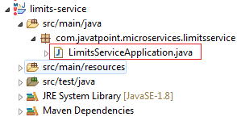
Step 9: Now run the LimitsServiceApplication.java as Java Application.
It started the Tomcat on port(s) 8080 (http).
Now we will add couple of services in the above project. For this we will have to follow the following steps:
Step 1: Open application.properties file and write the following code:
- spring.application.name=limits-service //name of application
- Step 2: Create a class file with name LimitsConfigurationController.java in the folder src/main/java under the package com.javatpoint.microservices.limitsservice and write the following code:

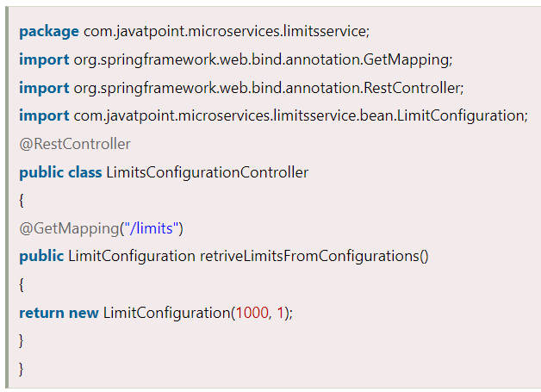

Step 3: Create a class file with name LimitConfiguration.java in the folder src/main/java under the package com.javatpoint.microservices.limitservice.bean and write the following code:

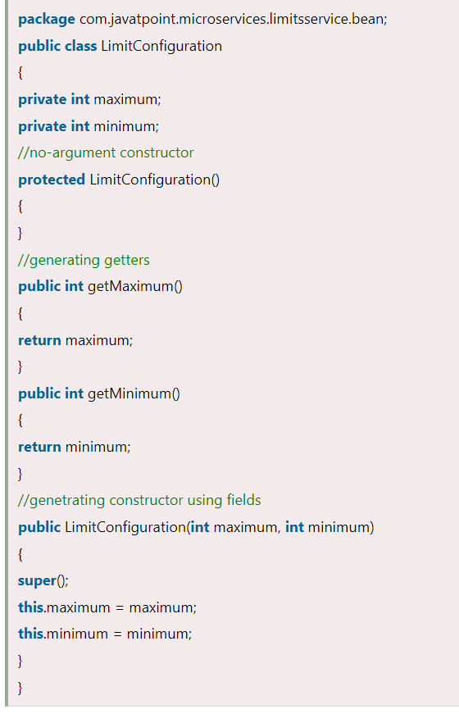
Type the localhost:8080/limits in the browser and press enter, we get the JSON response as output.
Output
{
maximum: 1000,
minimum: 1
}

Adding services to the application.properties

In the previous program, we will modify the code according to the requirement.
Now we call the limits-service from the application.properties file. In this file, we are configuring a couple of values.

- limits-service.minimum=99
- limits-service.maximum=9999
There is a better approach in Spring Boot to read values from the configuration using the annotation @ConfigurationProperties.

Step 1: Create a class with name Configuration.java in the folder src/main/java under the package com.javatpoint.microservices.limitservice.
Step 2: Add the annotations @Component and @ConfigurationProperties.
Step 3: Declare two variables minimum and maximum.
Step 4: If we are using the Configuration file, we need to generate getters and setters.
The Configuration.java file look like this.
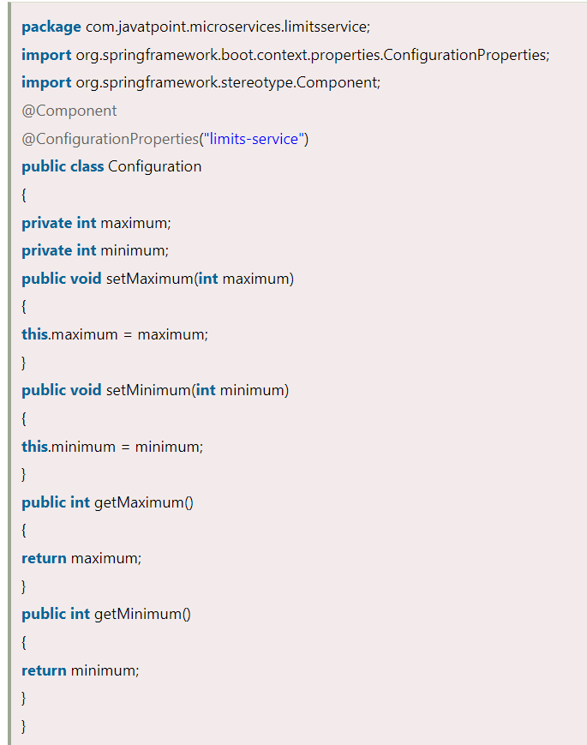

Setting up Spring Cloud Config Server
Step 1: Create a Maven project using Spring Initializr https://start.spring.io/
Step 2: Choose the Spring Boot version 2.2.0 M6 or higher version. Do not choose the snapshot version.
Step 3: Provide the Group name. In our case, com.javatpoint.microservices.
Step 4: Provide the Artifact id. We have provided spring-cloud-config-server.

Step 5: Add the Spring Boot DevTools and Config Server dependencies.
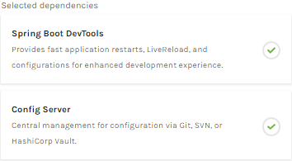
Step 6: Click on Generate the project button. A zip file will download, extract it in the hard disk.
Step 7: Now, open the eclipse. Import the downloaded maven project. It will download the required files.
In the next step, we will create a simple Git repository and configure the spring cloud config server to pick up the values from the particular Git repository. We need to install the local Git.

Installing Git and creating a local repository
Step 1: Download Git from https://git-scm.com/
and install it.
Step 2: Create a Git repository and store the files that we want to be able to configure a limits-service. We will try to access them from the spring-cloud-config-server. Open the Git bash and type the following commands:
Creating a new directory:

- mkdir git-localconfig-repo
- cd git-localconfig-repo/
Initializing a new Git repository:
- git init
It initializes an empty git repository.
Step 3: Now move to the spring-cloud-config-server project and add a link to the specific folder.
- Right-click on the spring-cloud-config-server project.
- Click on Build Path->Configure Build Path…
- Select the Source tab.
- Click on Link Source and browse the folder git-localconfig-repo.
- Right click on the folder-> New -> Other -> File -> Next -> Provide the file name: limits-service-properties-> Finish.
- Now write the following code in the properties file:

- limits-service.minimum=8
- limits-service.maximum=888

Step 4: Configure the user name and user email:
- git config -global user.email abc@example.com
- git config -global user.name "abc"
The command commits any file we have added with the git add command and also commits any files we have changed since then.
- git add -A
Now execute the command to commit the changes in the repository. It records or snapshots the file permanently in the version history.
- git commit -m "first commit"
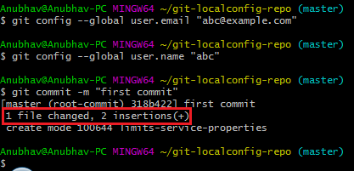
We can see that a file is changed with two new instructions. These instructions are changed in the local repository.

Connect Spring Cloud Config Server to Local Git Repository

